

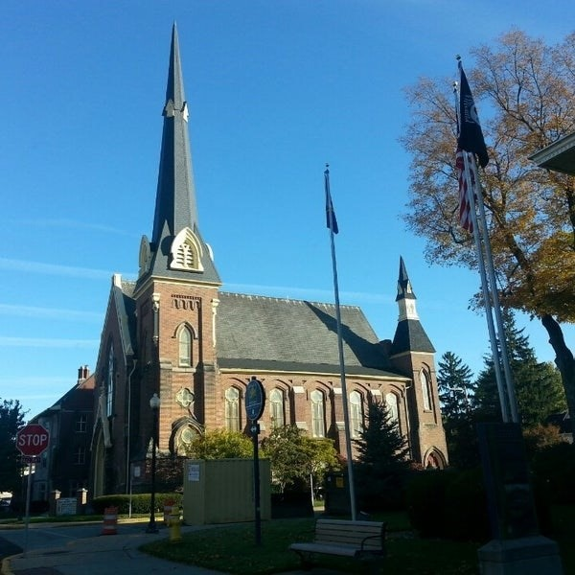
September 9, 2026

A Global Methodist Church
214 S. 5th Street
Goshen, IN 46528
Phone: 574-533-9518
Web Site: goshenfirstgmc.org

Office Hours: Monday-Thursday,
8:00 a.m.-1:00 p.m.
Worship: 9:00 a.m.
Sunday School: 10:30 a.m.
Pastor Jeff & Lisa
Associate Pastor Rich Hull
OUR VISION: “Growing in Faith, Gathering in Community, and Giving in Love”.

Grief Share
Grief Share started on August 12th from 6pm to 7pm at the church and will continue through November 11th. Sue Wirt is leading the class. If you plan on attending the class please contact Sue at 574-238-2894.

Come join us for Wednesday Night Church!!! The meal starts at 5:30p.m. and classes start at 6:00p.m. Choir at 7:00p.m. Exciting things happening here, don’t miss out!!

The Monday morning Bible Study continues to meet this fall. They are
studying the book, “Knowing God,” by J.I. Packer. All are welcome.

Primetimers will be going to Wellfield Bontanical Gardens on Tuesday September 15th. The bus will leave the life Center at 9:15a.m. This will be a free walk. Lunch will be at Perkins resturaunt at 11:30a.m. Everyone is welcome!

Reminder that Faith Weavers Sunday school will be doing the Wednesday night meal on September 16th.

The Newsletter will be bi-monthly starting in October. It will go out the first Wednesday and third Wednesday of the month.

VOLUNTEERS – Thank you for your service - Sunday morning, September 13
Greeters: Lenette Burckhart, Janice Leek VIP: Patty Krebs
Elevator Hosts: Mateo & Rachel Tenorio
Ushers: Randy Cripe, Pam Lichty, Dan Seltenright, Mateo Tenorio, Williston Tenorio
Scripture Reader: Gene Stutsman
Elementary Junior Church: Dee Dee Russell, Kelley Leeper
Junior High Church:
Coffee Hour: Faith Weavers
Bus Driver: Randy Cripe
Be sure to join us for worship at 9 a.m. in the sanctuary or on Facebook.
Last Sunday
Attendance: 70
Offering: $14,769.50

SEPTEMBER BIRTHDAYS
Scott Carter – 11
Nancy Eckelbarger – 20
Gretchen Martin – 21
Erv Herscshberger – 25
Allen Metzler – 26
Cheryl Priem- 28

