

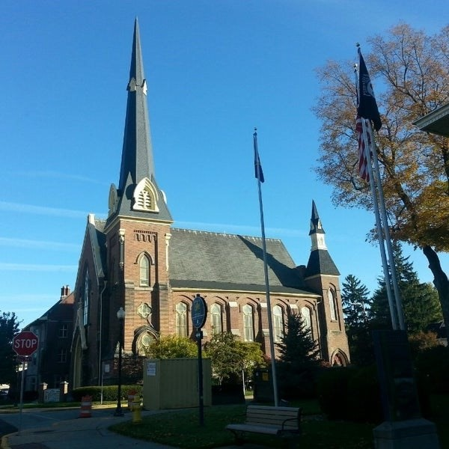
September 2, 2026

A Global Methodist Church
214 S. 5th Street
Goshen, IN 46528
Phone: 574-533-9518
Web Site: goshenfirstgmc.org

Office Hours: Monday-Thursday,
8:00 a.m.-1:00 p.m.
Worship: 9:00 a.m.
Sunday School: 10:30 a.m.
Pastor Jeff & Lisa
Associate Pastor Rich Hull
OUR VISION: “Growing in Faith, Gathering in Community, and Giving in Love”.

Grief Share
Grief Share started on August 12th from 6pm to 7pm at the church and will continue through November 11th. Sue Wirt will be leading the class. If you plan on attending the class please contact Sue at 574-238-2894.

The Monday morning Bible Study continues to meet this fall. They are
studying the book, “Knowing God,” by J.I. Packer. All are welcome.

The office will be closed on September 7th for Labor Day.
The Blood Pressure Clinic will be held in the Library following the worship service.

The Newsletter will be bi-monthly starting in October. It will go out the first Wednesday and third Wednesday of the month.

VOLUNTEERS – Thank you for your service - Sunday morning, September 2
Greeters: Mary Ann Eash, Arlene Randolph VIP: Patty Krebs
Elevator Hosts: Ken & Cathy Smith
Ushers: Randy Cripe, Pam Lichty, Dan Seltenright, Mateo Tenorio, Williston Tenorio
Scripture Reader: Dave Parsons
Elementary Junior Church: Rachel Parsons, Kelley Leeper
Junior High Church:
Coffee Hour: Faith Weavers
Bus Driver: Al Eppert
Blood Pressure Clinic:
Communion Servers: Cindy Bontrager, Kathy Robarge, Steve & Lori Warner
Be sure to join us for worship at 9 a.m. in the sanctuary or on Facebook.

CHURCH CALENDAR- SEPTEMBER
MONDAYS
9:30a.m. Bible Study- for men and women “Knowing God”
10:45-11:45a.m. Exercise (PIYO)
TUESDAYS
9:00-9:45a.m. Exercise class (Shred 60)
10:00a.m. Bible Study “Prevailing in the Battle Zone”
WEDNESDAYS
6:30 a.m. Men’s Breakfast at Angels
10:00 a.m Painting class
3:00 p.m Church Council (Sept. 9)
Wednesday Night Church starts Sept. 9
5:30 p.m. Meal
6:00 p.m. Classes
Children’s class “Adventures in Beattitude”
Grief Share
Bible Study Pastor Jeff “Prevailing in the Battle Zone”
7:00 p.m. Choir practice
THURSDAYS
9:00 a.m.-9:45 a.m Exercise class (Shred 60)
12:00-1:00p.m. Men’s Brown Bag Lunch (every week)
Primetimers (Sept. 15) Wellfield Gardens (times to be announced)
SATURDAYS
5:30-10:00 p.m.Contra Dance (first Saturday of the month- Sept.5
8:00 a.m.- 8:00 p.m. Goshen City Festival (September 19)
SUNDAYS
9:00 a.m. Worship “God: The Trinity”
10:30 a.m. Sunday School
4:00 p.m. “The Edge: Worship, Message, Communion and Prayer”



