

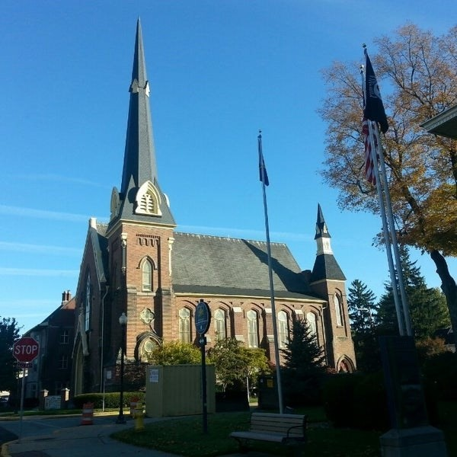
September 16, 2026

A Global Methodist Church
214 S. 5th Street
Goshen, IN 46528
Phone: 574-533-9518
Web Site: goshenfirstgmc.org

Office Hours: Monday-Thursday,
8:00 a.m.-1:00 p.m.
Worship: 9:00 a.m.
Sunday School: 10:30 a.m.
Pastor Jeff & Lisa
Associate Pastor Rich Hull
OUR VISION: “Growing in Faith, Gathering in Community, and Giving in Love”.

Grief Share
Grief Share is meeting from 6pm to 7pm at the church and will continue through November 11th. Sue Wirt is leading the class. If you plan on attending the class please contact Sue at 574-238-2894.

Come join us for Wednesday Night Church!!! The meal starts at 5:30p.m. and classes start at 6:00p.m. Choir at 7:00p.m. Exciting things happening here, don’t miss out!!

The Monday morning Bible Study continues to meet this fall. They are
studying the book, “Knowing God,” by J.I. Packer. All are welcome.

A workday for the Post is scheduled for October 20, 10:00 a.m. to 2:30 p.m. Volunteers will be doing general cleaning, organizing, and some out door work. You can sign up in the gym to volunteer.

Cathy Smith would like to thank the Church for the birthday carnation and the nice visit with Arlene Randolph who delivered the flower.

Reminder that Elaine McCann and Ben Whirledge’s Sunday school will be doing the Wednesday night meal on September 23rd.

The Newsletter will be bi-monthly starting in October. It will go out the first Wednesday and third Wednesday of the month.

VOLUNTEERS – Thank you for your service - Sunday morning, September 20
Greeters: Kathy Robarge VIP: Patty Krebs
Elevator Hosts: Lenette Burkhart and Jackie Lung
Ushers: Randy Cripe, Pam Lichty, Dan Seltenright, Mateo Tenorio, Williston Tenorio
Scripture Reader: Dar Dechant
Elementary Junior Church: Rachel and Lori
Junior High Church: Jeanne Bigler
Coffee Hour: Faith Weavers
Bus Driver: Steve Warner
Be sure to join us for worship at 9 a.m. in the sanctuary or on Facebook.


SEPTEMBER BIRTHDAYS
Nancy Eckelbarger – 20
Gretchen Martin – 21
Erv

