
Message Outline
The Scroll, the Witness,
and 7th Trumpet
Revelation 10-11
Intro: Halfway done…
- “Do not be afraid” (Rev.1:17)…
- Sections of doom/gloom (Rev.6ff.)…
- Failure to repent at last plagues (9:20-21)…

10:1—“mighty angel” (cf. 5:2)…
v.1-4—Described in terms similar to God’s throne (cf. Rev.4)…
- Who are the 7 thunders?
v.5-7—Noticing delays and “no more delay” (cf. 8:1, 2Pet.3:9-10)…
v.8-11—Eating books (cf. Ezek.3, Jer.15:16, Ps.119:103, Mt.4:4)…
11:1-2—Literal temple or believers as temple (cf. 1Cor.6:19-20)?
v.2-3—Timing and clothing of trampling…
v.4—“witnesses” as “olive trees” (cf. Rom.11) and “lampstands” (cf. 1:20)…
v.5-6—Signs during Moses and Elijah’s ministry (2Kgs.1, Jms.5:17,Ex.7:14)…
v.7-14—New characters and settings…
v.15—7th trumpet…
v.15-18—More songs of heaven…
v.19—Temple, ark, and more effects!

Lessons from Revelation 10-11

1) ___________________________________
- Revelation 6-16…sections of suffering but the offer of sealing (Rev.7).
- A song of damnation and salvation (11:18)
2) ___________________________________
- A Book to eat (cf. Rev.10:8-9, Mt.4:4)…
- Getting this Book inside us…
3) ___________________________________
- The need to witness even when it hurts (cf. 11:7, Lk.10:2-3, Col.4:2-6, 1Pet.3:15)…

Reading Plan Next Week: Revelation 12-13
Message Outline
The Scroll, the Witness,
and 7th Trumpet
Revelation 10-11
Intro: Halfway done…
- “Do not be afraid” (Rev.1:17)…
- Sections of doom/gloom (Rev.6ff.)…
- Failure to repent at last plagues (9:20-21)…

10:1—“mighty angel” (cf. 5:2)…
v.1-4—Described in terms similar to God’s throne (cf. Rev.4)…
- Who are the 7 thunders?
v.5-7—Noticing delays and “no more delay” (cf. 8:1, 2Pet.3:9-10)…
v.8-11—Eating books (cf. Ezek.3, Jer.15:16, Ps.119:103, Mt.4:4)…
11:1-2—Literal temple or believers as temple (cf. 1Cor.6:19-20)?
v.2-3—Timing and clothing of trampling…
v.4—“witnesses” as “olive trees” (cf. Rom.11) and “lampstands” (cf. 1:20)…
v.5-6—Signs during Moses and Elijah’s ministry (2Kgs.1, Jms.5:17,Ex.7:14)…
v.7-14—New characters and settings…
v.15—7th trumpet…
v.15-18—More songs of heaven…
v.19—Temple, ark, and more effects!

Lessons from Revelation 10-11

1) ___________________________________
- Revelation 6-16…sections of suffering but the offer of sealing (Rev.7).
- A song of damnation and salvation (11:18)
2) ___________________________________
- A Book to eat (cf. Rev.10:8-9, Mt.4:4)…
- Getting this Book inside us…
3) ___________________________________
- The need to witness even when it hurts (cf. 11:7, Lk.10:2-3, Col.4:2-6, 1Pet.3:15)…

Reading Plan Next Week: Revelation 12-13
Message Outline
The Scroll, the Witness,
and 7th Trumpet
Revelation 10-11
Intro: Halfway done…
- “Do not be afraid” (Rev.1:17)…
- Sections of doom/gloom (Rev.6ff.)…
- Failure to repent at last plagues (9:20-21)…

10:1—“mighty angel” (cf. 5:2)…
v.1-4—Described in terms similar to God’s throne (cf. Rev.4)…
- Who are the 7 thunders?
v.5-7—Noticing delays and “no more delay” (cf. 8:1, 2Pet.3:9-10)…
v.8-11—Eating books (cf. Ezek.3, Jer.15:16, Ps.119:103, Mt.4:4)…
11:1-2—Literal temple or believers as temple (cf. 1Cor.6:19-20)?
v.2-3—Timing and clothing of trampling…
v.4—“witnesses” as “olive trees” (cf. Rom.11) and “lampstands” (cf. 1:20)…
v.5-6—Signs during Moses and Elijah’s ministry (2Kgs.1, Jms.5:17,Ex.7:14)…
v.7-14—New characters and settings…
v.15—7th trumpet…
v.15-18—More songs of heaven…
v.19—Temple, ark, and more effects!

Lessons from Revelation 10-11

1) ___________________________________
- Revelation 6-16…sections of suffering but the offer of sealing (Rev.7).
- A song of damnation and salvation (11:18)
2) ___________________________________
- A Book to eat (cf. Rev.10:8-9, Mt.4:4)…
- Getting this Book inside us…
3) ___________________________________
- The need to witness even when it hurts (cf. 11:7, Lk.10:2-3, Col.4:2-6, 1Pet.3:15)…

Reading Plan Next Week: Revelation 12-13
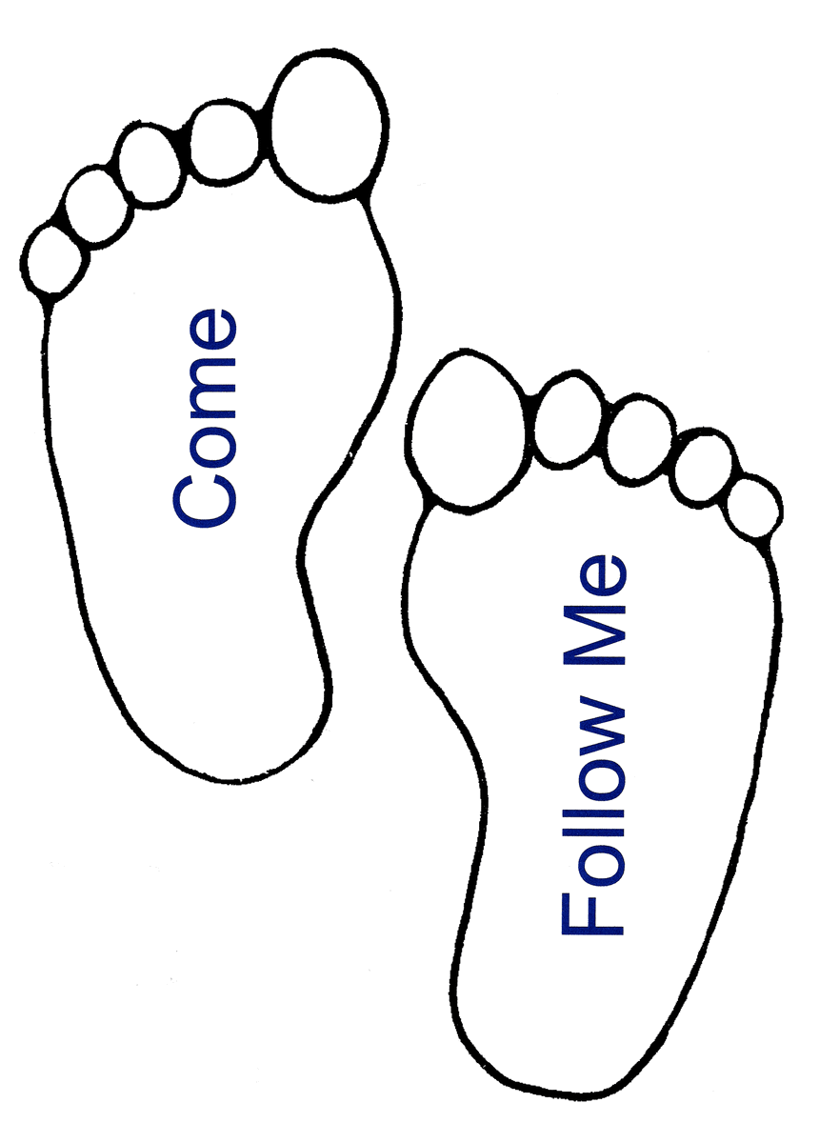

Small Group
Reflection Questions
(Please take time to ponder and pencil in
to prep for this week’s small group session.)

*Icebreaker: Today, we’ll begin talking about what it means to follow/walk with Jesus. Name one walk/hike/trail you’ve done that sticks out in your mind?

*What are you hoping Jesus will do in you through this course?

*As you look back on your life, who or what has had the greatest impact on your spiritual journey thus far?

*What do you think is the driving aim of your life? What are your top goals and priorities?

*How can we pray for you over the next 7 weeks?

Small Group
Reflection Questions
(Please take time to ponder and pencil in
to prep for this week’s small group session.)

*Icebreaker: Today, we’ll begin talking about what it means to follow/walk with Jesus. Name one walk/hike/trail you’ve done that sticks out in your mind?

*What are you hoping Jesus will do in you through this course?

*As you look back on your life, who or what has had the greatest impact on your spiritual journey thus far?

*What do you think is the driving aim of your life? What are your top goals and priorities?

*How can we pray for you over the next 7 weeks?

Small Group
Reflection Questions
(Please take time to ponder and pencil in
to prep for this week’s small group session.)

*Icebreaker: Today, we’ll begin talking about what it means to follow/walk with Jesus. Name one walk/hike/trail you’ve done that sticks out in your mind?

*What are you hoping Jesus will do in you through this course?

*As you look back on your life, who or what has had the greatest impact on your spiritual journey thus far?

*What do you think is the driving aim of your life? What are your top goals and priorities?

*How can we pray for you over the next 7 weeks?

