THE ORDER OF WORSHIP
September 20, 2026/17th Sunday of Pentecost
Greeter: Dale Dixon and Rachel Hawk
Please fill out your Prayer & Praise Cards. Announcements are on the screens. Please come to the front pews to meet with a member of our Prayer Team before or after the service.
Gathering
Prayer of Consecration: Pastor John
One: Wake up, sleeper, rise from the dead,
All: and Christ will shine on you. Jesus, I belong to you. I lift up my heart to you. I set my mind on you. I fix my eyes on you. I offer my body to you
as a living sacrifice. Jesus, we belong to you. Praying in the name of the Father, and the Son, and the Holy Spirit, amen.

Opening Chorus: “Step by Step” No. 671 David Beaker Strasser
Prelude: “Savior Like A Shepherd Lead Us” Lani Smith
Bringing In the Light of Christ: Ann Ragland
Welcome and Announcement: Rev. Ed Johnson

*Call to Worship: Rev. Ed Johnson
One: Let your light shine!
All: Let your hearts be glad!
One: God is faithful to us, and God rules in love.
All: Then let us worship God. Amen.

Greeting Our Brothers and Sisters in Christ

Proclamation and Response
*Opening Hymn: “Majesty” No. 63 Sing Twice
(Collection of Prayer & Praise Cards)

Gideon Speaker: Matthew Greenshields
Joys and Concerns: Pastor John
Prayer Chorus: “Breathe on Me Breath of God” No. 304- V. 1
Silent Prayer & Pastoral Prayer /Lord’s Prayer: Pastor John

Anthem: “He Will Surely Care for Me” John Carter
Collection of Tithes and Offerings: Barbara Austin & Dale Dixon
*The Doxology: “My Tribute” On the Screen
*The Apostles’ Creed: No. 691

Scripture Reading: Series: Letters of John
1 John 3:7-10
One: The word of God for the people of God.
All: Thanks be to God and I believe it.

Sermon: “Which Team Do You Play For?” Pastor John

Sending Forth
*Closing Hymn: “I Surrender All” No. 607
Postlude: “Song Without Words” Reginald W. Martin

Please be seated. You are invited to close your eyes and use the few moments of music at the end of our service to practice Listening Prayer. This is a time to expect God to speak to you before you leave the sanctuary. In John 10:17, Jesus tells us; “My sheep hear my voice, and I know them, and they follow me.” Let’s try listening as we are silent and still. Members of the prayer team will remain on the front pews after the service. Feel free to come forward.
Benediction: Pastor John

ANNOUNCEMENTS

TO OUR VISITORS: We welcome you to Laurel Hill and hope that you feel at home. We invite you to join Laurel Hill if you do not have a church home. Please call our church office at 804-795-2772. You will find our Laurel Hill family both warm and eager to welcome you into our fellowship. Please fill out a visitor’s card and place it in
the offering plate. The password for our public WiFi is LivingHope - feel free to connect with us.

THE ALTAR FLOWERS are presented to the Glory of Almighty God and given
in loving memory of Mary Duke and Julian Garber in remembrance of their anniversary.

NEWSLETTER ARTICLES are due now! Thank you.

THE CHURCH PICNIC will be TODAY starting at 3 pm at Osborne Landing Pavilion #2. This is a change from last year. Pavilion #2 is at the top of the hill next to the playground. The church will provide hot dogs, hamburgers, rolls, mustard, relish and ketchup, and paper products. Please bring a side to share and your own beverage. Thank you, The Fellowship Team

OUR BABY BOTTLE CAMPAIGN We will dedicate the Baby Bottles on the last Sunday in Setpember. Thank you for your support of this very important ministry.

FISH NEWS…If you have some time to donate to help price items for FISH, please call Pam Wilson and let her know when you are available. They need help! The FISH yard sale will be on Thursday, October 1st and Friday, October 2nd. We need help setting up on Wednesday, September 30th. We especially need men to set up the tables early in the morning followed by the ladies to fill the tables with items. Watch for specific times.

IN THE FRONT ENTRYWAY on the table under the mirror, you will find information on the three ballot measures that will be on the November 3, 2026 ballots. Early voting begins on September 18th. Please contact Pastor John: johnlynnbight@gmail.com, if you would like to receive electronic copies to share.

LAUREL HILL GLOBAL METHODIST CHURCH will be our new Facebook page. This will begin on September 25th. The old page will not be active after that. Plan to join us on the new page and keep up with all our church’s special events and weekly calendar.

SICK AND SHUT-INS – Kim Davis, Jean Miller, Evelyn Steele, Kathleen McKinsey, Sara Nelson, Regina Humphrey, David Torrence, Dot Gay, Sharon Loving & Family, Debra Deane, Agnes Stevenson and ML Yuhas.

KEEP IN OUR PRAYERS
- Our Weekday School – Margo Keeles (Director), our teachers, students and families.
- Our community of Varina and all the residents, our churches in our neighborhoods, schools, students, teachers, administrators and all employees.
- Our state of Virginia, our residents and leaders.
- The United States of America, our citizens and leaders, the countries of the world, their people and leaders. May God bless us all and His will be done.
- Those affected by war in Israel and Ukraine

WEEKLY CALENDAR

Monday 10:00 AM New Life House Church today. (804) 303-4828
Bible Study/New Study on Isaiah in person and on Zoom
Come join us in person or on Zoom.

Wednesday 9:00 AM Prayer Time with Communion
10:30 AM Bible Study today.
6:45 PM Handbell Choir Rehearsal

7:30 PM Chancel Choir Rehearsal

Thursday 7:00 PM PTL House Church at the Wilson’s (804) 795-7723

Friday 10:00 Thankful Hearts House Church (804) 737-7450

Saturday 9:00 AM Prayer Station at Dorey Park.

Sunday 10:00 AM Sunday School
10:30 AM Chancel Choir
11:00 AM Sunday Worship Service (also online)

Stewardship in the Bible
By Joshua Godon, https://theleadpastor.com/ (adapted)

Ten Fundamentals of Biblical Stewardship
7. Serving Others with Our Gifts (Service)
Our gifts are not just for ourselves. Our God-given abilities and resources are to help and support others, in our immediate family and beyond. In serving others, we follow Jesus' example and fulfill His command to love our neighbors as ourselves. Each of you should use whatever gift you have received to serve others, as faithful stewards of God's grace in its various forms. 1 Peter 4:10
Using our gifts to serve includes:
Recognizing our gifts: Understanding that every person has unique talents and abilities given by God.
Building community: Strengthening the church and broader community through acts of service and love.
By serving others with our gifts, we fulfill God's command to love our neighbors and reflect His love and generosity in our actions.
How can you give at Laurel Hill GMC?

1 – Cash and checks may be placed in the offering plate. Please contact the church office for offering envelopes.
2 - You may also give online. The QR code below will take you to our website’s giving page: https://laurelhill.tithelysetup.com/give

3 – Planned giving – including the LHGMC in your will is a wonderful way to ensure the ministries we are called to provide for Varina will continue into the future.

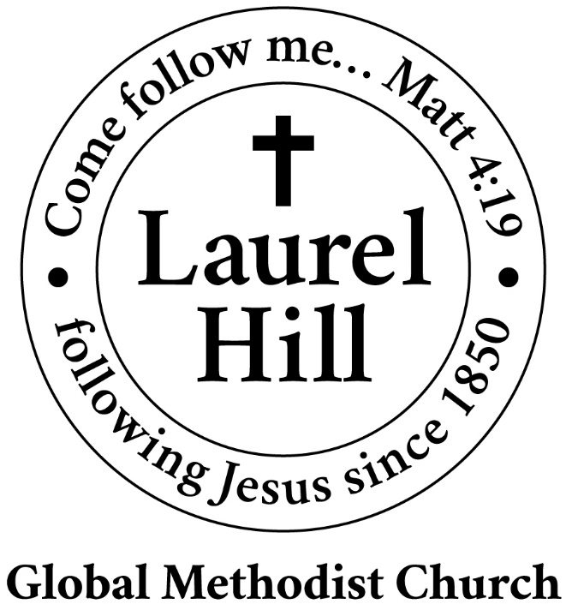
Our Mission: The Global Methodist Church exists to make disciples
of Jesus Christ and spread scriptural holiness across the globe.

1919 New Market Road, Henrico, VA 23231
On the web @ laurelhillchurch.org
Email to laurelhillchurch.varina@gmail.com
Phone: Office/804.795.2772 Pastor/804.437.0937

STAFF
Pastor: Rev. John Bright Organist/Choir Director: Pam Wilson
Secretary: Barbara Wendel School Director: Margo Keeles
Communications Assistant: Ben Wilson

that we you in thought, word, and deed.

