Colington United Methodist Church
A Lighthouse Congregation
September 20, 2026
Seventeenth Sunday after Pentecost


welcome
greeting
We gather in peace, graced by the living, risen Christ, who welcomes us!
We come with joy to meet our Savior. Alleluia!
prelude and lighting of altar candles
How Majestic Medley
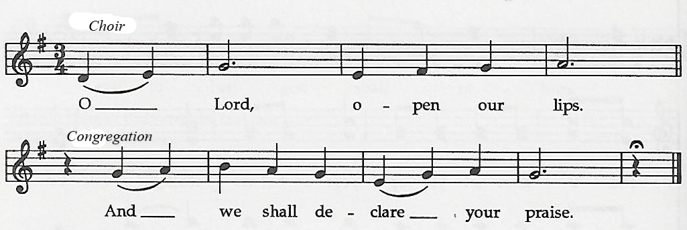
call to worship

†opening hymn
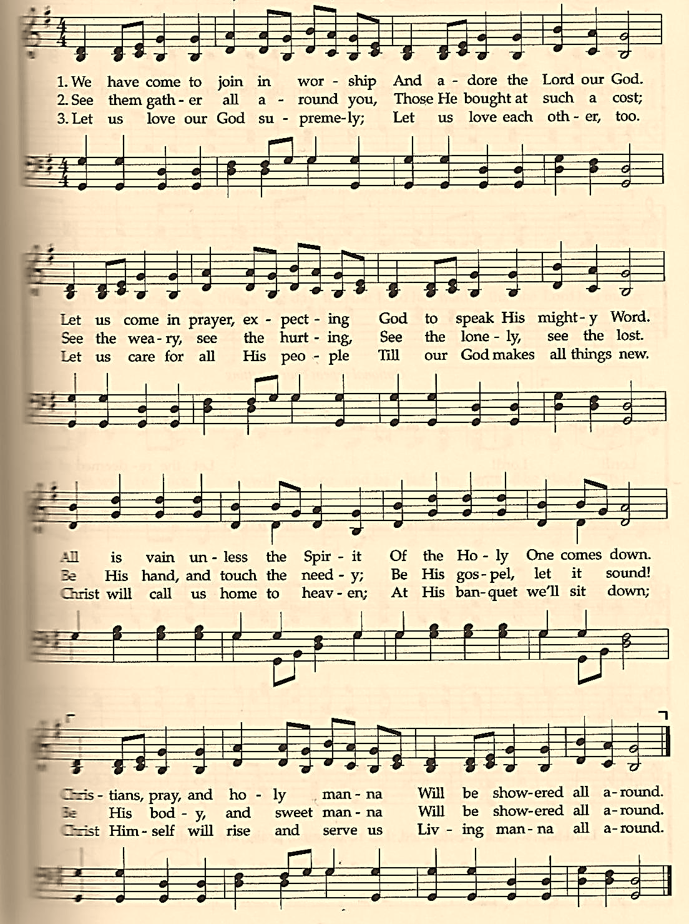
We Have Come to Join in Worship

the prayers of the people
the first lesson
Philippians 1:21-30
hymns by request
meditation
the second lesson
Jonah 3:10-4:11
hymns by request
meditation
†affirmation of praise
The Lord Is Good
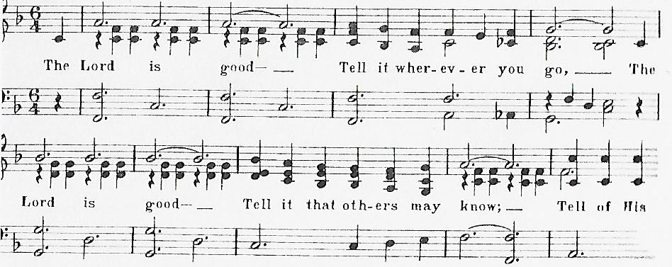

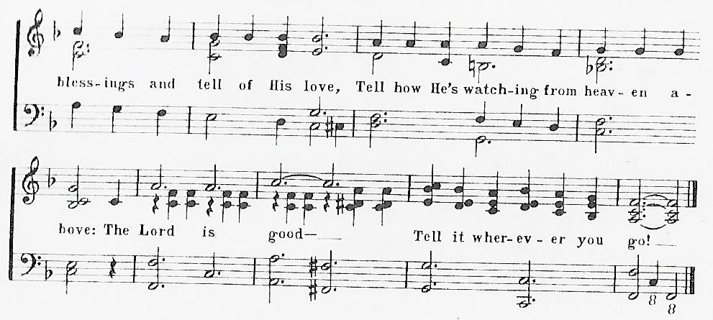

the lord’s supper
†closing hymn
To God Be the Glory ǀ UMH 98
_____________________________________________________________

this week at colington
These opportunities to serve as the Body of Christ are available.
Tuesday – 9 am – Prayer Group
Wednesday – 10am – Knitters and crocheters meet.
1:45pm – Volunteers to Beach Food Pantry.
5:30pm – Beach fellowship

coming up
Next Sunday – 8:15 – choir practice
9:30 am – Worship, in-person and Facebook Live and YouTube.
Mon., Sept. 28 – 8:00am – Student of the Month at FFES.

Thanks to today’s volunteers!
Ushers – Steve Knowles/ Ozzie Gray/ Wiley Beales
Scripture Reader – Pat Hansen
Communion Assistant – Stacy Murphy

The flowers on the altar are given by Merinda DeHart in celebration of her birthday.

If you would like to make an electronic donation, you may do so using the QR code below


