Preamble for Today’s Lesson

Psalm 5:11-12
But rejoice, all who take refuge in You, Sing for joy forever! And may You shelter them, that those who love Your name may rejoice in You.
For You bless the righteous person, Lord, You surround him with favor as with a shield.

Today’s Topic: “Favor”

Job 1:10
Have You not made a fence around him and his house and all that he has, on every side? You have blessed the work of his hands, and his possessions have increased in the land.

Favor . . . and I am referring to what many Christians now know, as “The Favor of God”, which happens to be a subset of Prosperity, and Prosperity is the ability to continually prosper in the Lord.
Is God’s Favor available to all?
Yes and No.
Yes, if you are born again, giving your life, that is the entirety of your being to Jesus, making Him the Lord of your life.
No, if Jesus is not the Lord of your life and you rather chose to adhere to the worldly principals and paths . . . this would be the wide road to travel on.
Is Favor automatic?
No.
Is that a reflection on the Goodness of God?
Absolutely not.
What about the storms of life, can you still have the Favor of the Lord and experience some difficult circumstances in your life?
Absolutely.
When adverse things happen in our life . . . do we grumble?
Maybe not verbally . . . but what about in our heart?
When times get tough, do we sometimes wonder; “Lord, where are you?”
Or maybe in a more severe troublesome condition, do we then say; “Lord, how come you are not doing anything, don’t you care that I am suffering?”
And as we search for reasons why our current burden is not being lifted; the way we think God should now be helping us out, we then ascribe all kinds of reasons “why” the Lord is tardy with His Responses – Job’s friends did that, and God was subsequently displeased.
Job 42:7-9
It came about after the Lord had spoken these words to Job, that the Lord said to Eliphaz the Temanite, “My wrath is kindled against you and against your two friends, because you have not spoken of Me what is trustworthy, as My servant Job has.
Now therefore, take for yourselves seven bulls and seven rams, and go to My servant Job, and offer up a burnt offering for yourselves, and My servant Job will pray for you. For I will accept him so as not to do with you as your foolishness deserves, because you have not spoken of Me what is trustworthy, as My servant Job has.”
So Eliphaz the Temanite, Bildad the Shuhite, and Zophar the Naamathite went and did as the Lord told them; and the Lord accepted Job.
Has God’s Character Changed?
Has He become less loving and more of a taskmaster down through the ages?
I think not.
Can I now suggest another path, when the storm clouds of life begin to gather?
Psalm 50: 14-15, 23
Offer God a sacrifice of thanksgiving and pay your vows to the Most High; Call upon Me on the day of trouble; I will rescue you, and you will honor Me.

He who offers a sacrifice of thanksgiving honors Me; And to him who sets his way properly I will show the salvation of God.”

A Prayer While in The Storm

“Lord, in my limited vision and understanding, concerning what I am now experiencing, I am currently unable to see all your loving activity, taking place for me and my family in this particular situation, but that, all by itself, is not the indicator of Your Goodness. Lord God Almighty, Heavenly Father you are too wonderful for words, I cannot accurately describe your continuous stream of love and genuine care that flows in my life, and in the lives of all those who lift your name on high. In light of my own blindness, my inability to see every loving thing that you are now orchestrating on my behalf, I still chose to honor and praise you with all the strength of my being. And I now know, as your word says, you will show me Your Salvation! Let there be no confusion surrounding my heart – I love you Lord, Amen.”
Now back to the topic of Favor . . . Not all favor shows up as a $100 bill taped to your forehead!

One small example of Favor that we witnessed on our recent trip to Alaska; we were trying to find a place to have lunch in Anchorage, a city totally new to us. Then, seemingly out of the blue, we were met by an angle of shorts, a pilot who flew cargo planes, in and out of Anchorage – he came to us, and he guided us to one of his favorite places to eat, the F Street Station, which is a favorite of local aviators. How this all came about was truly the Favor of God as I felt this pilot was sent to meet us, and then guide us.

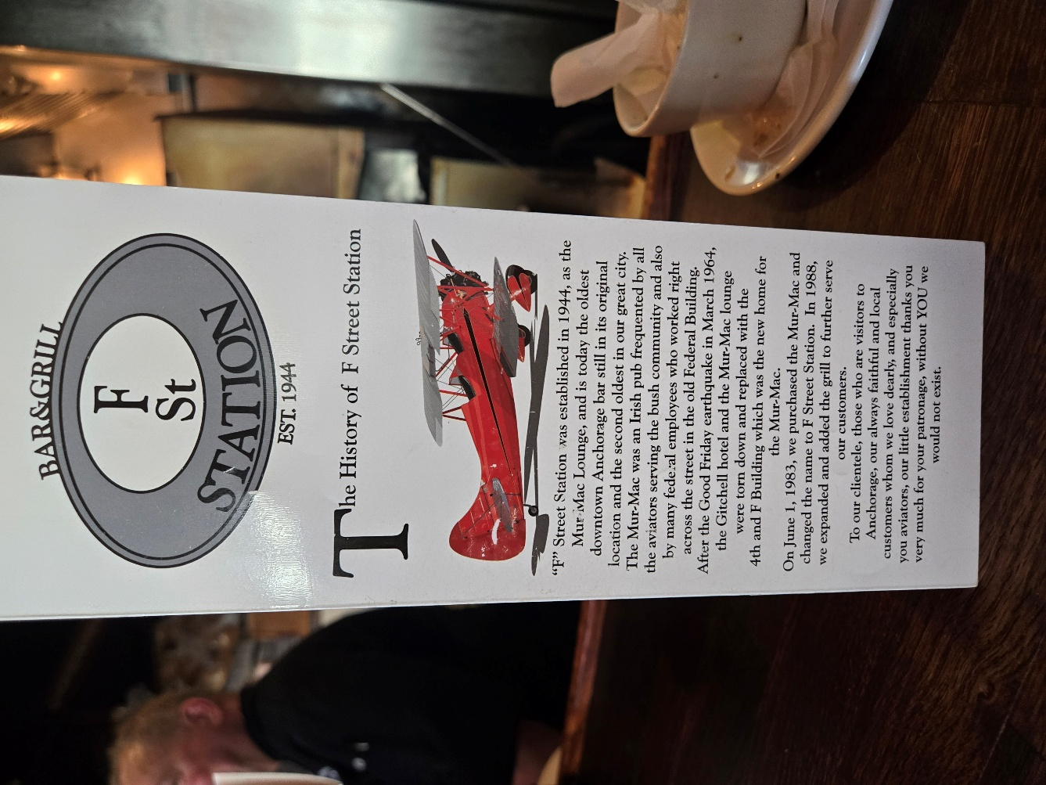
There were two seats open on the right side of the restaurant, right next to a wall filled with aviation memorabilia from WWII, specifically a tribute to “Pappy Boyington, a United Stated Marine Corp fighter ace, whom I was well familiar with in my study of U.S. Military history . . . the Lord placed us right next to this commemorative photograph on the wall – as the Lord knows I love this stuff!

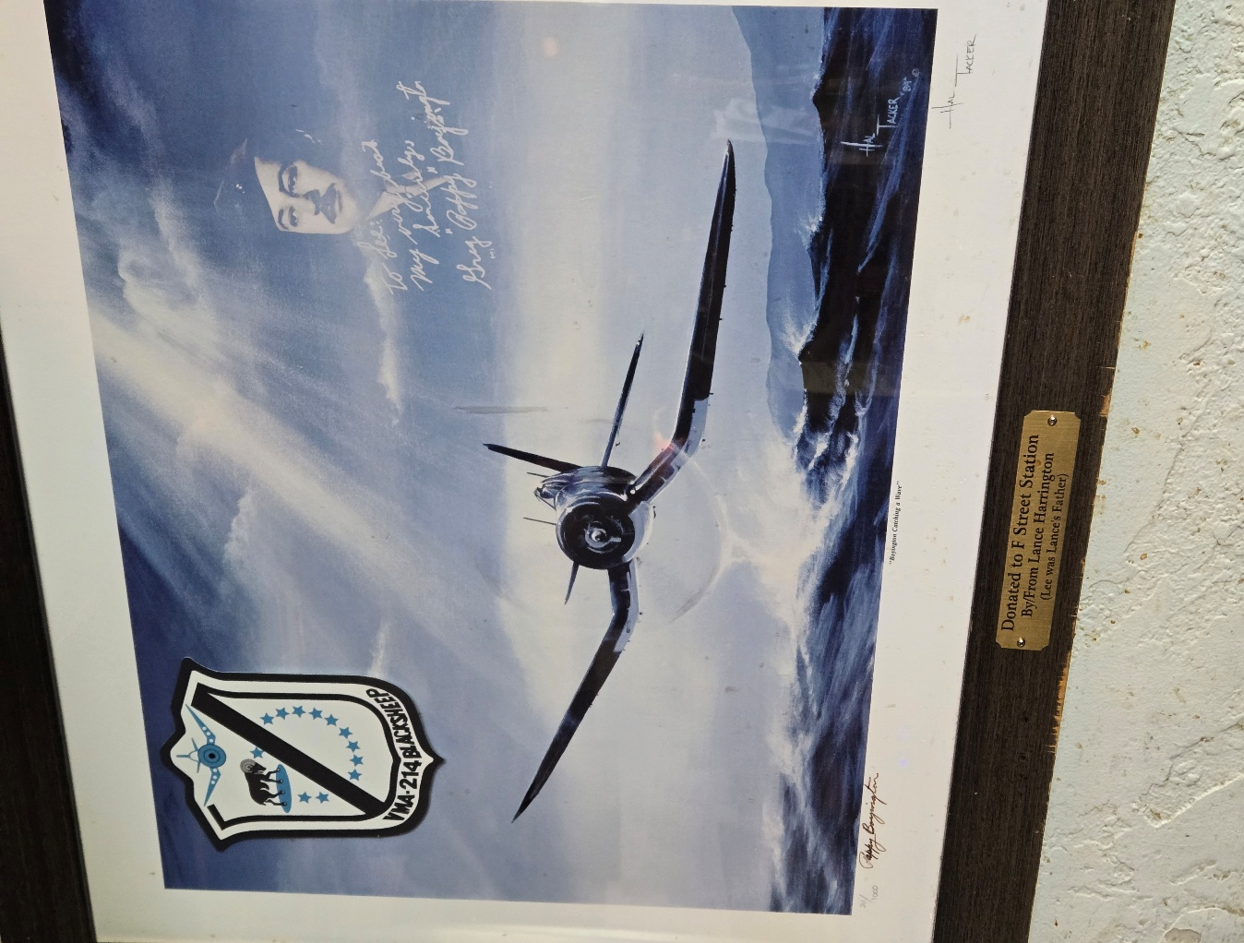

And can I just say the food there, the fresh fish lunch was fantastic!

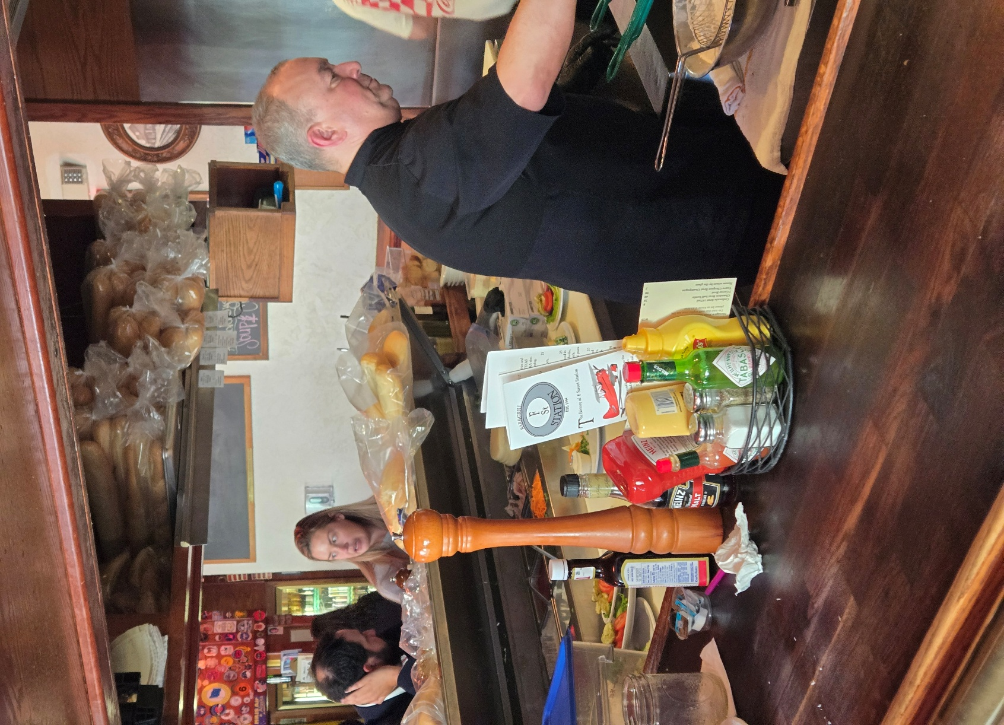

In closing . . . I am reminded of Psalmist’s encouragement, for each of us, found in His Word.

Psalm 27:14

¹⁴ Wait and hope for and expect the Lord; be brave and of good courage and let your heart be stout and enduring. Yes, wait for and hope for and expect the Lord.

