Diocese of Ottawa • Anglican Church of Canada



Seventeenth Sunday
after Pentecost

September 20th, 2026
Sung Eucharist ~ 10am
Book of Alternative Services, p. 185

Welcome to the Church of
St. John the Evangelist

We acknowledge that we gather at St. John’s on the traditional and unceded territory of the Algonquin Nation. May we dwell on this land with respect and peace.

This service is video recorded, streamed, and broadcast. By attending this service, you are agreeing to appear on video in our on-line worship offering through St. John’s website and Facebook pages.
Hymns are from the blue Common Praise hymnbook unless otherwise indicated.
Today’s service can be found on page 185 of the green Book of Alternative Services (BAS) located in the pew-back in front of you.

THE GATHERING OF THE COMMUNITY
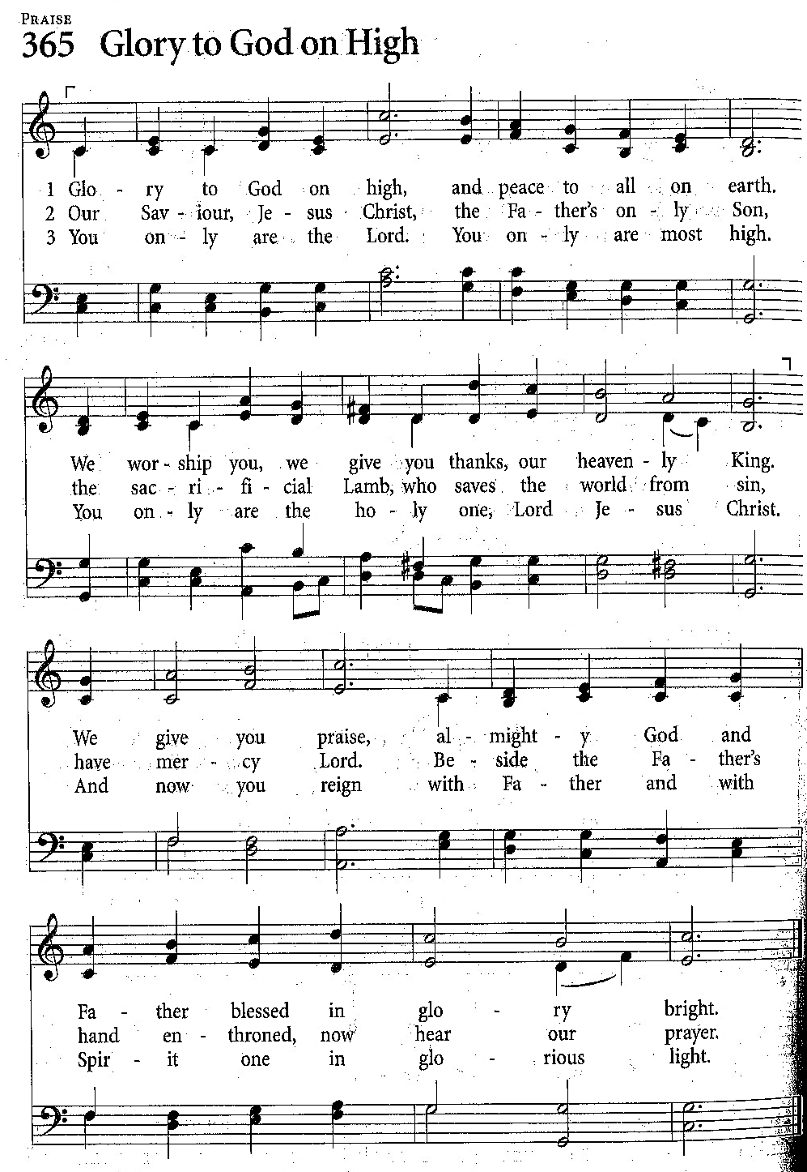

Announcements

Processional (Opening) Hymn:

380 – “O Worship the King”

Greeting, p.185

Collect for Purity, p.185

The Gloria
Sung as printed here.

Collect of the Day
Almighty God,
you have created the heavens and the earth,
and ourselves in your image.
Teach us to discern your hand in all your works
and to serve you with reverence and thanksgiving;
through Jesus Christ our Lord,
who is alive and reigns with you and the Holy Spirit,
one God, now and for ever.
Amen.

THE PROCLAMATION OF THE WORD

Reading Acclamation: Ancient Words

Holy words long preserved, for our walk in this world.
They resound with God’s own heart, oh let the Ancient words impart.

Words of life, words of hope, give us strength, help us cope.
In this world where e’er we roam, Ancient words will guide us Home.

Ancient words ever true, changing me and changing you.
We have come with open hearts, oh let the Ancient words impart.

First Reading Exodus 16:2-15
The whole congregation of the Israelites complained against Moses and Aaron in the wilderness. The Israelites said to them, ‘If only we had died by the hand of the Lord in the land of Egypt, when we sat by the fleshpots and ate our fill of bread; for you have brought us out into this wilderness to kill this whole assembly with hunger.’
Then the Lord said to Moses, ‘I am going to rain bread from heaven for you, and each day the people shall go out and gather enough for that day. In that way I will test them, whether they will follow my instruction or not. On the sixth day, when they prepare what they bring in, it will be twice as much as they gather on other days.’ So Moses and Aaron said to all the Israelites, ‘In the evening you shall know that it was the Lord who brought you out of the land of Egypt, and in the morning you shall see the glory of the Lord, because he has heard your complaining against the Lord. For what are we, that you complain against us?’ And Moses said, ‘When the Lord gives you meat to eat in the evening and your fill of bread in the morning, because the Lord has heard the complaining that you utter against him—what are we? Your complaining is not against us but against the Lord.’

Then Moses said to Aaron, ‘Say to the whole congregation of the Israelites, “Draw near to the Lord, for he has heard your complaining.”’ And as Aaron spoke to the whole congregation of the Israelites, they looked towards the wilderness, and the glory of the Lord appeared in the cloud. The Lord spoke to Moses and said, ‘I have heard the complaining of the Israelites; say to them, “At twilight you shall eat meat, and in the morning you shall have your fill of bread; then you shall know that I am the Lord your God.”’

In the evening quails came up and covered the camp; and in the morning there was a layer of dew around the camp. When the layer of dew lifted, there on the surface of the wilderness was a fine flaky substance, as fine as frost on the ground. When the Israelites saw it, they said to one another, ‘What is it?’ For they did not know what it was. Moses said to them, ‘It is the bread that the Lord has given you to eat’.

Reader: The Word of the Lord
People: Thanks be to God

Psalm 105 (sung) Tune: Land of Rest

Give thanks to God, make known his Name,
His deeds, to everyone;
Sing praise, sing praise to him and tell
The wonders he has done.

Rejoice in him, all hearts that seek
To know his Name and grace;
Search for the Lord and all his strength,
And ever seek his face.

Recall the marvels God has done,
The judgments of his mouth,
O Abraham’s children, Jacob’s heirs,
Whom he has chosen out.

The Lord is God, throughout the world
His righteous laws prevail;
His covenant and promises
He keeps and will not fail.

Second Reading Philippians 1:21-30

For to me, living is Christ and dying is gain. If I am to live in the flesh, that means fruitful labour for me; and I do not know which I prefer. I am hard pressed between the two: my desire is to depart and be with Christ, for that is far better; but to remain in the flesh is more necessary for you. Since I am convinced of this, I know that I will remain and continue with all of you for your progress and joy in faith, so that I may share abundantly in your boasting in Christ Jesus when I come to you again.

Only, live your life in a manner worthy of the gospel of Christ, so that, whether I come and see you or am absent and hear about you, I will know that you are standing firm in one spirit, striving side by side with one mind for the faith of the gospel, and are in no way intimidated by your opponents. For them this is evidence of their destruction, but of your salvation. And this is God’s doing. For he has graciously granted you the privilege not only of believing in Christ, but of suffering for him as well— since you are having the same struggle that you saw I had and now hear that I still have.

Reader: The Word of the Lord
People: Thanks be to God

Reading Acclamation: Ancient Words

Holy words long preserved, for our walk in this world.
They resound with God’s own heart, oh let the Ancient words impart.

Words of life, words of hope, give us strength, help us cope.
In this world where e’er we roam, Ancient words will guide us Home.

Ancient words ever true, changing me and changing you.
We have come with open hearts, oh let the Ancient words impart.

Holy Gospel Matthew 20:1-16

Gospeller: The Lord be with you
All: And also with you
Gospeller: The Gospel of our Lord, Jesus Christ according to Matthew
All: Glory to you, Lord Jesus Christ
Jesus said, "For the kingdom of heaven is like a landowner who went out early in the morning to hire labourers for his vineyard. After agreeing with the labourers for the usual daily wage, he sent them into his vineyard. When he went out about nine o'clock, he saw others standing idle in the marketplace; and he said to them, 'You also go into the vineyard, and I will pay you whatever is right.' So they went. When he went out again about noon and about three o'clock, he did the same. And about five o'clock he went out and found others standing around; and he said to them, 'Why are you standing here idle all day?' They said to him, 'Because no one has hired us.' He said to them, 'You also go into the vineyard.' When evening came, the owner of the vineyard said to his manager, 'Call the labourers and give them their pay, beginning with the last and then going to the first.' When those hired about five o'clock came, each of them received the usual daily wage. Now when the first came, they thought they would receive more; but each of them also received the usual daily wage. And when they received it, they grumbled against the landowner, saying, 'These last worked only one hour, and you have made them equal to us who have borne the burden of the day and the scorching heat.' But he replied to one of them, 'Friend, I am doing you no wrong; did you not agree with me for the usual daily wage? Take what belongs to you and go; I choose to give to this last the same as I give to you. Am I not allowed to do what I choose with what belongs to me? Or are you envious because I am generous?' So the last will be first, and the first will be last."

Gospeller: The Gospel of Christ
People: Praise to you, Lord Jesus Christ

Holy words long preserved, for our walk in this world.
They resound with God’s own heart, oh let the Ancient words impart.

Words of life, words of hope, give us strength, help us cope.
In this world where e’er we roam, Ancient words will guide us Home.

Ancient words ever true, changing me and changing you.
We have come with open hearts, oh let the Ancient words impart.

Sermon
The Apostles’ Creed p. 189

Prayers of the People

Confession and Absolution p. 191

The Exchange of the Peace p. 192

People may greet one another with the peace of Christ.

Offertory Hymn 546 – “God Moves in a Mysterious Way”
THE CELEBRATION OF THE EUCHARIST

Prayer over the Gifts
God of power,
the glory of your works fills us with wonder and awe.
Accept our offering this day,
and help us to live in peace and harmony
with all your creation,
for the sake of Jesus Christ our Lord.
Amen.

Eucharistic Prayer 2 p. 196

Sanctus (sung to the tune of Skye Boat Song)
Holy, Holy, Holy, Lord,
God of power and might
Heaven and Earth are full of Your Light.
Glory to You our God.

Blessed is He, Blessed are We, Blessed are all who come.
Hosannas ring, Archangels sing, Blessed are all who come.

Holy, Holy, Holy, Lord,
God of power and might
Heaven and Earth are full of Your Light.
Glory to You our God.

The Lord’s Prayer (sung)
Our Father in Heaven, hallowed be your name;
Your kingdom come, Your will be done on earth, as in Heaven.
Give us today, our daily bread;
Forgive us our sins as we forgive those who sin against us.
Save us from the time of trial, and deliver us from evil.
For the kingdom, and the power, and the glory are yours;
Now and forever.
Amen.

Breaking of the Bread 2 p. 212
Celebrant: We break this bread
to share in the body of Christ.
All: We, being many, are one body,
for we all share in the one bread.

Agnus Dei (Lamb of God) Sung as printed here.

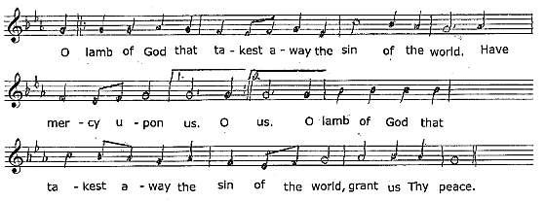

Communion
All who are baptized are welcome to receive the bread and/or the wine of Holy Communion. At the Greeter’s direction, please make your way to receive the elements if you wish to. All are welcome to come forward for a blessing.

Hymns during Communion: Beginnings – (see insert)
“Good and Gracious King”
“Great Are You Lord”

Prayer after Communion
Ruler of the universe,
all creation yearns for its fulfilment in your Son.
May we who have shared in holy things
grow into maturity in him.
This we ask in the name of the same Jesus Christ our Lord.
Amen.

Doxology p. 214

The Blessing

Recessional Hymn – 565 – “Guide Me, O Thou Great Jehovah”

Dismissal

ANNOUNCEMENTS

Frozen Food to Bless Those in Need: St. John’s is collecting frozen prepared meals to help those in need. Our goal is to have a supply of pre-packaged frozen meals available in the Parish Hall freezer to distribute to those needing a little extra help. If you are able, please consider purchasing a frozen meal and place it in the freezer for someone in our community that can use our help. Suggestions include packaged, frozen meat pies, pizza, shepherd’s pie or pasta. Individual or family sizes are welcome. Together we can be the hands and feet of Jesus, offering both nourishment and hope. If you have questions feel free to contact Cindy Penman 613.283.5002.

We’ve been hearing rumours circulating St John’s that there is interest in: Home study groups, bible studies, book studies, Alpha, video series, an Advent study and other opportunities to learn, share, grow and extend an invitation. Parish Council has agreed that a Spiritual Development Committee to build an intentional plan for spiritual growth is called for. If this interests you, please come to the Link after the 10 AM service this morning. Membership does not mean you have to lead or be responsible for any of the aforementioned activities. Looking to measure interest and share ideas.

Monday Night Bible Study: Beginning Monday, September 21st, at 7.15pm, there will be a new study on the book “Romans for Everyone: Part 2”, by N.T. Wright. Meetings will be on Zoom on Monday nights, and everyone is welcome. Please note that it is not a requirement to have read Part 1. If interested, please let Laura S in the Church office know. If you have any questions, please contact Sue Norman at 613.806.6761.

Sunday School: We are excited to announce that Sunday School at St. John's has begun! Children of all ages are welcome to join us for a fun and engaging program where they will learn about faith, friendship, and God's love through stories, activities, and discussion. We look forward to welcoming both returning and new families as we start another wonderful year together.

Gluten free Wafers: If you would like a gluten free wafer at communion, please bring your bulletin up with you to the communion rail.

Restrictions for use of Back Parking Lot Continue – Although two of the three dumpsters have been removed, only those with mobility issues will continue to have access to the back parking lot for the 10am service. Thank you for your consideration and kindness ensuring that those who need that access will have it.

Chancel Update: The new flooring, solid prefinished hardwood and carpet (claret), is on order so we will tread on subflooring until installation is complete. A bin is in place in the parking lot to hold the waste created during the demolition and remodelling. Sorry for the disruption.

Bishop Kathryn is pleased to announce that the Venerable Brian Kauk has been appointed to be Incumbent of the Parish of All Saints Westboro and Archdeacon of Central Ottawa, effective October 27th, 2026.
We wish Brian many blessings on his new appointment.

Presider & Preacher: The Reverend Canon Jim Roberts
Greeters:
Reader/Intercessor: Trish Warren
Communion Assistant: Mike McCulloch
Server: Mike McCulloch
Altar Guild: Ruth Anderson & Jessica Coughlan
Interim Organist: Sterling Bennett
Readings for next Sunday, Sep 27, 2026 ~
EX 17:1-7; PS 78:1-4, 12-16; PHIL 2:1-13; MT 21:23-32

ST. JOHN THE EVANGELIST ANGLICAN CHURCH
2 George Street South, Smiths Falls, Ontario K7A 1X4
613.283.1261 | stjohns.smithsfalls@gmail.com
www.stjohn-smithsfalls.com

Follow us on Facebook at:
St-John-the-Evangelist-Anglican-Church-Smiths-Falls

Laura Savage – Parish Administrator
Office Hours: Monday – Wednesday 9am – 12 noon
Thursday 1 – 4pm
Friday 9am – 12 noon

Weekly Liturgies
Holy Eucharist – Sundays 8am & 10am* – Wednesdays 10am
*Sunday School offered at 10am from September – June

The Right Reverend Kathryn Otley – Bishop of Ottawa

The Reverend Canon Baxter Park – Interim Priest in Charge
The Reverend Canon Jim Roberts – Interim Assistant

Sterling Bennett – Interim Organist
Dan Willis – Rector’s Warden 613.884.5095
Lois Arkell – People’s Warden 613.485.9181
Tammy Mulrooney – Deputy Warden 613.485.3128
Cindy Penman – Deputy Warden 613.283.5002
Tammy Mulrooney – Envelope Secretary
sjsfenvelopesecretary@gmail.com

