This Week at PPBC

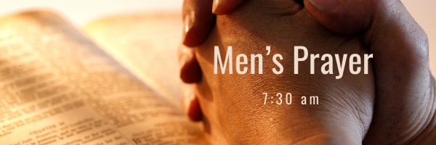


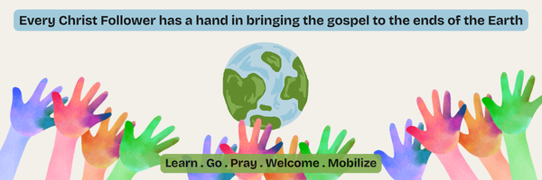A Prayer Request from the Lambs: Mission aviation is a life line for the remote work being done by Ethnos where missionaries are translating the Bible into tribal languages. We rejoice that our helicopter in Indonesia is now finally authorized and flying our missionaries and tribal workers. Our third helicopter for PNG is getting ready to be shipped. Please pray for all the logistics and safe arrival.
October 10, 2026
Wednesday Night DUGOUT
Children's Program - Wednesday, October 7, 2026
We are excited to annouce that The Dugout 2026-2027 is right around the corner! The program is for children aged 3 to grade 6 and runs Wednesdays from 6:30 pm to 8:00 pm. Program runs from October through to April
Start Date: October 7th, 2026
Time: 6:30-8pm, every Wednesday
Cost: Free!

Notes

Sunday Ministry Schedules
Below are ministry schedules for Nursery, Jr. Church, Greeters, Ushers, and Sound & Video:
Nursery
Sept 20: Jan Gerrow, Lisa Dallas, Hannah Colwell, Brantley Colwell
Sept 27: Jen Werner, Laura Saunders, Audrianna Angrove
Jr. Church; ages 3 to grade 1
Sept 20: Kelsey Schoenrock, Alyssa Summers
Sept 27: Abby Saunders, Kristine VanKessel
Jr. Church; grades 2 to 6
Sept 20: Gregg & Karen Anderson, Tiffany Green
Sept 27: Jenna Anderson, Jen Owens
Greeters
Sept 20: Scott & Catherine Willison
Sept 27: Roy & Elizabeth Werner
Ushers
Sept 20: Eric Duchesne, Roy Wilson
Sept 27: Gregg Anderson, Graeme Foster
Parking Attendants
Sept 20: Matt Saunders, Mark McLaren
Sept 27: Ben Millson, Steve Owens
Sound & Video
Sept 20: Sound: Charlie Deane | Video: Gary VanKessel
Sept 27: Sound: Eric Duchesne | Video: Darryl Piwek

Sunday Service
Welcome
Song – O For A Thousand Tongues to Sing
Scripture
Song – I Am His and He is Mine
Song – Christ is Mine Forever More
Prayer
Message – Jim Clemens
Song – Holy Spirit

Madeline will be out of the Office from Saturday, September 19th until Thursday, October 1st.
Responses to emails and phone calls will be delayed. Thank you for your understanding.

Praise & Prayer Highlights
PRAY for Josh & Madeline as they prepare for their wedding and marriage on Saturday, September 19th. PRAY that God would be ever present in their marriage and be an example to those around them.
PRAY for the Lord to provide the main leader for the Dugout Ministry in the fall.
PRAY for Scott & Justine and their family as they go to Harmony Rd Baptist to preach Sept 20th, 27th and Oct. 4th.
PRAY for Karen Loney who is back in Hospital.
PRAY for Betty Collins and her ongoing health concerns. PRAY for her comfort and healing as she recovers in Whitby Hospital.
PRAY for Ray Collins who is sick, PRAY for his healing and recovery.
PRAY for John and Joan Mank and their ongoing health concerns.
PRAY for John and Elizabeth Kulchycki as they search for a new place to rent. If you know of any possibilities please let John know.

Giving
Just as a reminder, there are several ways you can give:
In Person using the offering box located on the back wall of the sanctuary. Donation envelopes are available at the Welcome Centre. Please contact the church office if you would like a box of donation envelopes (office@portperrybaptist.ca)
Through your online banking, you may send electronic transfers to ppbcdonations@gmail.com.
You can also give through Canada Helps. Donation receipts will be provided by Canada Helps, and transaction fees apply.
***********************************************************************
Weekly Newsletter
The PPBC Newsletter is emailed to the church family every Friday. If you would like to be added to the weekly email list, please contact the office by phone: 905-985-8681 or by email: office@portperrybaptist.ca.
*****************************************************************
Church Information:
Location:
2210 Hwy 7A
Port Perry, ON
L9L 1B4
Office Hours:
Monday: 8:30am – 4:00pm
Tuesday: 8:30am – 4:00pm
Wednesday: Closed
Thursday: 8:30am – 4:00pm
Friday: 8:30 am - 3:00 pm
Contact:
Phone: 905.985.8681
Email: office@portperrybaptist.ca
Website: www.portperrybaptist.ca
Staff:
Sr. Pastor – Rev. Jim Clemens
Administrative Assistant – Madeline Werner
Family Ministries Director – Josh Anderson
Pastoral Resident – Scott McKenzie

PPBC Newsletter
Sunday, September 20, 2026


Sunday Starting Point
Sunday, September 20, 2026 - 9:30 am
“Beginning the day with the Word and prayer”
Adults:
Adults will meet in the sanctuary for a time of study and prayer.
Youth:
Jr & Sr High will join the Adults in the Sanctuary.
Children Aged 3 – Grade 6:
All children will meet together in Room #26 for a time of singing and Bible lesson
(Please note nursery is unavailable during Sunday School)
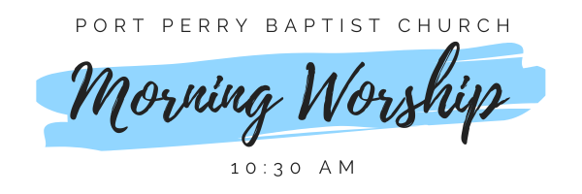Sunday Morning Worship
Sunday, September 20, 2026 - 10:30 am
We are meeting in the sanctuary and will continue to live-stream for those who are unable to attend.
Message: Prophecy, Tongues & A Healthy Church
Scripture: 1 Corinthians 14:1-2
Pastor Jim Clemens

