All Saints Anglican Church
6904 Lougheed Highway, Agassiz, B.C. V0M 1A0
Bulletin September 14th, 2026 – September 20th, 2026

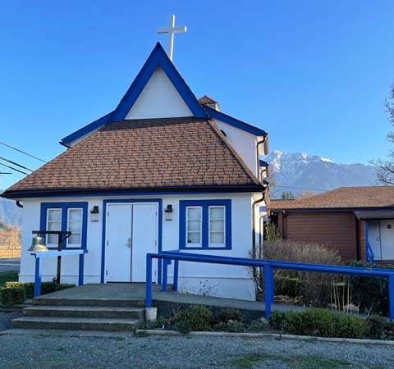

‘The ground we walk does not belong to us; for thousands of years it has been - and remains - the territory of the Stó:lō. We are grateful for their sharing.

Phone: 604-796-3553
Website: www.allsaints-agassiz.ca
https://www.facebook.com/groups/AllSaintsFamily
OUR DOOR IS OPEN AND ALL ARE WELCOME
September 20th, 2026, Seventeenth Sunday After Pentecost
Priest in Charge: The Reverend Philip Barker
Hosts: Graham Featherstone/Jennifer Pinlac
Intercessor: Jennifer Pinlac
Lay Administrator: Dorothy Cresswell
Announcer: Virginia Jennings
Organ/Piano: Francesca Froehlich
Readers: David Hamilton/Judy Gibb
Coffee Time: Graham/Claudia

Vicar’s cell phone: Revd. Philip Barker. 778-867-2461

Vicar’s Warden: Ginny Jennings. 604-796-2206
People’s Warden: Lynn Laughlin. 604-799-5131
Parish email: revpb1950@gmail.com
Please contact either warden if you have an issue that needs to be brought to the attention of the Vicar - or contact the Vicar direct (see above for details).

All Saint’s Calendar/Announcements:

- Book Club – On August 19th Book Club will be starting "Two Steps Forward" by Sharon Garlough Brown, an experienced leader of spiritual formation retreats in the UK and US. The 4 women from Sensible Shoes are taking their next steps in the spiritual formation journey. But each of them is finding roadblocks along the way.
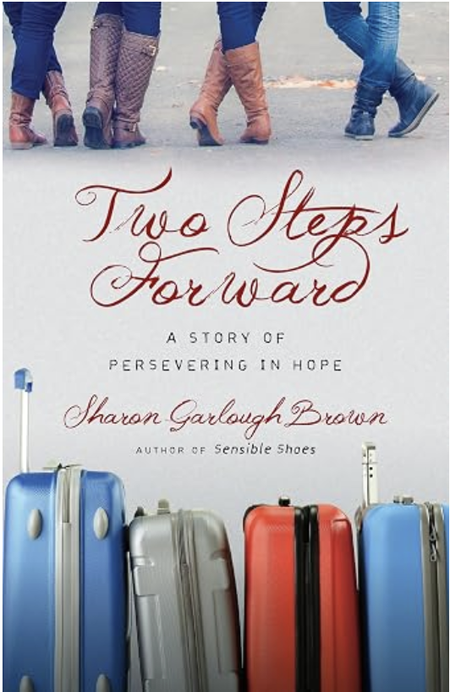

Please contact Sheila Barker at sjbarker0379@gmail.com
if you would like an invitation to the Zoom meetings
at 5.00 pm on Wednesdays or a copy of the book.
The book is available on amazon for $31.43 including tax.

- Bible Study is every Saturday morning 0830-0900 on Zoom. All are welcome to preview and discuss the readings for the Sunday service. Please ask Valerie to add your email address to the invitation list.

- Prayer Requests can be given on a piece of paper to either of the Wardens or the Vicar or entered in the Prayer Request Book on the lectern. Alternatively, you can contact Anthea Lewis at antheamlewis@shaw.ca for Pray First Prayer Circle, which is a confidential online prayer circle.

- Music Requests may be given to the Wardens or the Vicar.

- AA meets in the hall every Tuesday and Friday at noon.

- Every Thursday in the hall 1100-1200 we have a social time with coffee, games if you like or just talk.

- At 1000-1100 on Thursdays there is an Interactive Bible Study on the day’s Lectionary readings. All are welcome – discover the treasures in this amazing book!

- 5th Sunday of each month will be a potluck lunch after the service.

- Please sign up to help with the October 3rd garage sale, on the notice board by the kitchen.

- If you would like to book a table at the Craft Fair on October 24th, please see Fran. Cost is $35

Ministerial Meandering
Teamwork

There is a distinct possibility that my next few MM’s will have some reference to the fact that we are in the process of moving house to another country. It rather tends to occupy the mind - and fill the schedule with deadlines and activities that tax the brain, the emotional capacity, and space in the diary.

What came foremost to my mind this morning was how important it is that Sheila and I pull together as a team to make this work. However motivated we are, it will be twice as hard an evolution if we are pulling in opposite directions. However obvious that may seem to you, it actually isn’t - and I’ll tell you why.

Leaving a place where you have been happy and fulfilled, and moving to an unknown place, is always going to be accompanied by some sadness. It would be bizarre if it were not. But challenges are bitter-sweet, and should be so, because otherwise they would not be challenges at all. I am well aware that there is some opposition from some members of the family, and also there has been some questioning of the ‘rightness’ of the decision by members of the parish. But we are born (I think) to push the boundaries, to stretch ourselves, to take risks; if we don’t there are no adventures, no danger, no excitement.

There are those who feel that after a certain age people should ‘slow down’ - and there are many who are happy to do just that. I suppose if that mould suits you, then fine - but the ‘mould’ will grow on you. I watched that happen to my father who spent the majority of his thirty+ years of retirement doing just that. It became too much effort even to see his next door neighbours for a cup of coffee. In many ways I’m surprised that he didn’t die earlier than at 93 - but of sheer boredom.

When both my parents were alive - and still together, they would go off and have adventures. They pulled together, and it worked. Eventually, sadly, they were pulling in different directions, and although lip-service was paid to their individual needs, it was clear that it would be impossible to work out a practical solution. Once they had parted, my mother went on to have more adventures, but my father never did - ever again. His second wife had a similarly obtunded sense of adventure. He let his passport expire, and when I asked him why he would not visit us in our homes abroad, he would say, “Why would I want to do that? I haven’t even visited the Isle of Wight.” (The Isle of Wight was just off the south coast of England, and my father lived on the south coast.) But I suppose you could say that he and my step-mother were pulling in the same direction, and so it was teamwork - but the pulling never got either of them further than from their armchairs to the kitchen or bedroom.

I find it enormously encouraging when I hear that some of you in your eighties (= just past middle age) are still going off on adventures. My Uncle Keith and Auntie Lyn are going off on another cruise shortly, and never cease to be involved both with us - as a church - and their own community at home in England. They, too, pull together.

It is not necessary to have a life-partner to pull together - but it is essential to have a friend to travel with - even if it is only to the shops or the local cinema. Our bible study, book club, Men’s Shed, garage sales, and so many other things are all examples of having adventures and pulling together. I’ve said before - ‘no man is an island’, and we should all take note of Dylan Thomas’ villanelle to his sick father, to ‘Do not go gentle into that good night. Rage, rage against the dying of the light.’

Philip+

A Little Chuckle…

My wife asked me to hang out the washing as she had an errand to run, I could have said, I can’t be bothered, but that sort of answer is not really compatible with marital harmony or possibly, even survival.

Birthdays in the September 

Rick Probert – 4 Wendy Young – 10
David Hamilton – 10 Sonya Hill – 17
Allen Cresswell – 19 Fern Northcott – 28

Diocesan Cycle of Prayer: We Pray for the Clergy and Congregation:

Standing Committees on Finance and Property & Constitution & Canons; St. Alban, Richmond & The 360 Community - The Revd Bill Mok

Anglican Church of Canada Cycle of Prayer – We Pray for:

The Provincial Synod of the Ecclesiastical Province of British Columbia and Yukon

Collect

Almighty God, you have created the heavens and the earth, and ourselves in your image. Teach us to discern your hand in all your works and to serve you with reverence and thanksgiving; through Jesus Christ our Lord, who is alive and reigns with you and the Holy Spirit, one God, now and for ever

Exodus 16:2-15 David Hamilton

² In the desert the whole community grumbled against Moses and Aaron. ³ The Israelites said to them, “If only we had died by the Lord’s hand in Egypt! There we sat around pots of meat and ate all the food we wanted, but you have brought us out into this desert to starve this entire assembly to death.”

⁴ Then the Lord said to Moses, “I will rain down bread from heaven for you. The people are to go out each day and gather enough for that day. In this way I will test them and see whether they will follow my instructions. ⁵ On the sixth day they are to prepare what they bring in, and that is to be twice as much as they gather on the other days.”

⁶ So Moses and Aaron said to all the Israelites, “In the evening you will know that it was the Lord who brought you out of Egypt, ⁷ and in the morning you will see the glory of the Lord, because he has heard your grumbling against him. Who are we, that you should grumble against us?” ⁸ Moses also said, “You will know that it was the Lord when he gives you meat to eat in the evening and all the bread you want in the morning, because he has heard your grumbling against him. Who are we? You are not grumbling against us, but against the Lord.”

⁹ Then Moses told Aaron, “Say to the entire Israelite community, ‘Come before the Lord, for he has heard your grumbling.’”

¹⁰ While Aaron was speaking to the whole Israelite community, they looked toward the desert, and there was the glory of the Lord appearing in the cloud.

¹¹ The Lord said to Moses, ¹² “I have heard the grumbling of the Israelites. Tell them, ‘At twilight you will eat meat, and in the morning you will be filled with bread. Then you will know that I am the Lord your God.’”

¹³ That evening quail came and covered the camp, and in the morning there was a layer of dew around the camp. ¹⁴ When the dew was gone, thin flakes like frost on the ground appeared on the desert floor. ¹⁵ When the Israelites saw it, they said to each other, “What is it?” For they did not know what it was.

Moses said to them, “It is the bread the Lord has given you to eat.

Psalm 105:1-6, 37-45

¹ Give praise to the Lord, proclaim his name;
make known among the nations what he has done.
² Sing to him, sing praise to him;
tell of all his wonderful acts.
³ Glory in his holy name;
let the hearts of those who seek the Lord rejoice.
⁴ Look to the Lord and his strength;
seek his face always.

⁵ Remember the wonders he has done,
his miracles, and the judgments he pronounced,
⁶ you his servants, the descendants of Abraham,
his chosen ones, the children of Jacob.

³⁷ He brought out Israel, laden with silver and gold,
and from among their tribes no one faltered.
³⁸ Egypt was glad when they left,
because dread of Israel had fallen on them.

³⁹ He spread out a cloud as a covering,
and a fire to give light at night.
⁴⁰ They asked, and he brought them quail;
he fed them well with the bread of heaven.
⁴¹ He opened the rock, and water gushed out;
it flowed like a river in the desert.

⁴² For he remembered his holy promise
given to his servant Abraham.
⁴³ He brought out his people with rejoicing,
his chosen ones with shouts of joy;
⁴⁴ he gave them the lands of the nations,
and they fell heir to what others had toiled for—
⁴⁵ that they might keep his precepts
and observe his laws.

Praise the Lord.

Philippians 1:21-30 Judy Gibb

²¹ For to me, to live is Christ and to die is gain. ²² If I am to go on living in the body, this will mean fruitful labor for me. Yet what shall I choose? I do not know! ²³ I am torn between the two: I desire to depart and be with Christ, which is better by far; ²⁴ but it is more necessary for you that I remain in the body. ²⁵ Convinced of this, I know that I will remain, and I will continue with all of you for your progress and joy in the faith, ²⁶ so that through my being with you again your boasting in Christ Jesus will abound on account of me.

²⁷ Whatever happens, conduct yourselves in a manner worthy of the gospel of Christ. Then, whether I come and see you or only hear about you in my absence, I will know that you stand firm in the one Spirit, striving together as one for the faith of the gospel ²⁸ without being frightened in any way by those who oppose you. This is a sign to them that they will be destroyed, but that you will be saved—and that by God. ²⁹ For it has been granted to you on behalf of Christ not only to believe in him, but also to suffer for him, ³⁰ since you are going through the same struggle you saw I had, and now hear that I still have.

Matthew 20:1-16 Vicar Philip Barker
¹“For the kingdom of heaven is like a landowner who went out early in the morning to hire workers for his vineyard. ² He agreed to pay them a denarius for the day and sent them into his vineyard.

³ “About nine in the morning he went out and saw others standing in the marketplace doing nothing. ⁴ He told them, ‘You also go and work in my vineyard, and I will pay you whatever is right.’ ⁵ So they went.

“He went out again about noon and about three in the afternoon and did the same thing. ⁶ About five in the afternoon he went out and found still others standing around. He asked them, ‘Why have you been standing here all day long doing nothing?’

⁷ “‘Because no one has hired us,’ they answered.

“He said to them, ‘You also go and work in my vineyard.’

⁸ “When evening came, the owner of the vineyard said to his foreman, ‘Call the workers and pay them their wages, beginning with the last ones hired and going on to the first.’

⁹ “The workers who were hired about five in the afternoon came and each received a denarius. ¹⁰ So when those came who were hired first, they expected to receive more. But each one of them also received a denarius. ¹¹ When they received it, they began to grumble against the landowner. ¹² ‘These who were hired last worked only one hour,’ they said, ‘and you have made them equal to us who have borne the burden of the work and the heat of the day.’

¹³ “But he answered one of them, ‘I am not being unfair to you, friend. Didn’t you agree to work for a denarius? ¹⁴ Take your pay and go. I want to give the one who was hired last the same as I gave you. ¹⁵ Don’t I have the right to do what I want with my own money? Or are you envious because I am generous?’

¹⁶ “So the last will be first, and the first will be last.”

Odds and Ends




