Parkside Lutheran Church
Rediscovering the Radical Love of Jesus
Gathering All
Serving All
Caring For All



September 20th, 2026
Holy Communion 10:00am
The Rev. Jeremiah Smith
Parkside Lutheran Values

Proclaiming Grace - Jesus shared and lived out a message of grace, love, and new life. We believe these promises come from God freely, as a gift for all. We are loved and the Spirit inspires us to share this good news in accessible, relevant, and new ways. Luke 4:17-19, John 1:16-17, John 3:16-17, Ephesians 2:8-9

Practicing Hospitality – Jesus welcomed the little children, broke bread with outcasts, and proclaimed the Good News to all. Whether you are strong in faith, wrestling with doubt, or somewhere in between, we affirm that you are welcome here. Jesus is for everyone. Leviticus 19:34, Matthew 9:10, Matthew 19:14, Hebrews 13:2

Loving Boldly - Jesus challenged traditions to demonstrate God’s justice and love of neighbor. His compassionate and sacrificial love inspires us to take risks. Striving to follow his command to love neighbor, our ministries serve, transform, and advocate for folks near and far. Micah 6:8, Mark 11:15-17, Luke 10:25-28, John 15:12-13

Cultivating Community - Jesus built communities that transformed lives. We are the body of Christ and we are called to continue this ministry of transformation. Guided by the Holy Spirit, we build connections within and outside of these walls, and with all of God’s creation. Ecclesiastes 4:9-12, Matthew 28:16-20, 1 Corinthians 12:12-14, Galatians 3:26-29

Welcome Visitors!
Please use QR code to let us know you were here today or to sign up for our weekly enewsletter. Find us on Facebook & Instagram
WIFI: Balcony password: FreeGrace

For your safety in the event of an emergency: In addition to the three exits in the back of the sanctuary, there are exits on either side of the altar (on left side: floor level near piano and up steps past altar. On right side: up steps to the altar, past band area)

Contact us: (716) 836-1361
2 Wallace Ave. Buffalo, NY 14214
parksidelutheran.org | parksidelutheran@gmail.com

GATHER
The Holy Spirit calls us together as the people of God.
Introduction to the Day: Matthew narrates one of Jesus’ controversial parables in which Jesus says that the reign of God is like that of a landowner who pays his workers the same wage no matter what time of day they began to work. When God changes God’s mind about punishing Nineveh for their evil ways, Jonah is angry. Yet God is gracious and merciful, abounding in steadfast love. In baptism, we receive the grace of God that is freely given to all. As Martin Luther wrote, in the presence of God’s mercy we are all beggars.

Prelude: “Great is the Lord” by Michael W. Smith and Deborah D. Smith
Faith Journey

Please stand as you are able

Call to Worship
WA: Already overburdened with the demands of work and leisure, family and friends, we come to this place in search of rest.
C: May we find here the strength to work for justice.
WA: Forgiveness is elusive and anger is justified, too often we settle for the sweet fleeting fruit of revenge.
C: May we find here the patience to embody mercy.
WA: Deluded by the world in which we live receiving power and prestige and money as just reward missing the Spirit's call to a life grounded in humble service.
C: May we find here the wisdom to walk in the Spirit.

+Gathering Hymn: Praise and Thanksgiving
Praise and thanksgiving, Father, we offer
For all things living, created good:
Harvest of sown fields, fruits of the orchard,
Hay from the mown fields, blossom and wood

Bless, Lord, the labor we bring to serve you,
That with our neighbor we may be fed.
Sowing or tilling, we would work with you,
Harvesting, milling for daily bread.
Father, providing food for your children,
By your wise guiding teach us to share
One with another, so that, rejoicing
With us, all others may know your care.

Then will your blessing reach every people,
Freely confessing your gracious hand.
Where all obey you, no one will hunger;
In your love’s sway you nourish the land.

Welcome and Announcements

Please stand as you are able

+Confession and Forgiveness
P: Blessed be the holy Trinity, ☩ one God, who pours love into our hearts
and healing upon the earth. C: Amen.
P: Confident that God justifies us by grace through faith, let us confess our sin.
(a brief silence)
P: Compassionate God,
C: we confess that we struggle to embody your goodness in the world and in our own hearts. Creation groans from overuse. Jealousy and bitterness strain our relationships. Indifference keeps us from seeking justice. Divisions disrupt your call to show genuine love to others. Turn our hearts back to you. Restore our world and reconcile us to one another. Renew us to live as your holy people, following the way of Jesus Christ. Amen.
P: Hear this good news: We have peace with God through ☩ Jesus Christ, in whom there is no condemnation, but only forgiveness and the promise of eternal life. Receive freely this healing gift of grace. C: Amen.

Greeting

WA: The grace of our Lord, Jesus Christ, the love of God, and the communion of the Holy Spirit be with you all. C: And also with you.

Kyrie Setting 8 (p. 184)
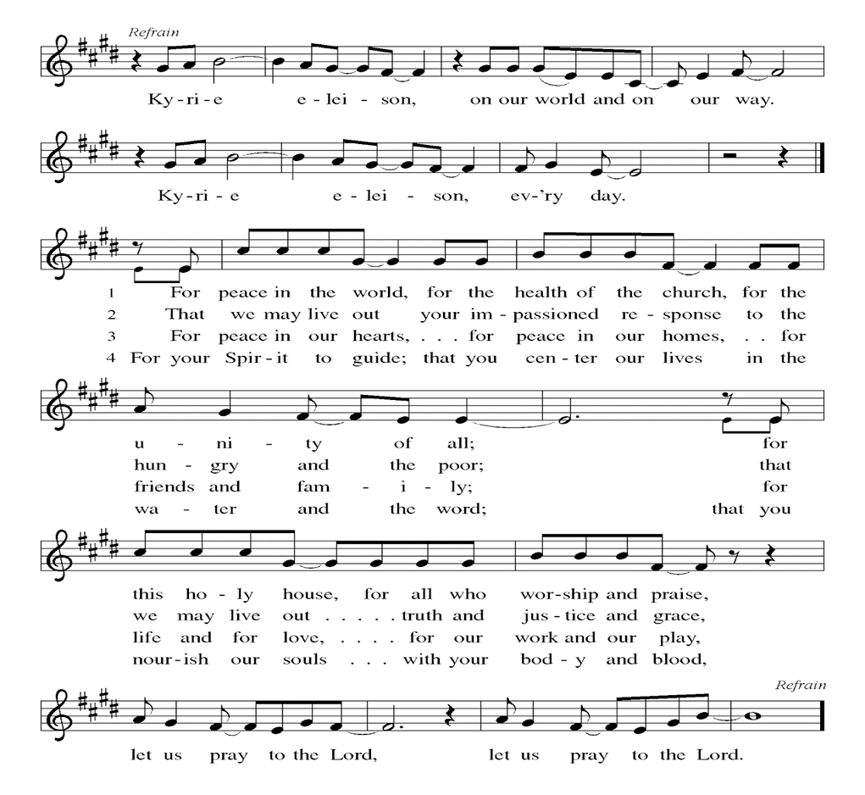

Prayer of the Day
WA: Let us pray together.
C: Almighty and eternal God, you show perpetual lovingkindness to us your servants. Because we cannot rely on our own abilities, grant us your merciful judgment, and train us to embody the generosity of your Son, Jesus Christ, our Savior and Lord. Amen.

Children’s Sermon: Jesus said, “Let the little children come to me!”
We welcome children in worship.

WORD
God speaks to us in scripture readings, preaching and song.

First Reading: Jonah 3:10-4:11
After Jonah’s short sermon in 3:4, the Ninevites all repented and God decided to spare the city. Jonah objected to this and became even more angry when God ordered a worm to destroy a plant that was providing shade. The book ends with a question that challenges any who are not ready to forgive: You, Jonah, are all worked up about a bush, but shouldn’t I be concerned about a hundred and twenty thousand Ninevites?
L: ¹⁰ When God saw what [the people of Ninevah] did, how they turned from their evil ways, God changed his mind about the calamity that he had said he would bring upon them, and he did not do it.
^{4:1} But this was very displeasing to Jonah, and he became angry. ² He prayed to the Lord and said, “O Lord! Is not this what I said while I was still in my own country? That is why I fled to Tarshish at the beginning, for I knew that you are a gracious and merciful God, slow to anger, abounding in steadfast love, and relenting from punishment. ³ And now, O Lord, please take my life from me, for it is better for me to die than to live.” ⁴ And the Lord said, “Is it right for you to be angry?” ⁵ Then Jonah went out of the city and sat down east of the city and made a booth for himself there. He sat under it in the shade, waiting to see what would become of the city.
⁶ The Lord God appointed a bush and made it come up over Jonah, to give shade over his head, to save him from his discomfort, so Jonah was very happy about the bush. ⁷ But when dawn came up the next day, God appointed a worm that attacked the bush, so that it withered. ⁸ When the sun rose, God prepared a sultry east wind, and the sun beat down on the head of Jonah so that he was faint and asked that he might die. He said, “It is better for me to die than to live.”
⁹ But God said to Jonah, “Is it right for you to be angry about the bush?” And he said, “Yes, angry enough to die.” ¹⁰ Then the Lord said, “You are concerned about the bush, for which you did not labor and which you did not grow; it came into being in a night and perished in a night. ¹¹ And should I not be concerned about Nineveh, that great city, in which there are more than a hundred and twenty thousand persons who do not know their right hand from their left and also many animals?”
L: Word of God, word of life. C: Thanks be to God.

Psalm: Psalm 145:1-8 The Lord is slow to anger and abounding in steadfast love.

(Ps. 145:8)
L: ¹ I will exalt you, my God and king, and bless your name forever and ever.
C: ² Every day will I bless you and praise your name forever and ever.
L: ³ Great is the Lord and greatly to be praised! There is no end to your greatness.
C: ⁴ One generation shall praise your works to another
and shall declare your power.
L: ⁵ I will speak of the glorious splendor of your majesty
and all your marvelous works
C: ⁶ They shall tell of the might of your wondrous acts,
and I will recount your greatness.
L: ⁷ They shall publish the remembrance of your great goodness;
they shall sing joyfully of your righteousness.
C: ⁸ The Lord is gracious and full of compassion,
slow to anger and abounding in steadfast love.
L: Word of God, word of life. C: Thanks be to God.

Second Reading: Philippians 1:21-30
Paul writes to the Philippians from prison. Though he is uncertain about the outcome of his imprisonment, he is committed to the ministry of the gospel and calls on the Philippians to live lives that reflect and enhance the gospel mission. L: ²¹ For to me, living is Christ and dying is gain. ²² If I am to live in the flesh, that means fruitful labor for me, yet I cannot say which I will choose. ²³ I am hard pressed between the two: my desire is to depart and be with Christ, for that is far better, ²⁴ but to remain in the flesh is more necessary for you. ²⁵ Since I am convinced of this, I know that I will remain and continue with all of you for your progress and joy in faith, ²⁶ so that, by my presence again with you, your boast might abound in Christ Jesus because of me.
²⁷ Only, live your life in a manner worthy of the gospel of Christ, so that, whether I come and see you or am absent and hear about you, I will know that you are standing firm in one spirit, striving side by side with one mind for the faith of the gospel ²⁸ and in no way frightened by those opposing you. For them, this is evidence of their destruction but of your salvation. And this is God’s doing. ²⁹ For he has graciously granted you the privilege not only of believing in Christ but of suffering for him as well, ³⁰ since you are having the same struggle that you saw I had and now hear that I still have.
L: Word of God, word of life. C: Thanks be to God.

Please stand as you are able

Gospel Acclamation Setting 8 (p. 188)
(printed next page)
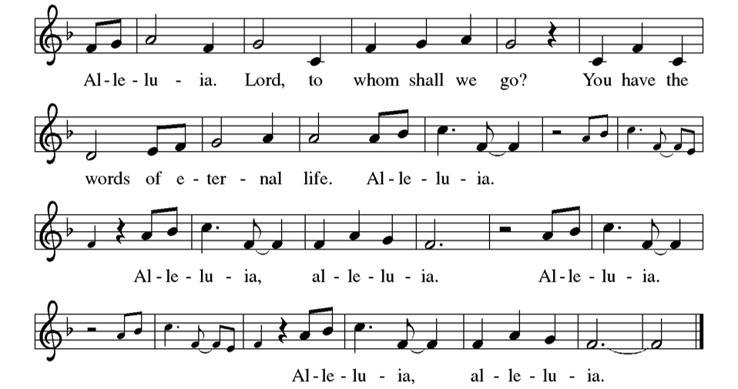
Gospel Reading: Matthew 20:1-16
Jesus tells a parable about God’s generosity, challenging the common assumption that God rewards people according to what they have earned or deserve.
P: The Holy Gospel according to Matthew. C: Glory to you, O Lord.
P: [Jesus said to the disciples:] ¹ “The kingdom of heaven is like a landowner who went out early in the morning to hire laborers for his vineyard. ² After agreeing with the laborers for a denarius for the day, he sent them into his vineyard. ³ When he went out about nine o’clock, he saw others standing idle in the marketplace, ⁴ and he said to them, ‘You also go into the vineyard, and I will pay you whatever is right.’ So they went. ⁵ When he went out again about noon and about three o’clock, he did the same. ⁶ And about five o’clock he went out and found others standing around, and he said to them, ‘Why are you standing here idle all day?’ ⁷ They said to him, ‘Because no one has hired us.’ He said to them, ‘You also go into the vineyard.’ ⁸ When evening came, the owner of the vineyard said to his manager, ‘Call the laborers and give them their pay, beginning with the last and then going to the first.’ ⁹ When those hired about five o’clock came, each of them received a denarius. ¹⁰ Now when the first came, they thought they would receive more; but each of them also received a denarius. ¹¹ And when they received it, they grumbled against the landowner, ¹² saying, ‘These last worked only one hour, and you have made them equal to us who have borne the burden of the day and the scorching heat.’ ¹³ But he replied to one of them, ‘Friend, I am doing you no wrong; did you not agree with me for a denarius? ¹⁴ Take what belongs to you and go; I choose to give to this last the same as I give to you. ¹⁵ Am I not allowed to do what I choose with what belongs to me? Or are you envious because I am generous?’ ¹⁶ So the last will be first, and the first will be last.”
P: The Gospel of the Lord. C: Praise to you, O Christ.
Sermon Rev. Jeremiah Smith

Please stand as you are able

+Hymn of the Day: Just a Closer Walk with Thee
(chorus) Just a closer walk with thee, grant it, Jesus, if you please.
Daily walking close to thee, let it be, dear Lord, let it be.

I am weak but thou art strong; Jesus, keep me from all wrong;
I’ll be satisfied as long as I walk, dear Lord, close to thee.

(Instrumental verse)

Through this world of toil and snares, If I falter, Lord, who cares?
Who with me my burden shares? None but thee, dear Lord, none but thee.

When my feeble life is o’er, time for me will be no more;
On that bright eternal shore, I will walk, dear Lord, close to Thee. (chorus)

Apostles’ Creed
WA: Let us confess the faith using the words of the Apostles’ Creed.
C: I believe in God, the Father almighty, creator of heaven and earth.
I believe in Jesus Christ, God’s only Son, our Lord, who was conceived by the Holy Spirit, born of the virgin Mary, suffered under Pontius Pilate, was crucified, died, and was buried; he descended to the dead. On the third day he rose again; he ascended into heaven, he is seated at the right hand of the Father, and he will come to judge the living and the dead.
I believe in the Holy Spirit, the holy catholic church, the communion of saints, the forgiveness of sins, the resurrection of the body, and the life everlasting. Amen.

Prayers of the People WA: Reminded of God’s gracious and abundant love, we offer our prayers, confident that God hears us. (a brief silence)
WA: Hold your church accountable for our unwillingness to share your good news and our anger at your generosity to others. Nourish us by your grace to be witnesses to your love. Hear us, O God. C: Your mercy is great.

WA: Show employees the benefits of equal pay standards for all their employees. Reconcile conflicts between employees. Fill places of employment with camaraderie, and bring an end to employment disparity. Hear us, O God.
C: Your mercy is great.

WA: Encourage any who cannot work or who cannot work a full day with the truth that their value comes from your everlasting love for them. Provide for those who are injured, ill, and for all in any need, especially those we name aloud or in the silence of our hearts…. Hear us, O God, C: Your mercy is great.

WA: Strengthen all those in this congregation whose labor serves the needs of others in the community. Inspire all in this congregation to support community endeavors with our time and talents. Hear us, O God, C: Your mercy is great.

WA: Comfort us with the promise of the resurrection as we remember all our loved ones whose desire to be with Jesus is fulfilled. Hear us, O God.
C: Your mercy is great.

WA: Grant the prayers we have offered, what we have forgotten to ask, and whatever else you see that we need. We ask this in Jesus’ name. C: Amen.
Peace
P: The peace of Christ be with you always. C: And also with you.

Meal - God feeds us with the presence of Jesus Christ

Offering
We are grateful to those who help sustain our mission. To donate online, please use QR code:


Offering Music: “Spirit Song” by John Wimber
+ Offering Prayer
WA: Let us pray together:
C: God of creation, you send rain and the earth springs forth abundantly. All blessings are from you; make us generous with what we have. Use our gifts, our abilities, and our hearts in service to you and in love to our neighbors today and always. Amen.

+ Offertory Song: “Praise God From Whom….” (doxology)
ELW 885 (music from ELW 883)
Praise God, from whom all blessings flow;
praise God, all creatures here below;
praise God above, ye heav’nly host;
praise Father, Son, and Holy Ghost. Amen.
Great Thanksgiving
P: The Lord be with you. C: And also with you.
P: Lift up your hearts. C: We lift them to the Lord.
P: Let us give thanks to the Lord our God.
C: It is right to give our thanks and praise.

Preface
P: It is indeed right, our duty and our joy, that we should at all times and in all places give thanks and praise to you, almighty and merciful God, through our Savior Jesus Christ; who on this day overcame death and the grave, and by his glorious resurrection opened to us the way of everlasting life. And so, with all the choirs of angels, with the church on earth and the host of heaven, we praise your name and join their unending hymn:

Holy Holy Holy ELW setting 8 (p. 190)
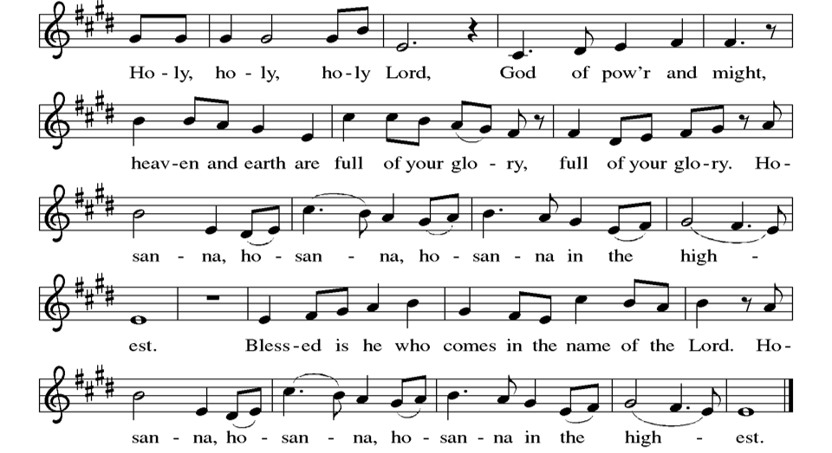

Thanksgiving at the Table

P: In the night in which he was betrayed, our Lord Jesus took bread, and gave thanks; broke it, and gave it to his disciples, saying: Take and eat; this is my body, give for you. Do this for the remembrance of me. Again, after supper, he took the cup, gave thanks, and gave it for all to drink, saying: This cup is the new covenant in my blood, shed for you and for all people for the forgiveness of sin. Do this for the remembrance of me.

Lord’s Prayer
P: Lord, remember us in your kingdom and teach us to pray.
C: Our Father in heaven, hallowed be your name, your kingdom come, your will be done, on earth as in heaven. Give us today our daily bread. Forgive us our sins as we forgive those who sin against us. Save us from the time of trial and deliver us from evil. For the kingdom, the power, and the glory are yours, now and forever. Amen.

Invitation to the Table
At Parkside Lutheran Church we have an open table. We believe the invitation to receive comes from Jesus himself and all are welcome at Christ’s table. More than just Bread and Wine these are tangible signs of God’s love for you! If you do not wish to receive communion but would like a blessing, come forward and cross your arms over your chest. The Pastor will give you a blessing before you return to your seat via the side aisle. You’ll receive a communion wafer* in your hands. You may dip it in the cup of wine or juice. When giving the bread and cup, the communion ministers say: “The body of Christ, given for you. The blood of Christ, shed for you.”
and each person may respond: Amen
*Please let Pastor know if you need a gluten-free wafer
P: Christ invites you to this table. All who are hungry, all who are thirsty, come!

The Communion Distribution

Communion Song ELW setting 10 (p. 191)
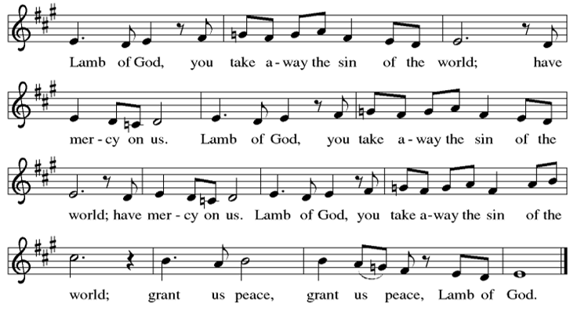

Communion Song: Here is Bread, Here is Wine ELW #483
Here is bread, here is wine. Christ is with us, he is with us.
Break the bread, drink the wine. Christ is with us here.

Here is grace, here is peace. Christ is with us, he is with us.
Know his grace, find his peace. Christ is with us here.

Refrain: In this bread there is healing; in this cup there’s life forever.
In this moment, by the Spirit, Christ is with us here.

Here we are, joined in one. Christ is with us, he is with us.
We’ll proclaim ‘til he comes, Jesus crucified. Refrain

Communion Song: Sanctuary

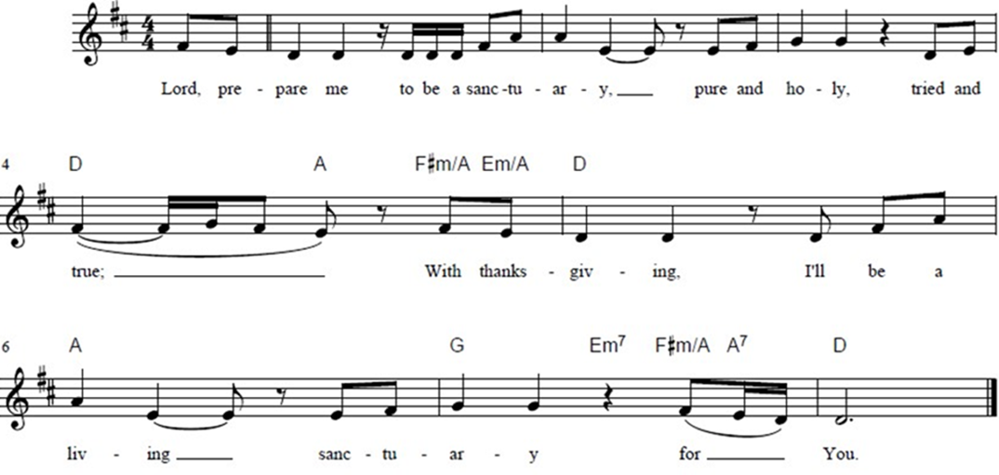

Post Communion Blessing
P: The Body and Blood of our Lord and Savior, Jesus Christ, strengthen you and keep you in God's grace. C: Amen.

Prayer After Communion
WA: Let us pray together.
C: Sustaining God, with this bread and cup, you nourish us with mercy and abundant life. By your Spirit, send us from this table to serve a needy world. Make us living signs of your liberation, healing, and love,
following the way of Jesus, in whose name we pray. Amen.

Sending - God blesses us and sends us in mission to the world.

Blessing
P: The God of love draw you into full accord and one mind, in the body of Christ Jesus. C: Amen.
P: The God of hope grant you strength and joy in all circumstances through the interceding of the Spirit. C: Amen.
P: The God of grace ☩ bless you now and forever. C: Amen.

Sending Hymn: Lord, I Lift Your Name on High ELW #857
Lord, I lift your name on High; Lord, I love to sing your praises.
I’m so glad you’re in my life, I’m so glad you came to save us.
You came from heaven to earth to show the way,
From the earth to the cross my debt to pay;
From the cross to the grave, from the grave to the sky;
Lord, I lift your name on high.

Dismissal
P: Parkside Lutheran Church is rediscovering the radical love of Jesus.
C: Gathering All, Serving All, Caring for All
P: Go out in joy. Be led forth in peace.
C: Thanks be to God.

Postlude: “To Live On” by Larry Olson

ELW Music licensed from Sundays & Seasons, Augsburg Fortress CCLI MUSIC License # 11440069 , CCLI Streaming License#21835523 Do not duplicate any music or Liturgy herein without license and permission
scripture readings adapted and written by susan lukey

PARKSIDE STAFF:
• The Rev. Jeremiah Smith: prjeremiahpsmith@gmail.com
• Kris Pope & Suzanne Gracie, Admin. Assistants (Church Office): parksidelutheran@gmail.com
• Mike Hooker, Music Director: mrhooker@me.com
CHURCH OFFICE HOURS: M/T/R 10:00am-3:00pm (716)836-1361
Acolytes: |  | Worship Assistants:
9/20 – Grace & Lorenzo |  | 9/20 – John
9/27 – Chris & Katie |  | 9/27 – Susan
Readers: |  | Ushers:
9/20 – Dave P |  | 9/20 – Nick, Tom, John, Charlie
9/27 – Anne |  | 9/27 – Ricky, Shannon, David

Coming up:
TODAY – God’s Work, Our Hands, after Worship
TODAY – Communion Class, after Worship
TODAY – Line Dance Fundraiser, after Worship in Fellowship Hall

September 27th – Communion Celebration
October 4th – Bible Study & Confirmation Classes Resume
October 16th - Parkside Meat Raffle – TICKETS ON SALE NOW
Visit our website for more information about these and other Events at Parkside – www.parksidelutheran.org/events

