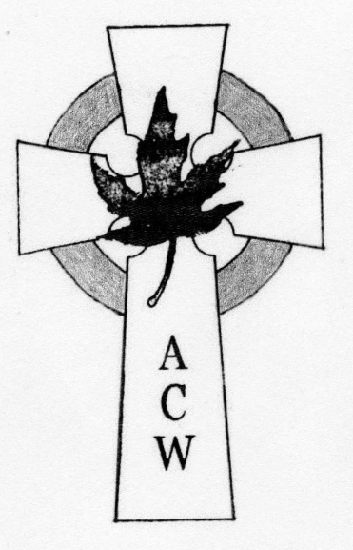
In Touch

Diocese of Edmonton
ACW Quarterly newsletter September 2026

WA
W A

Thankfulness

Psalm 118:29
(Revised Standard Version)
O give thanks to the Lord, for he is good;
for his steadfast love endures for ever!

A Song of Praise
Give thanks to the Lord, proclaim his greatness; tell the nations what he has done.

1 Chronicles 16:8 (Good News Translation)

Give thanks to the LORD, for He is good; His love endures forever.
Psalm 107:1
Same words different Psalm



And whatever you do, in word or deed, do everything in the name of the Lord Jesus, giving thanks to God the Father through him. Colossians 3:17

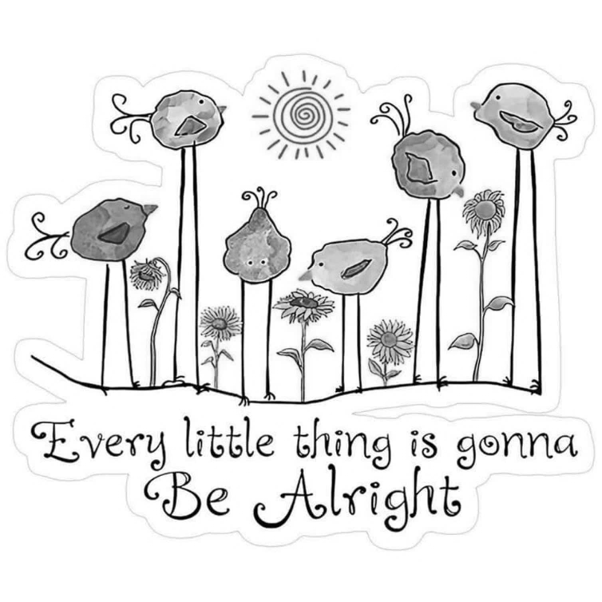
Father, the beauty of Your provision is ever on display.
Thank You for the richness of Your creation.
Please give me eyes to see Your handiwork, and let it remind me of Your goodness.

Diocesan ACW Report

Hello once again. It hardly seems possibly that summer is almost over and we are back into the business of our operating year. Our Fall programs begin with the West Region Meeting on September 19, being held at Good Shepherd parish, hosted by our friends from St. Timothy. And on Oct 3, the East Region Meeting is being held at and hosted by Immanuel, Wetaskiwin.
As a reminder, West Region parishes with active ACW chapters are asked to send representatives to the West Region meeting, and similarly East Region parishes to the East Region meeting however any ACW members (and any friends you would like to bring along) from any parishes in the Diocese may attend any Regional Meeting.
West Region parishes currently with active ACW chapters are: All Saints, Drayton Valley, St. John the Divine, Onoway, St. Augustine Parkland, Spruce Grove, Good Shepherd, Edmonton and St. Timothy, Edmonton.
East Region parishes currently with active ACW chapters are: St. Mary, Ponoka, Immanuel, Wetaskiwin, St. Andrew, Camrose, St. Columba, Beaumont, St. George, Fort Saskatchewan, Emmanuel, Gibbons.
Having said this, the Executive’s planned in-person meeting on June 20 was postponed due to the season’s first heavy rain storm (monsoon!) We held it later, July 4, via Zoom. Due to the change of date, some parish representatives were not able to attend. We look forward to seeing them at our next Executive meeting on Oct 17. Please mark your calendar.
The National Anglican Church Women’s Annual Conference is being held in Grande Prairie from September 25 through 27. Your President (me) and Secretary (Margaret Warwick) are attending.
Another important date for your calendar is noon on Thursday December 3 at the Cathedral for our annual Reunion Communion. Do plan bring a group from your parish to this beautiful Advent service followed by a Christmas tea. And speaking of tea, Good Shepherd’s High Tea is on September 12.
Finally, a suggestion raised at the Annual Meeting. Early September is a great time for church bazaars to sell– or gift – the many Christmas ornaments we no longer have room for. Share the joy and make a bit of space for ourselves at the same time. If your parish is planning a bazaar and is asking for donations, let me know! I can put the word out.
Asking God’s blessings on you as we transition into this next season.
God of all seasons, we thank you for autumn. We praise you for the cooler air, the changing colour of the trees and the harvest of the earth. Just as the leaves let go from the branches, help us to let go of our worries and rest in your care. Transform our hearts with your spirit as you transform the earth. Amen.

Elaine, President

Diocesan
ACW Executive

2025—2026

Patron
The Rt. Rev. Steve London
Chaplain *
The Rev. Helen Chan Bennett

President
Elaine Dickie
Past President
Judy Korop
Vice Presidents
First—Vacant
Second—Vacant
Recording Secretary
Margaret Warwick
Corresponding Secretary
Elaine Dickie
Treasurer
Gen Ashwell
Prayer Partners

Social Action
Kathy Budd
Life Members
Tracey Fodchuk
Education/Family Life
Ann Marie Nicklin
*Book of Remembrance Appointed

*Lone Members Appointed

*In Touch Editor Appointed
Contact
acw.dioceseofedmonton@gmail.com

Regional Contacts
West ACW Region
Yellowhead / Edmonton West
Gen Ashwell

East ACW Region
Whitemud / Battle River/ Cold Lake
Wetaskiwin
Diocesan ACW
c/o Anglican Diocese of Edmonton
10035 – 103 Street NW
Edmonton, AB T5J 0X5

email:
acw.dioceseofedmonton@gmail.com

Education & Family Life

Starfish
Or: From the mouths of babes! (Okay, in this case a nine-year-old.)
Listening to and learning from our children!

I have been on a high learning curve over the past few months. My teacher – my nine year old granddaughter, “Starfish.” It started out at the end of May. Our priest/pastor had said he wanted more children involved in the worship on the last Sunday of May. I was on the schedule to lead prayers that Sunday, so I approached Mark and asked him if he would like me to help Starfish to say them in my place. His response was positive.

Two Saturdays before the appointed Sunday, Starfish and I sat down. We read through the lessons appointed for the Sunday. We discussed what they meant. Then looking at the lessons individually, I asked her what she might want to pray about them. She gave me some ideas and I wrote them down for her. I printed off the lessons and her thoughts and gave them to her. During the week she looked at them and jotted down more thoughts. The Saturday before she was to say prayers, we got together again. She gave me her new thoughts. I put them with the original ones and broadly categorized them. We then put them together in a litany. I changed very few words. I made very few suggestions as to direction. To all intents and purposes, these were the Starfish’s prayers.

The prayers were mostly prayers of thanksgiving rather than petition. I started listening more. Anytime the Starfish prayed prayers that were not memorized (her nightly prayers are by rote), she gave thanks.

I thought about it. When I compose prayers, they are predominantly prayers of supplication. As a priest when I led prayers and left space for people to contribute, they would do so during prayers of supplication. But come to a prayer of thanksgiving – crickets. Is this part of what Matthew 18:3 means: “Truly I tell you, unless you change and become like children, you will never enter the kingdom of heaven.” Is part of the meaning the child’s ability to see God at work in the kingdom in the most common and most basic of things and simply say “thank you?”

Stay tuned for part two.
Rev. Ann Marie

You are invited to take part in this Alongside Hope Benefit October 17, 2026, 1-4 p.m.
- (Easy Method) The simplest way is to print one of the sponsor sheets and place the poster at the back of your church for people to donate monies.
- Collecting monies before hand. On the selected day. Have one or a few teams keep a rocking chair rocking for three hours. You may wish to be part of the zoom connection to Camrose on October 17th to be part of the greater Anglican Community. You may wish to have a simple coffee hour going or a potluck afterwards for community connections.
- (Travel Method) Each parish is asked to put together a team of 4-10 people all ages invited to St. Andrew’s Camrose to keep a rocking chair going for three hours and enjoy fellowship and a potluck at the end.

Any further questions please contact:
Donna email
DMPederson@outlook.com

The WEST EDMONTON ACW REGIONAL
hosted by St. Timothy’s ACW, will take place at Good Shepherd Anglican Church on Saturday, September 19.
Registration at 9:15 am. Eucharist at 10 am, officiated by Rev. Jordan rector of St. Timothy’s.

Please bring your own bag lunch. Coffee, juice, water available after the service. The speakers are Nancy and/or Colin and Diann , all parishioners of St. Timothy’s. The theme is Pilgrimage- a video of The Camino de Santiago and via France will preface the talks. After lunch we will have a Bible study lead by Rev. Jordan, a business meeting and hymn sing. There is no registration fee, but we are all encouraged to contribute to the offering, to support ALONGSIDE HOPE, and SANCTUARY OF PEACE (new name for Inner City Pastoral Ministry).

Life Member Secretary

The summer has had unsettled weather at best. I was very thankful for the sunny days with lots of fresh air to enjoy. This edition’s theme of In Touch is thankfulness. So on that note I would like to talk about how thankful our A.C.W. was for the In Touch. The In Touch was passed around for many years at our meetings. We all enjoyed reading it and everyone had their favorite sections. We shared the recipes, knitting projects and games. It kept us up-to-date with all other A.C.W’s in the diocese and when the regional meetings took place. We enjoyed learning what other A.C.W.’s were doing and sometimes we would follow their examples for fundraisers and ideas for fellowship. We are very thankful for all the years Willa has put in to keeping the InTouch going. Her hard work and faith was so appreciated over the years.
At our meetings while going over the In Touch we would always check the list of members from the Book of Remembrance. When one of our members was listed we took the time to reminisce and talk about them with loving memories. Melissa Lee has done a wonderful job keeping up our Book of Remembrance and keeping in touch with Lone Members. Thank you Melissa.
Our Life Members so appreciated the beautiful certificate that Mary Jean Locock made. Thank you Mary Jean. The pin and certificate was an honour to receive. A reminder of service, hard work and faith over the years.

Our A.C.W. at St. Columba, Beaumont has remained strong over the years. We are a sisterhood of shared strength and faith. We have held each other up in good times and bad. We are so thankful to be part of the larger diocesan A.C.W.

May God Bless,
Tracey
St. Columba,

The East ACW Regional Meeting, Immanuel, Wetaskiwin October 3rd, stating at 9:30 to 10 am for registration, coffee and muffins. No charge for the day.
Our theme is “Peace and Justice”, with the bible verse John 16:33.

Book of Remembrance

Monica Johnson 1930-2018 Church of the Good Shepherd, Edmonton
Elisabeth 'Margaret' Taylor 1921-2018 St. Saviour's, Vermilion
Edna Irene Squarok 1922-2019 St. Michael & All Angels, Edmonton
Virginia Sherburne 1924-2018 Immanuel, Wetaskiwin
Lila May Thompson 1938-2019 Immanuel, Wetaskiwin

GIFTS

Gifts for birthdays
Sent with prayer
Remind us all
That God does care.

Just go outside
And see the view
The Holy Father
Paints for you!

We are so thankful
For God’s care
As well as gifts
That all can share.

Behold a bird
High in the sky
Who’s practicing
A lullaby.

A field of green
And all the rest
The chosen tree
To build her nest.

The waters blue
Entices us there
To view the beauty
We all share.

So now I end
I do declare
Our thanks to God.
For Beauty rare.

Joan Lugg May 11/95
(for the Cold Lake ACW
Regional Meeting)
More
ALONGSIDE HOPE - Solar Suitcases
“The ward was well-lit. I had no fear of the risks and I trusted the midwives.” These are the words of Soraya José, a mother of five in Mozambique describing the experience of giving birth in a health clinic equipped with a Solar Suitcase.
Since 2016, when Anglicans in Canada first provided Solar Suitcases in Mozambique, more than 80,000 babies have been safely delivered in 115 maternity clinics where electricity was unreliable. In some communities, night-time deliveries have increased 17-fold because families knew it was safe to seek care after dark.
You can help equip the next clinic.
Each Solar Suitcase costs $6,500 to install, providing years of reliable solar power for mothers, newborns and the health workers who care for them.

Good Shepherd Activities

1.Good Shepherd will be hosting their annual High Tea Saturday, September 12, 2026, 2:00 to 4:00 pm. Tickets are $25.00 each and can purchased from Joyce. There are 120 tickets printed and they go fast so don’t miss out. Hats are optional.
2. Good Shepherd will be having the West ACW Regional Meeting for St. Timothy’s September 19, 2026, 9:15 am registration
3. Good Shepherd will be hosting their annual Christmas Bazaar & Tea, November 24, 2026, 10:30 to 3:00. We have many table rentals also.

Deadline Dates for Life Member Applications

Deadlines for applications to be in to have the presentation at:
West Region (Yellowhead/Edmonton West) (Sept meeting) End of May
East Region (Whitemud/Battle River Cold Lake) (Oct meeting) End of May
Diocesan Annual Meeting (May meeting) End of January
Contacts for Life Members & Book of Remembrance
Life Members: Tracey

Book of Remembrance: ACW Diocese of Edmonton
10035 103 St. NW Edmonton AB T5J 0X5
Puzzle Page & Past Time Pursuits
GOD'S GIFTS

R | E | T | H | G | U | A | L | S | S | U | N | D | A | Y
B | E | A | U | T | Y | L | O | P | T | S | Y | O | J | N
N | V | A | L | L | I | F | T | R | O | E | P | A | E | A
E | I | R | S | G | T | E | A | I | R | D | M | D | S | T
R | E | E | H | O | V | M | E | N | M | E | R | B | U | U
D | C | T | E | O | N | E | R | G | S | A | L | B | S | R
L | E | A | L | D | E | A | G | E | G | E | T | L | C | E
I | R | W | P | A | N | S | R | E | S | O | N | E | H | H
H | S | T | E | S | N | U | S | S | K | R | D | S | R | T
C | C | O | U | N | T | R | Y | S | I | D | E | S | I | G
W | I | N | D | A | H | E | A | T | E | T | F | E | S | N
H | O | M | E | C | A | D | R | E | S | C | N | D | T | E
T | E | R | T | R | L | A | N | R | E | T | E | I | R | R
A | C | A | T | T | E | N | I | H | S | N | U | S | A | T
B | W | H | D | H | A | P | P | I | N | E | S | S | P | S
SNAP
SOFT
SON
SPRING
STORMS
STRENGTH
SUNDAY
SUNSETS
SUNSHINE
ULTIMATE
USED
WATCH
WATER
WIND
WORTH

HOME
JAMES
JESUS CHRIST
JOY
LAUGHTER
LIFT
LIGHT
LOVE
MEASURED
NATURE
PART
RAY
RESON
RECEIVE
SAINT
SEE
SKIES

ALL
BATH
BEAUTY
BLESS
BLESSEDD

The Wonder Word
is: _ _ _ _ _ _ _.
(note: there is some creative spelling. The words in the puzzle are like the list.)
HAVE
HEAD
HEART
HEAT
HELP

GARDEN
GOD
GOOD
GREAT
HAPPINESS
CHILDREN
COUNTRYSIDE
CREATURES
EARTH
ETERNAL

One of my favorite recipes and I don’t think I have printed it before in In Touch Enjoy it is my daughter’s favorite.

CHOCOLATE MARBLE BROWNIES
Ingredients
2/3 CUP flour 1/2 tsp. baking powder
1/4 tsp. salt 1/2 cup butter (marg)
1/2 cup cocoa 1 cup sugar
2 eggs 3/4 tsp. vanilla
Cream Cheese Filling
Instructions
Stir together flour, baking powder, salt. Melt butter, remove from heat stir in cocoa. Beat in sugar, eggs and vanilla. Blend in dry ingredients. Pour half of the batter into a greased 9" square pan. Carefully spread the cream cheese filling on top ; spoon remaining batter over the top. Pull a knife through both batters to create a marbled effect Bake at 350 F for 40-45 min Cool makes 2 dozen brownies.

Cream Cheese Filling: Beat 250 g softened cream cheese. Gradually beat in 1/3 cup sugar, 1 egg, & 1/2 tsp. vanilla until smooth.

The Wonder Word is: _ _ _ _ _ _ _.

Giving thanks is the very life of prayer. Tell God how grateful you are for the fruit that falls from your tree.

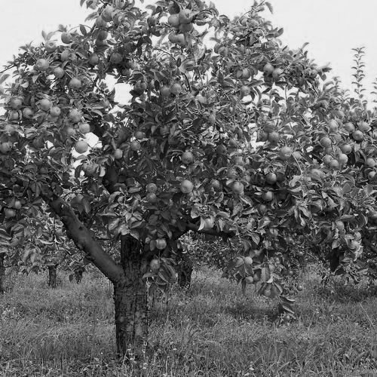
Upcoming Events

- Good Shepherd will be hosting their annual High Tea Saturday, September 12, 2026, 2:00 to 4:00 pm.
- Good Shepherd will be having the West Regional Meeting hosted by St. Timothy’s September 19, 2026, 9:15 am registration
- The East ACW Regional Meeting, Immanuel, Wetaskiwin, October 3rd, stating at 9:30 to 10 am for registration.
- Good Shepherd will be hosting their annual Christmas Bazaar & Tea, November 24, 2026, 10:30 to 3:00.
- All Saints Cathedral ACW Reunion Communion 12 o’clock noon Thursday December 3.

TEXTURED KNIT
DISHCLOTH
ABREVIATIONS
Alt = Alternate,
Approx = Approximate(ly)
K = Knit P = Purl Rep = Repeat
RS = Right side, St(s) = Stitch(es)
WS = Wrong side
YARN Lily® Sugar’n Cream 1 ball 77 yards
MEASUREMENTS Approx 9” [23 cm] square. GAUGE 20 sts and 26 rows 4” [10 cm] in stocking st.
INSTRUCTIONS Cast on 42 sts. Knit 9 rows (garter st), noting first row is WS. 1st and alt rows: (RS). Knit.
2nd row: K5. Purl to last 5 sts. K5. 4th row: K5. P2. *K4. P2. Rep from * to last 5 sts. K5. 6th row: As 4th row. 8th row: As 2nd row. 10th row: K8. *P2. K4. Rep from * to last 4 sts. K4. 12th row: As 10th row. Rep last 12 rows until work from beg measures approx 8” [20.5 cm], ending on a 3rd or 9th row. Knit 8 rows (garter st). Cast off knitwise.

Quick and Easy Cake
(too Good to be True)
1 pkg Cake mix 480 gm - any flavour
1 can pie filling - any flavour
3 large eggs
Mix all together and place in a 9X13” pan Bake at 350 degrees for 30 – 35 min. or until a toothpick come out clean when sampled in the middle.
Your choice of flavours:
White cake & blueberry pie filling
Yellow cake and strawberry – rhubarb pie filling or apple pie filling
Chocolate cake and cherry pie filling
And I want to try spice cake and pumpkin PIE Filling (not pure pumpkin).
Maybe spice cake and raisin pie filling would also be good.
I have also done white cake & cherry pie filling
Seve with a chocolate or caramel drizzle, cool whip or ice cream
This recipe was in Sept 2024 In Touch.

The most significant prayer you will ever pray is just two words long: “Thank You”.
Postage Stamps: please remember to save all the used postage stamps you receive and turn them in (at a Regional meeting would be great). We pass them on to the Canadian Bible Society who use them to fund their programs.

From Willa

Dear Ladies This issue of In Touch has been very difficult to put together. Maybe because it is my last one. I have so much to be Thankful for. Being able to do this for 22 years. For all the ladies I have met and the Friends I have made (and Lost). Joan Lugg was one of those friends, she passed away September 1998. A few times my husband and I drove to Mannville to have supper with Joan. Please enjoy Joan’s poem on page 5 of this issue and remember her fondly.

There are two articles on Alongside Hope. I was very fascinated last December at the Reunion Communion when we heard about the Solar Suitcases. What a wonderful program for women to support.

Looking back through the InTouch I see a few articles that stand out. Only twice did I print one page in color (it is way too expensive to print much in color) The first one was September 2012 and pictures of The Remembrance Fields of poppies out side Westminster Abby that are there every year (since 1928). My daughter, grandson & I were visiting in London in November and just happened to come across them – so stirring. We are all Thankful & thoughtful of all the Veterans who have given us our freedom. The September 2016 issue had colored pictures of mitts and a stole that was made for Beth Anne’s Husband while he was Rector in Old Crow. These articles are now in ‘The Old Log House Museum’ in Whitehorse. One other article that was memorable was about a War Bride, Edna Squarok and her stories of coming to Canada and a farm east of Edmonton. If you have kept all your issues (like I have) go back and enjoy these again.

I will still be happy to hear from you so e-mail or write. Elaine says she is going to continue In Touch but they are still looking for someone to take over.
Blessings to Everyone Willa


The Wonder Word
Answer: PERFECT

When you pray, God listens.
When you listen, God speaks.
When you believe, God works.

Dear God, thank You that I'm safe in Your hands.

As I close my last issue as Editor:

The grace of the Lord Jesus Christ and the love of God and the fellowship of the Holy Spirit be with you all.

In Touch Subscriptions

To subscribe–– Cost is $10 per year––subscribe for up to 3 years. Mail your name, address, phone number and cheque (payable to ACW Diocese of Edmonton ) to:
In Touch Editor,

To renew––Check the date marked on your envelope. If it is highlighted in
YELLOW, your subscription has expired––please complete the enclosed renewal form.

Be In Touch
We welcome all submissions. The Editor reserves the right to edit submissions
selected for publication. Send submissions and queries to:

Mailing Address:
Diocesan ACW In Touch Editor,
c/o Anglican Diocese of Edmonton
10035 – 103 Street NW
Edmonton, AB T5J 0X5
Email:
acw.dioceseofedmonton@gmail.com

Next deadline for submitting articles is November 15, 2026

