Colington United Methodist Church
We are a Lighthouse Congregation, committed to offering safety and stability to United Methodists who have been displaced or wounded through disaffiliation.



September 13, 2026
Sixteenth Sunday after Pentecost

welcome and announcements
centering
prelude and lighting of altar candles
O For a Thousand Tongues/The God of Abraham Praise
call to worship
Lord, open our lips.
And our mouth shall proclaim your praise.
The mercy of the Lord is everlasting.
Come let us adore him.
introit
Humble Thyself in the Sight of the Lord
opening prayer
†opening hymn
Guide Me, O Thou Great Jehovah ǀ UMH 127
prayers of the people
the first lesson
Romans 14:1-12
anthem
Worthy of Worship
the gospel lesson
Matthew 18:21-35
sermon
“Jesus and Paul Make Life Difficult”
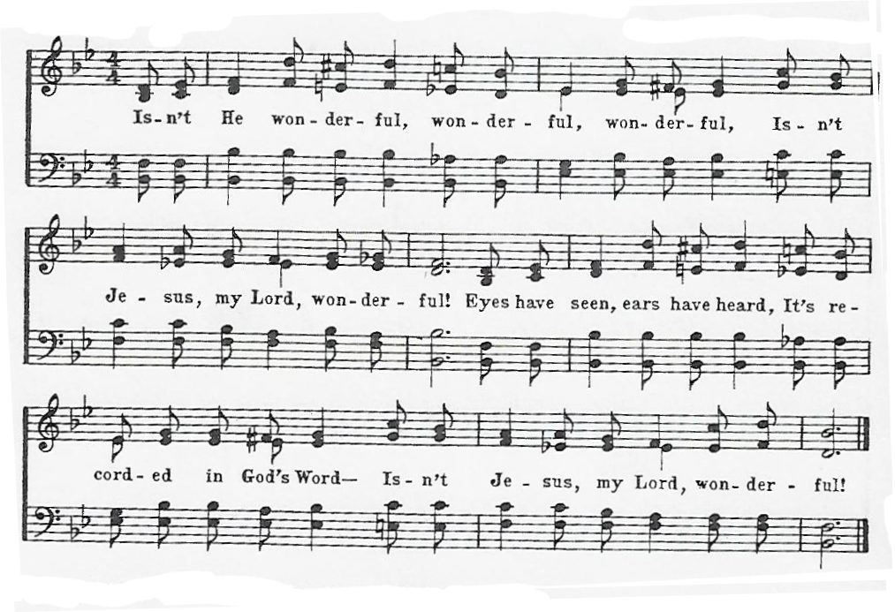
†affirmation of praise
Isn’t He Wonderful!

†creed
The Apostles’ Creed ǀ UMH 881
confession and pardon ǀ UMH 8
†doxology
Praise God, from Whom All Blessings Flow ǀ UMH 95
†prayer of thanksgiving
†closing hymn
This Is My Father’s World ǀ UMH 144

this week at colington
These opportunities to serve as t.he Body of Christ are available.
Tuesday – 9 am – Prayer Group
Wednesday – 6pm – Beach fellowship
Thursday– 7:30am - FCA breakfast at FFMS.
Saturday – 9am - Men’s ministry breakfast meeting.

coming up
Next Sunday – 8:15 – choir practice
9:30 am – Worship, in-person and Facebook Live and Youtube.
Wed., Sept. 23 – 10am – Knitters and crocheters meet.
1:45pm – Volunteers to Beach Food Pantry.
Mon., Sept. 28 – 8:00am – Student of the Month at FFES.

Thanks to today’s volunteers!
Ushers – Steve Knowles/Ozzie Gray/ Wiley Beales
Scripture Reader – Sherry Rollason
The flowers on the altar are given by Maggie Fazenbaker in memory of her Dad’s birthday, Tom Fazenbaker.


To make an electronic donation via Zelle, please use this QR code. You’ll need to provide the last four digits of your phone number.

