All Saints Anglican Church
6904 Lougheed Highway, Agassiz, B.C. V0M 1A0
Bulletin August 31st, 2026 – September 6th, 2026

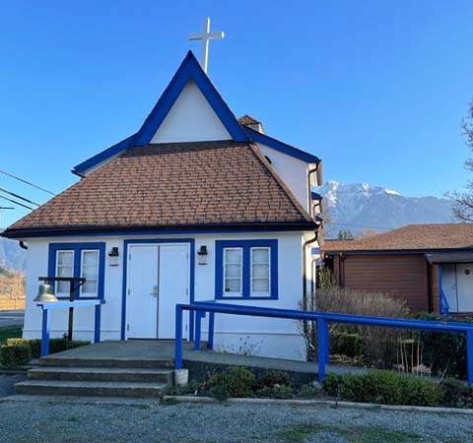

‘The ground we walk does not belong to us; for thousands of years it has been - and remains - the territory of the Stó:lō. We are grateful for their sharing.

Phone: 604-796-3553
Website: www.allsaints-agassiz.ca
https://www.facebook.com/groups/AllSaintsFamily
OUR DOOR IS OPEN AND ALL ARE WELCOME
September 6th, 2026, Fifteenth Sunday After Pentecost
Priest in Charge: The Reverend Philip Barker
Hosts: Graham Featherstone/Jennifer Pinlac
Intercessor: Keith Fossey
Lay Administrator: Dorothy Cresswell
Announcer: Virginia Jennings
Organ/Piano: Francesca Froehlich
Readers: Sheila Barker/Ginny Jennings
Coffee Time: Jennifer/Peggy

Vicar’s cell phone: Revd. Philip Barker. 778-867-2461

Vicar’s Warden: Ginny Jennings. 604-796-2206
People’s Warden: Lynn Laughlin. 604-799-5131
Parish email: revpb1950@gmail.com
Please contact either warden if you have an issue that needs to be brought to the attention of the Vicar - or contact the Vicar direct (see above for details).

All Saint’s Calendar/Announcements:

- Book Club – On August 19th Book Club will be starting "Two Steps Forward" by Sharon Garlough Brown, an experienced leader of spiritual formation retreats in the UK and US. The 4 women from Sensible Shoes are taking their next steps in the spiritual formation journey. But each of them is finding roadblocks along the way.
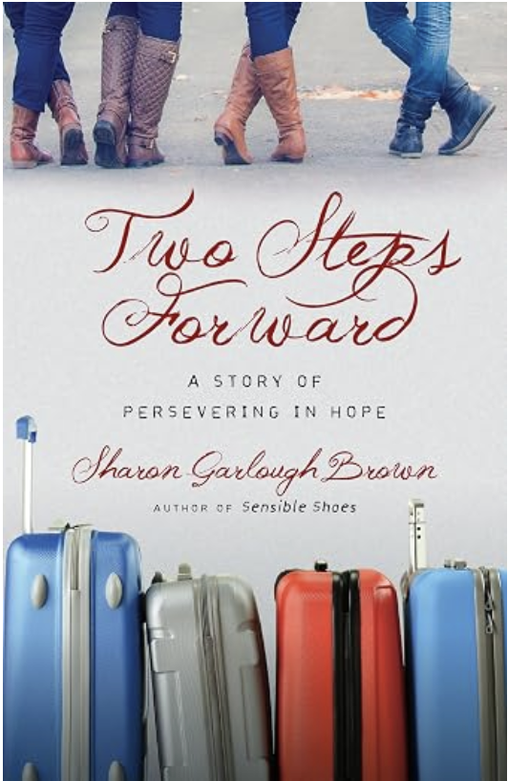

Please contact Sheila Barker at sjbarker0379@gmail.com
if you would like an invitation to the Zoom meetings
at 5.00 pm on Wednesdays or a copy of the book.
The book is available on amazon for $31.43 including tax.

- Bible Study is every Saturday morning 0830-0900 on Zoom. All are welcome to preview and discuss the readings for the Sunday service. Please ask Valerie to add your email address to the invitation list.

- Prayer Requests can be given on a piece of paper to either of the Wardens or the Vicar or entered in the Prayer Request Book on the lectern. Alternatively, you can contact Anthea Lewis at antheamlewis@shaw.ca for Pray First Prayer Circle, which is a confidential online prayer circle.

- Music Requests may be given to the Wardens or the Vicar.

- AA meets in the hall every Tuesday and Friday at noon.

- Every Thursday in the hall 1100-1200 we have a social time with coffee, games if you like or just talk.

- At 1000-1100 on Thursdays there is an Interactive Bible Study on the day’s Lectionary readings. All are welcome – discover the treasures in this amazing book!

- 5th Sunday of each month will be a potluck lunch after the service.

Ministerial Meandering
Medical what?

“Oh - I can’t tell you that - it’s confidential,” said a nurse. I was simply trying to locate a parishioner in the local General Hospital - not asking her how my neighbour’s sex-change operation had gone. Unfortunately, this seems to be the default response to almost any question you ask - of almost any health care worker these days.

I recall a day long past, when I, as a young locum doctor in my teaching hospital, had been given the task of telling the family about the prognosis of the father, who had been admitted to the pulmonary ward with metastatic lung cancer. At that stage of my career, it was not my place to question decisions made by my senior colleagues, so I prepared myself to speak to his daughter and son-in-law, and tell them that dad had only months to live - if that. The patient’s permission had not been sought, as far as I knew, but it was still felt that someone in the family ought to know, so that appropriate preparations might be made. Being so junior in the pecking order, I was not allowed any private space to hold this delicate conversation - even the ward sister would not allow me ten minutes in her office. So I had to meet these two on the landing outside the lifts (elevators).

This was the first time I had been tasked with breaking bad news, and I had no instruction or role model to follow. And of course, I blew it - big style.
I introduced myself (which was a plus, because most doctors these days don’t even bother to do that), and then opened with, “I suppose you realize that your father is dying?” They didn’t. What I hadn’t been told was that they had been given a lie when dad was originally admitted, saying that he had some ‘arthritis’ in his shoulder, and of course, he still had his cough from his ‘bronchitis.’
The truth was that he had advanced lung cancer, and the pain in his shoulder was from bony secondaries. That news almost produced a collapse in the daughter, and certainly produced an instant and vitriolic verbal attack on me from the daughter’s husband. Quite justified, I would say. But I felt like I had been set up. I tried to retrieve the situation by saying, “Let’s start again then. Tell me what you have been told.” At this point they told me the utter rubbish about arthritis and bronchitis.

Obviously, these situations should never happen, and I vowed at that moment never to leave the most junior member of the team to pass bad news to patients or their relatives. In fact, when I became a consultant, I took courses on the topic, and used to specifically train my junior staff in how to perform this most difficult of tasks; usually by direct observation of my example.

However, in this country now, there seems to be a conspiracy of silence. Probably based on ignorance and lack of communication, but silence nonetheless.
As a pastor and retired surgeon, I feel it would not be unreasonable to share at least some medical details of the patient’s condition with me, especially when they have given permission. Even if this is not allowed, I think it unreasonable to even withhold information on the patient’s location or future possible discharge.
On three occasions in the last week this basic information has been denied to me on the basis of ‘confidentiality.’ And despite my wearing a hospital staff badge delineating me as one of the Spiritual Care Team. I did mange to find out that one patient had been transferred from ICU to a certain ward, but when I went to that ward, he was not to be found. Not only did they not tell me if he had been discharged, transferred to another ward - or to a care home - or to the mortuary; they would not even confirm that he had ever been on the ward. How, in heaven’s name, is that confidential? These are not even medical details.

I fear that we have clearly slipped from any vestige of ‘medical-in-confidence’, to ‘medical incompetence.’

Philip+

Something to think about…

"A year from now you may wish you had started today." — Karen Lamb

Birthdays in the September 

Rick Probert – 4 Wendy Young – 10
David Hamilton – 10 Sonya Hill – 17
Allen Cresswell – 19 Fern Northcott – 28

Diocesan Cycle of Prayer: We Pray for the Clergy and Congregation:

The West Point Grey Neighbourhood Ministry; St. John the Baptist, Sardis – The Revd Matt Koovisk

Anglican Church of Canada Cycle of Prayer – We Pray for:

The theological colleges and training programs within the Ecclesiastical Province of Northern Lights: Arthur Turner Training School, the Centre for Christian Studies, the College of Emmanuel and St. Chad, Henry Budd College for Ministry, Saint John’s College, Dr. William Winter School for Ministry, James Settee College for Ministry. For the Season of Creation which continues in the month ahead and a renewed commitment to a healthy relationship with the Earth.

Collect

Stir up, O Lord, the wills of your faithful people, that richly bearing the fruit of good works, we may by you be richly rewarded; through Jesus Christ our Lord,
who is alive and reigns with you and the Holy Spirit, one God, now and for ever.

Exodus 12:1-14 Sheila Barker

¹ The Lord said to Moses and Aaron in Egypt, ² “This month is to be for you the first month, the first month of your year. ³ Tell the whole community of Israel that on the tenth day of this month each man is to take a lamb for his family, one for each household. ⁴ If any household is too small for a whole lamb, they must share one with their nearest neighbor, having taken into account the number of people there are. You are to determine the amount of lamb needed in accordance with what each person will eat. ⁵ The animals you choose must be year-old males without defect, and you may take them from the sheep or the goats. ⁶ Take care of them until the fourteenth day of the month, when all the members of the community of Israel must slaughter them at twilight. ⁷ Then they are to take some of the blood and put it on the sides and tops of the doorframes of the houses where they eat the lambs. ⁸ That same night they are to eat the meat roasted over the fire, along with bitter herbs, and bread made without yeast. ⁹ Do not eat the meat raw or boiled in water, but roast it over a fire—with the head, legs and internal organs. ¹⁰ Do not leave any of it till morning; if some is left till morning, you must burn it. ¹¹ This is how you are to eat it: with your cloak tucked into your belt, your sandals on your feet and your staff in your hand. Eat it in haste; it is the Lord’s Passover.

¹² “On that same night I will pass through Egypt and strike down every firstborn of both people and animals, and I will bring judgment on all the gods of Egypt. I am the Lord. ¹³ The blood will be a sign for you on the houses where you are, and when I see the blood, I will pass over you. No destructive plague will touch you when I strike Egypt.

¹⁴ “This is a day you are to commemorate; for the generations to come you shall celebrate it as a festival to the Lord —a lasting ordinance.

Psalm 149

¹ Praise the Lord.

Sing to the Lord a new song,
his praise in the assembly of his faithful people.

² Let Israel rejoice in their Maker;
let the people of Zion be glad in their King.
³ Let them praise his name with dancing
and make music to him with timbrel and harp.
⁴ For the Lord takes delight in his people;
he crowns the humble with victory.
⁵ Let his faithful people rejoice in this honor
and sing for joy on their beds.

⁶ May the praise of God be in their mouths
and a double-edged sword in their hands,
⁷ to inflict vengeance on the nations
and punishment on the peoples,
⁸ to bind their kings with fetters,
their nobles with shackles of iron,
⁹ to carry out the sentence written against them—
this is the glory of all his faithful people.

Praise the Lord.

Romans 13:8-14 Ginny Jennings

⁸ Let no debt remain outstanding, except the continuing debt to love one another, for whoever loves others has fulfilled the law. ⁹ The commandments, “You shall not commit adultery,” “You shall not murder,” “You shall not steal,” “You shall not covet,” and whatever other command there may be, are summed up in this one command: “Love your neighbor as yourself.” ¹⁰ Love does no harm to a neighbor. Therefore love is the fulfillment of the law.

¹¹ And do this, understanding the present time: The hour has already come for you to wake up from your slumber, because our salvation is nearer now than when we first believed. ¹² The night is nearly over; the day is almost here. So let us put aside the deeds of darkness and put on the armor of light. ¹³ Let us behave decently, as in the daytime, not in carousing and drunkenness, not in sexual immorality and debauchery, not in dissension and jealousy. ¹⁴ Rather, clothe yourselves with the Lord Jesus Christ, and do not think about how to gratify the desires of the flesh.

Matthew 18:15-20 Vicar Philip Barker
¹⁵ “If your brother or sister sins, go and point out their fault, just between the two of you. If they listen to you, you have won them over. ¹⁶ But if they will not listen, take one or two others along, so that ‘every matter may be established by the testimony of two or three witnesses.’ ¹⁷ If they still refuse to listen, tell it to the church; and if they refuse to listen even to the church, treat them as you would a pagan or a tax collector.

¹⁸ “Truly I tell you, whatever you bind on earth will be bound in heaven, and whatever you loose on earth will be loosed in heaven.

¹⁹ “Again, truly I tell you that if two of you on earth agree about anything they ask for, it will be done for them by my Father in heaven. ²⁰ For where two or three gather in my name, there am I with them.”

Odds and Ends

~Save the Date~

Saturday October 3rd

All Saints Anglican Church
Garage Sale


~Save the Date~

Saturday October 24th

All Saints Anglican Church
Fall Craft Sale

