Galatians #23 Pastor Tom Stegall
September 6, 2026 Duluth Bible Church

WHY SHOULD YOU SEPARATE FROM LEGALISM?
(Galatians 4:21-31)

1. REVERSION: Reverting to legalism, either to be justified before God or sanctified, results in spiritual _________________. (4:3, 9-10, 21, 24-25; 5:1)

- What is legalism?

2. ILLUSTRATION: Legalism stands in ________________ with God’s method of ________________ and grace as illustrated by Paul’s allegory of Sarah, Hagar, and their two sons, Isaac and Ishmael. (4:22-28)

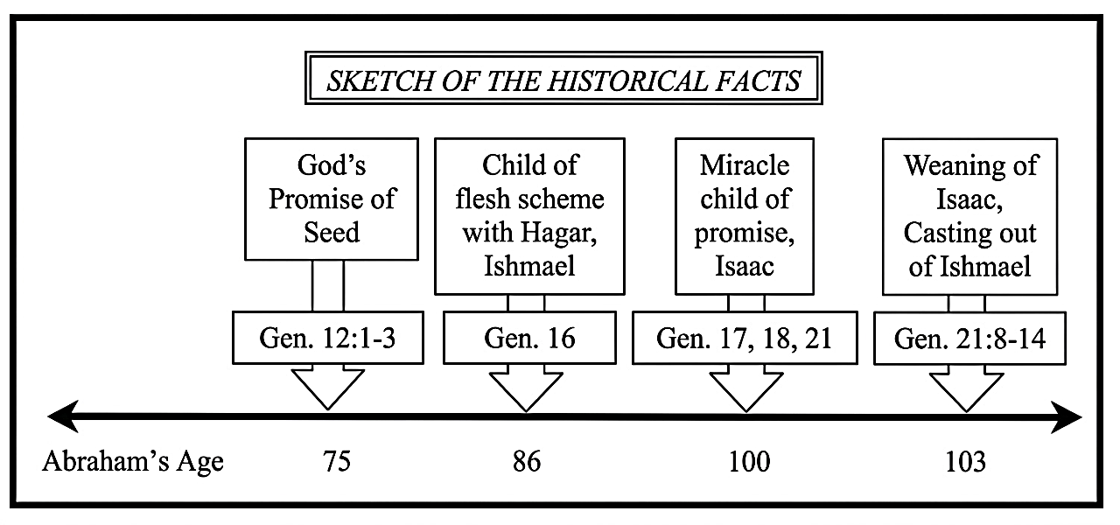

- How is Paul’s creation of an allegory in Galatians 4 different from the allegorical method of Bible interpretation used throughout church history?

2 Mothers (v. 22) | Hagar, who was a ______________ | Sarah, who was _______________
2 Sons  (v. 23) | Ishmael, who had a _____________ birth (of flesh) | Isaac, who had a _______________ ______________ birth (of promise)
2 Covenants  (v. 24) | _____________ Covt. (Mt. Sinai) | _____________ Covt. (of promise)
2 Cities  (vv. 25-26) | __________________ Jerusalem | __________________ Jerusalem
2 Results  (vv. 24, 31) | ______________________ | ___________________

3. PERSECUTION: Religious legalists have a ____________________ to persecute grace-based believers (3:4; 4:29; 5:11; 6:12), which should not ________________ us as believers (1 Peter 4:12-13).

- How was this true with Ishmael and Isaac? (Gen. 21:8-9)

- How was this true with Paul at Galatia? (Acts 13:45, 50-52; 14:1-6, 19)

- How has this been true throughout church history?

4. SEPARATION: God _____________________ us as church-age believers living in the dispensation of grace to separate from legalistic false teaching and teachers. (4:30; 5:12)

- Was the separation of Abraham, Sarah, and Isaac from Hagar and Ishmael merely Sarah’s will or God’s will? (Gen. 21:9-12)

- Is the practice of biblical separation unloving or ungracious?

5. LIBERATION: As believers who are children of God, we have been ______________________ by Jesus Christ and called to ___________________ in Him, so ______________________ for it! (4:31–5:1)

