


www.umcsummit.org

Pastor: Rev. Laura Steele
Director of Music: JoAnne Teubner Prussak
CYF Minister: Janice Powell
Office Manager: Kimberle Gray
Mental Health Minister: Dr. Alison Johnson
Sexton: Fred Herse
Video Ministry: Parker LaJeunesse

September 6th, 2026
Fifteenth Sunday After Pentecost

The United Methodist Church of Summit is a diverse church committed to serving the Lord Jesus Christ,

dedicated to building disciples, passionate about growing in faith,

and motivated to be a voice of hope for the world.

PRELUDE: Voluntary on “Praise to the Lord”

GREETING AND ANNOUNCEMENTS

PREPARATION OF HEARTS AND MINDS FOR WORSHIP

*CALL TO WORSHIP: (please rise as you are able) Janice Powell
Leader: The Spirit of God has gathered us here.
People: We come to worship the One who knows us and loves us.
Leader: In joy and in struggle, in harmony and in disagreement,
People: God remains present among us.
Leader: When we gather in Christ’s name, we do not gather alone.
People: Christ is here, drawing us closer to God and to one another.
Leader: So let us open our hearts, lift our voices, and make a joyful song to the Lord.
People: For God is here among us. Let us worship!

*CENTERING PRAYER: (in unison) Janice Powell

Gracious God, quiet the noise within us and draw our hearts toward you. As we gather in this sacred place, remind us that Christ is here among us in our worship, in our relationships, and even in the places where understanding is difficult. Give us ears to listen, hearts willing to love, and courage to seek one another with grace. Gather us into your presence, and make us one in Christ we pray, Amen.

*OPENING HYMN (please remain standing as you are able)
UMH#158 Come, Christians, Join to Sing

CHILDREN’S MOMENT: Janice Powell, CYF Minister

PRAYERS OF THE PEOPLE: Carol Conway

SCRIPTURE READING: Janice Powell

Old Testament: Psalm 149 (NRSV)

Praise for God’s Goodness to Israel
Praise the Lord! Sing to the Lord a new song, his praise in the assembly of the faithful. Let Israel be glad in its Maker, let the children of Zion rejoice in their King. Let them praise his name with dancing, making melody to him with tambourine and lyre. For the Lord takes pleasure in his people; he adorns the humble with victory. Let the faithful exult in glory; let them sing for joy on their couches. Let the high praises of God be in their throats and two-edged swords in their hands, to execute vengeance on the nations
and punishment on the peoples, to bind their kings with fetters and their nobles with chains of iron, to execute on them the judgment decreed. This is glory for all his faithful ones. Praise the Lord!

New Testament: Matthew 18:15-20 (NRSV)

Reproving Another Who Sins

“If your brother or sister sins against you, go and point out the fault when the two of you are alone. If you are listened to, you have regained that one. But if you are not listened to, take one or two others along with you, so that every word may be confirmed by the evidence of two or three witnesses. If that person refuses to listen to them, tell it to the church, and if the offender refuses to listen even to the church, let such a one be to you as a gentile and a tax collector. Truly I tell you, whatever you bind on earth will be bound in heaven, and whatever you loose on earth will be loosed in heaven. Again, truly I tell you, if two of you agree on earth about anything you ask, it will be done for you by my Father in heaven. For where two or three are gathered in my name, I am there among them.” This is the Word of God for the people of God, People: Thanks be to God.

*HYMN OF PREPARATION: (please rise as you are able)
TFWS#2222 Servant Song

SERMON: Meet Me in the Middle Rev. Laura Steele

OFFERING
(please place offering envelope in basket or text “dollar amount you wish to give” to 908-224-7670)

MUSIC FOR MEDITATION:
Variations on the Hymn: “On Christ the Solid Rock I Stand”
William Teubner, Trumpet

*DOXOLOGY (please rise as you are able)
UMH #95 Praise God from Whom All Blessings Flow

HOLY COMMUNION: UMH p.13 (or see insert)

COMMUNION MUSIC:
We Are a Wilderness Wandering People
Contemporary Ensemble

*CLOSING HYMN: (please rise as you are able)
UMH#733 Marching to Zion

*BENEDICTION: A Labor Day Blessing
Gracious God, we give you thanks for the work of our hands, minds, and hearts. Bless all who labor, all who seek meaningful work, and all whose work goes unseen. Grant rest to the weary, dignity to every worker, and wisdom to use our gifts for the good of others. May all that we do reflect your love and serve your kingdom. Amen.
POSTLUDE: “Majestic Recessional in A Major”
for Trumpet and Organ

* Denotes please rise in body or spirit as you are able

*PLEASE NOTE: All of our services are livestreamed publicly.
If you do not wish to have yourself or your loved ones on camera,
please see Pastor Laura.

This Week’s Schedule

Sunday, September 6th:
9:00am-9:30am Instrumental Rehearsal
10:00am-10:30am Summer Choir
10:30am-11:30am In-person/online Worship
11:30am-12:30pm Coffee Hour
7:30pm-8:30pm Pilgrim Group (Fellowship Room)

Monday, September 7th:
7:45pm-9:30pm Gamblers Anonymous (Chapel, Social Hall)

Tuesday, September 8th:
7:30pm-8:30pm Pilgrim Group (Fellowship Room)

Friday, September 11th:
7:30pm-8:30pm Pilgrim Group (Fellowship Room)
1PM-7PM Sanctuary Open for 9/11 Prayers

Saturday, September 12th:
7:00AM – 1PM Miss Debbie Open House (Social Hall)
2:00PM – 5PM The Sunday School Remix (Social Hall)
2:00pm-3:00pm Instrumental Rehearsal
2:00pm-10:00pm Casa de Estudio de Torah (Fellowship Room

In Our Thoughts and Prayers
Mike Stewart as he mourns the loss of his brother Ron, Joe Kunyz, Al Lord Sr., Gary Friez, Patricia, The LaJeunesse family, Brian Johnson, Chuck Farnham; the Rodriguez Family who lost their home and possessions in a fire; the family of Kathleen Whipps; Laurie Kelly; Roydon Moreau; the family and fans of Kyle Busch; the family of Beverly Alexis; the family of David Quackenbush; the family of Millie Eichhorn; Susan Reitmeyer (UMC Absecon) and family; the uncle of Steven Brown; the family and friends of John L. Troianello,; pray for me to feel home ♥;Shela Waldron; the friends and family of Mateo Kaufman Sandler; Vincenzo Lamanginne’s mother Angela and brother Mike, rest their souls.

ANNOUNCEMENTS

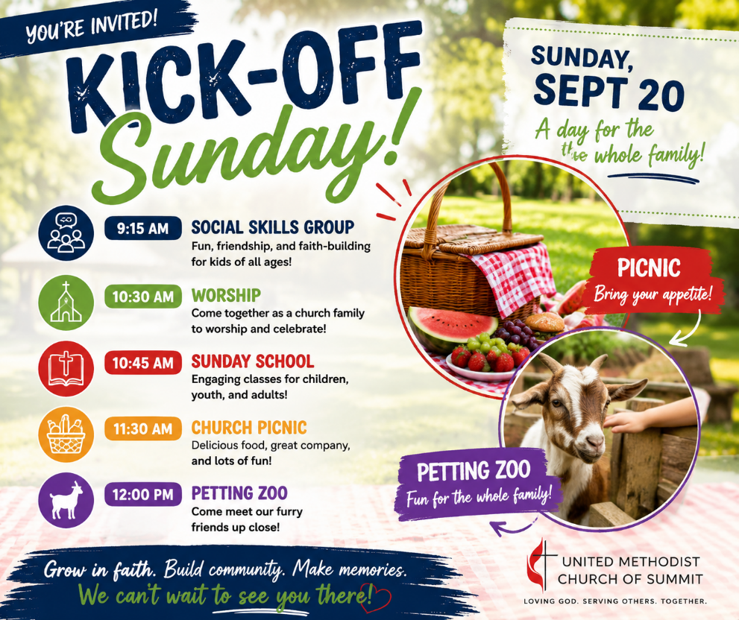

Fall Kick-Off Sunday – September 20!
Join us as we launch an exciting new year of worship, and fellowship at the United Methodist Church of Summit!
9:15 AM – Social Skills Class
9:30 AM – Chancel Choir
10:30 AM – Worship Service
10:45 AM – Sunday School Kick-Off (Children begin in worship before being dismissed to their classes.)
11:30 AM – Church Picnic
12:00 PM – Petting Zoo
There's something for everyone! Invite your family, friends, and neighbors as we celebrate the start of a wonderful new season together.


The Sunday School Remix:
Laugh, Learn & Launch!
Saturday, Sept. 12th
2:00-5:00PM
Join us for an exciting evening of food, fun, laughter, and a preview of our brand-new Sunday School experience! Enjoy refreshments, a clean comedy show, music, classroom tours, and the opportunity to register your children for the upcoming year. Invite friends and neighbors—this is a great night for families to discover all that's happening in our children's and youth ministries!

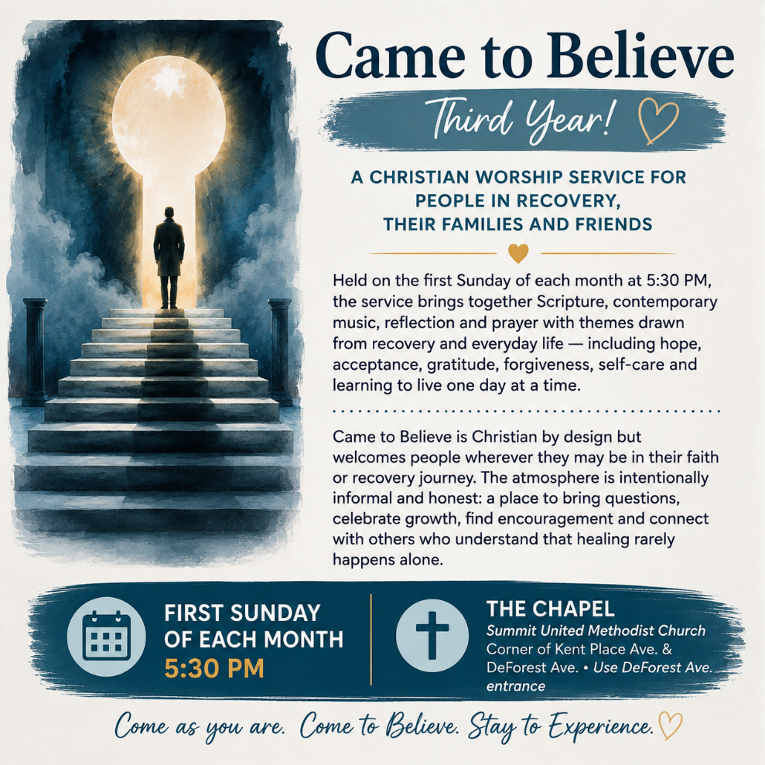

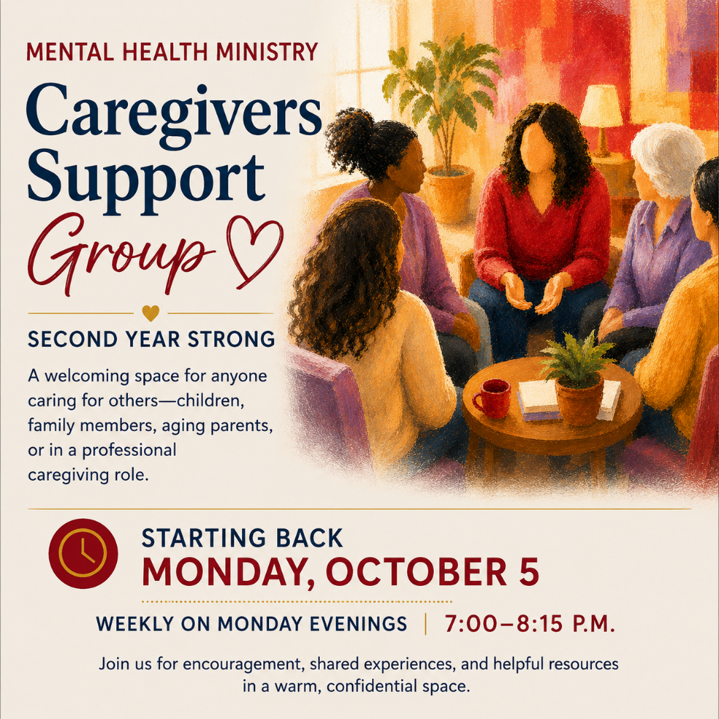


Please note there will be no YogaFaith classes this week as we observe the 25th anniversary of 9/11. Classes will be switching to Monday nights in mid-September. Stay tuned for more information.



Come and share in the wonder of making a Joyful Sound!

Let's share the excitement of beginning our Fall Season. Our Kick-Off Sunday will be September 20th. In preparation, our Chancel Choir will begin rehearsals on Sunday, September 13th at 9:30 a.m., and sing the service music at worship. Our first Saturday rehearsal will be on September 19th at 12:00 noon. The schedule of rehearsals will continue, Saturdays at 12:00 and Sundays at 9:30 a.m.

Our Contemporary Ensemble will begin rehearsals on Saturday, September 19th at 1:00 p.m., as we prepare for World Communion Sunday, October 4th.

Our Bell Choir rehearsals will resume on Saturday, September 26th at 1:30 p.m., and Sunday, September 27th at 10:00 a.m., ringing praises.

Our Singing Believers Family Choir will have our rehearsals following worship at 11:45 a.m., beginning on September 27th as we praise "We Are The Church".

Please notate our starting dates as we prepare for an amazing Fall and Christmas Season. Our Christmas Concert is scheduled for Sunday, December 13th at 3:00 p.m.

“Serve the Lord with gladness,
come into his presence with singing.”

Make a joyful sound and share your gift of music!

With much love,

JoAnne Teubner Prussak, Director of Music



DEAR CHURCH: Ancient Letters, Timely Truth
This fall, join us for a new worship series, Dear Church, as we journey through Paul’s letters to the early Christian communities. Paul wrote to real churches facing real challenges: conflict, change, disagreement, uncertainty, questions of faith, and the struggle to live together as the Body of Christ. Thousands of years later, his words still have something to say to us.
Each Sunday, we’ll open a different letter and ask: What was Paul saying to the Church then, and what might God be saying to the Church today?
DEAR CHURCH
A Fall Worship Series
Beginning September 13
Worship at 10:30 AM
Come discover what these ancient letters can teach us about faith, community, unity, grace, and being the Church together in a very uncertain world.

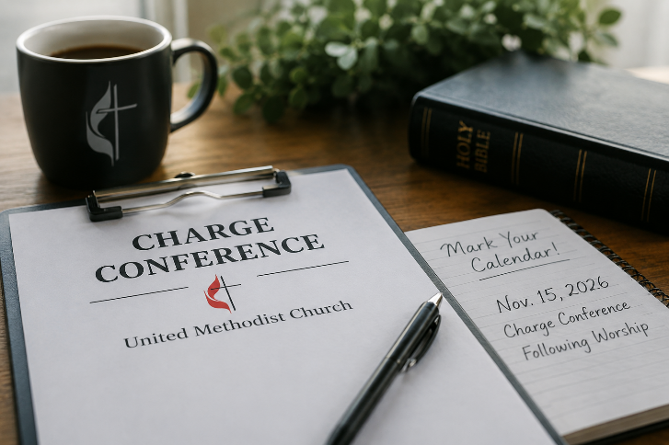

Annual Charge Conference – Save the Date!!
Sunday November 15th, 2026 – 11:30AM
Our annual Charge Conference will be held on Sunday, November 15, 2026, immediately following worship in the Fellowship Room.
The Rev. Sam Park will join us that morning to preach during worship and will represent District Superintendent Rev. Williams at our Charge Conference.
Church leaders, please note: All required Charge Conference paperwork must be completed and submitted no later than September 30, 2026. Please begin preparing your reports and necessary forms and be sure to mark these important dates on your calendar.
📅 Paperwork Due: September 30
📅 Charge Conference: Sunday, November 15, following worship
📍 Fellowship Room
Thank you to all of our church leaders for your preparation and faithful service to the ministries of UMC of Summit!


September 11th Community Remembrance
As our community marks the 25th anniversary of September 11, 2001, we invite you to join the City of Summit in remembering the lives lost and honoring the courage, service, and sacrifice of so many. The City of Summit will host a memorial observance for the 25th anniversary of the 9/11 terrorist attacks on Friday, September 11, 2026, at 9:45 AM at the new Firehouse: 281 Broad Street, Summit, NJ.
On Friday, September 11, our sanctuary will be open from 1:00–7:00 PM for anyone who would like a quiet place for prayer, reflection, remembrance, and peace. All are welcome to come and go as they wish.
May we remember those we lost, hold their families in prayer, honor those who served, and continue to be people who seek peace.

