City Road United Methodist Church
A Lighthouse Congregation

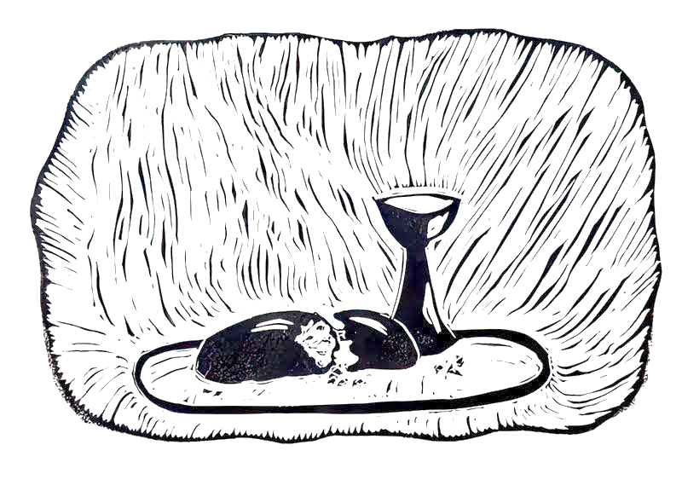
Rev. Tim Nicholson, Pastor

Office: (252) 335-2658
cityroadec.net crumcec@gmail.com

Facebook: https://www.facebook.com/CityRoadUMC

Sunday School: 10:00 a.m.
Sanctuary Worship: 11:00 a.m.

Tommy Venters- Organist/Choir Director
Dawn Baker- Secretary/Technology Specialist
Jo Ann Herring- We Care

Service of Word & Table
15th Sunday After Pentecost
September 6th, 2026 11:00 am
Gathering
Prelude
*Introit: “Rejoice, the Lord Is King” UMH 715
Words of Welcome
*Call to Worship
Family of God, we live in a world full of conflict and division.
God calls us to be a people of reconciliation.
We live in a world full of misinformation and confusion.
God calls us to be a people of truth and clarity.
We live in a world that wants to settle disputes with harmful words and actions.
God calls us to be a people who make peace through compassion and honesty.
We live in a world that does not understand the ways of Jesus.
Yet Jesus teaches us to be a people of reconciliation and peace for the good of the whole world. Thanks be to God! Amen.
Written by Dr. Lisa Hancock, Discipleship Ministries, May 2026.

*Opening Hymn “Lead Me, Lord” UMH 473

Pastoral Prayer

Proclamation & Response
Psalter Reading Psalm 149
Children’s Time
Call to the Offering
Offertory
*Doxology UMH 95
*Prayer of Dedication

Anthem Chancel Choir

Gospel Reading Matthew 18:15-20
Message “Conflict” Pastor Tim Nicholson

Invitation to Christ’s Table UMH 7
Prayer of Confession UMH 8
In the name of Jesus Christ, you are forgiven.
In the name of Jesus Christ, you are forgiven.
Glory to God, Amen!

Sharing Peace

Holy Communion

Prayer of Great Thanksgiving UMH 9
The Lord’s Prayer
*Receiving the Bread and Cup

Prayer After Communion UMH 7
Eternal God, we give you thanks for this holy mystery
In which you have given yourself to us.
Grant that we might go into the world
in the strength of your Spirit,
to give ourselves for others,
in the name of Jesus Christ our Lord.
Amen.

Sending Fourth
*Sending Hymn “Sent Forth by God’s Blessing” UMH 664
Verse 1
*Benediction
*Postlude

Cara B. Hochhalter, Communion/Eucharist. http://diglib.library.vanderbilt.edu/act-imagelink.pl?RC=57515
CCLI License # 11639232

