Announcements

Tuesday, September 8
Outreach meeting Zoom 3:30p.m.

Wednesday, September 9
Choir practice Banquet hall 7:00p.m.

Thursday, September 10
Thursday night group Banquet hall 7:00p.m.

Saturday, September 12
Repair café practice run Banquet hall 10:00a.m.

Sunday, September 13
Rally Sunday banquet hall after service

Choir start up dates
Beaver Valley Concert Band:
Every Monday 5:30 - 8:00 (Start up Sept. 14)

Bay Wind Flutes Ensemble: Alternate Wednesdays:
5:00 - 6:30. (Start up date to be announced)

Adult Choir: Every Wednesday 7:00- 8:40
Start up Date Wed. Sept. 9

Junior Choir: Alternate Wednesdays (to be announced)
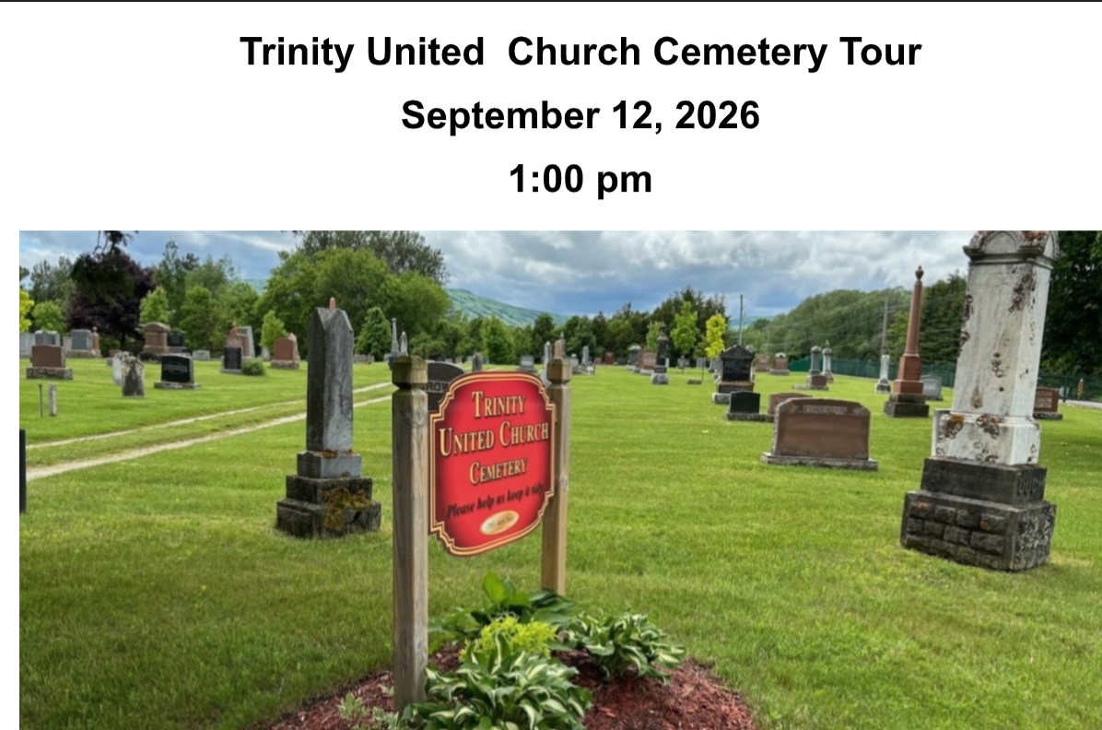
Join us for a thoughtful and informative afternoon as the Trinity United Church Cemetery Board invites you to explore the rich history resting beneath our grounds.

Ralph Sneyd, our resident historian, will guide you through stories of Collingwood’s past, highlighting the lives and legacies of some of our town’s most notable citizens.

Larry Hogarth will also be present to answer questions about burial plots, urns, the columbarium, and other end-of-life arrangements.
Whether you’re curious about local history or planning for the future, this tour offers a meaningful way to connect with our community’s heritage.

Note:
You may wish to bring a folding chair to be comfortable at the history sites.

Adult Book Study
Valley of the Birdtail an Indian reserve, a white town and the road to reconciliation.
Mondays from 10:00 – 11:30 September 14, 21, 28 and October 5
Through the tale of two towns ( Rossburn and Waywayseecapo) learn more about racism, the Indian Act, Residential Schools, and the way forward.
Contact Beth about getting a copy from the library book club kit and which chapters we are discussing each week.

Prayer Shawl ministry
Will meet on Monday September 14 and Monday September 28 @ 1:30p.m. in the board room

Affirming Ministry committee
Are you interested in the opportunity to:
· support our congregation in faithfully living out its Affirming Ministry commitment
· ensure that everyone can feel they belong and where all people are valued?
Looking forward to hearing from you!

Rev. Beth Kerr (she/her)
Diaconal Minister
Trinity United Church
140 Maple Street,
Collingwood, ON L9Y 2P8
www.collingwoodunitedchurch.ca
705-445-3901 (church)
204-872-2370 (cell)
Please note: Friday and Saturday are my sabbath days. I will reply to emails received on those days on the following Monday. For emergencies, please contact my cell phone.

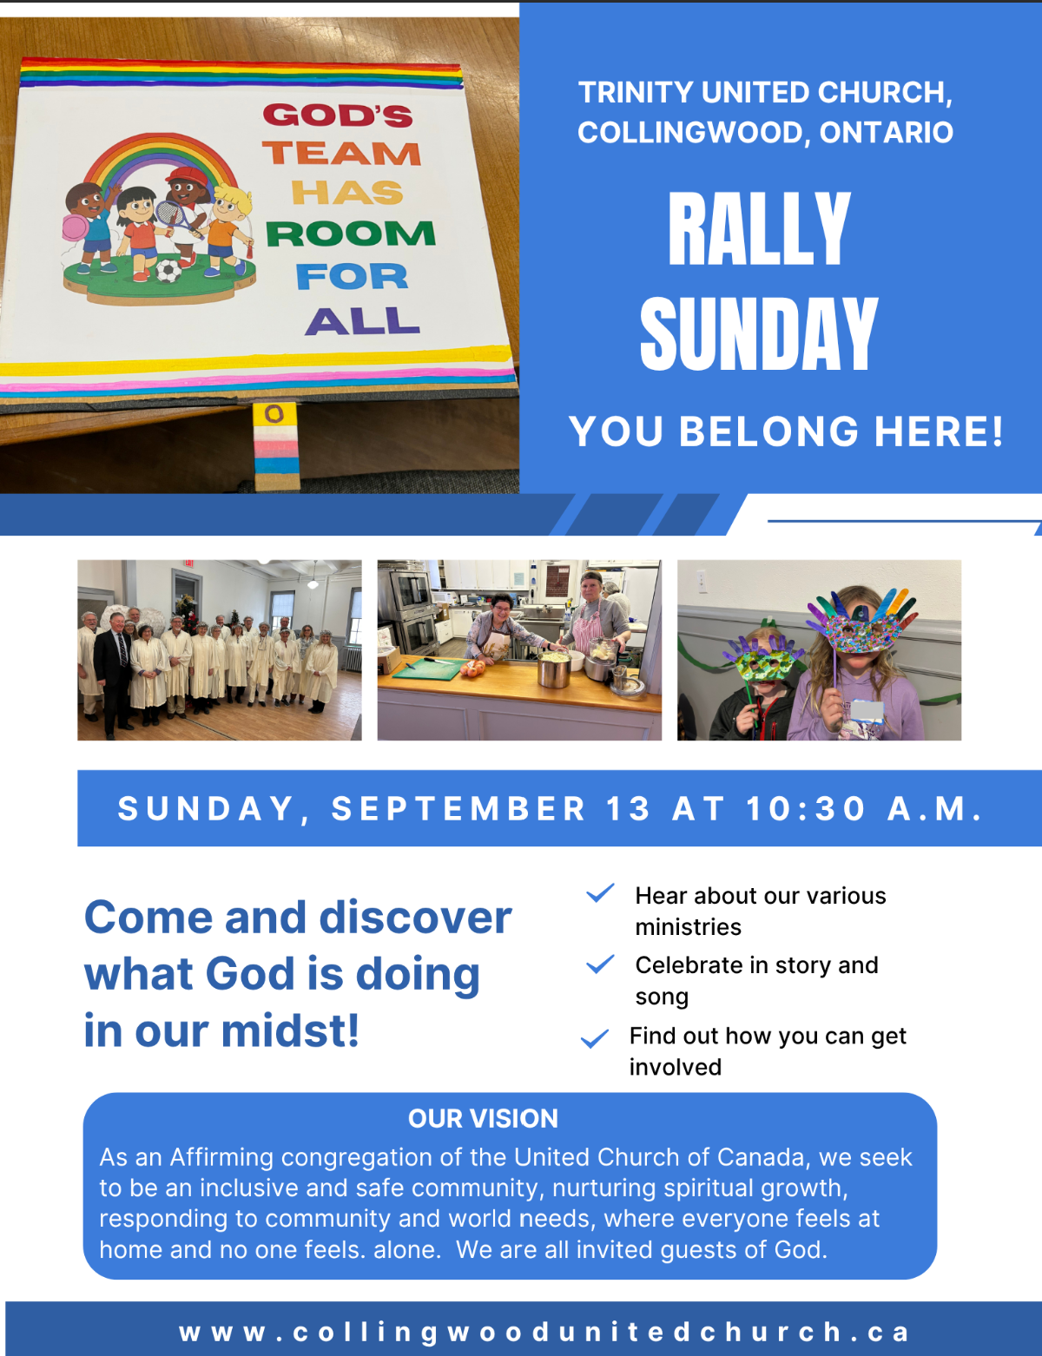
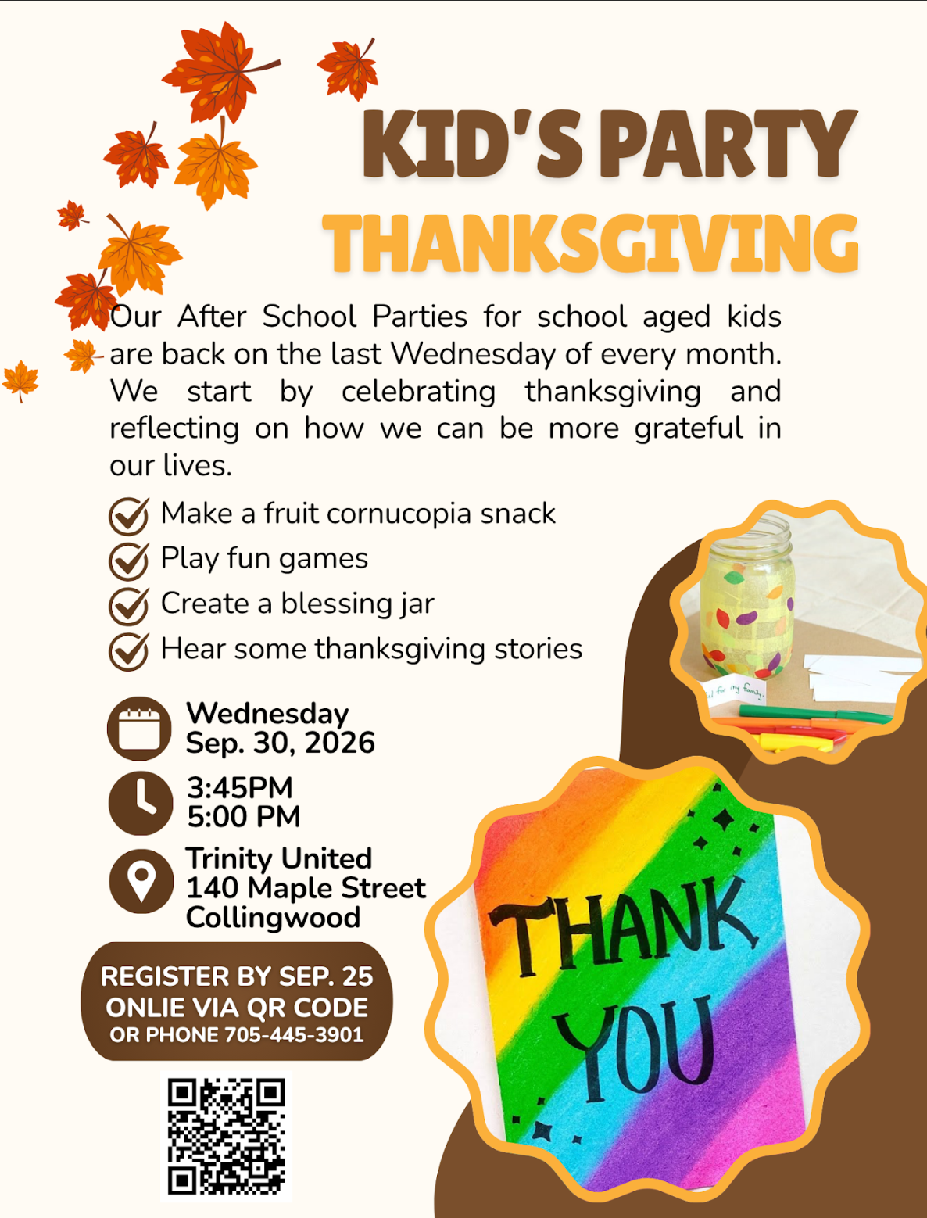

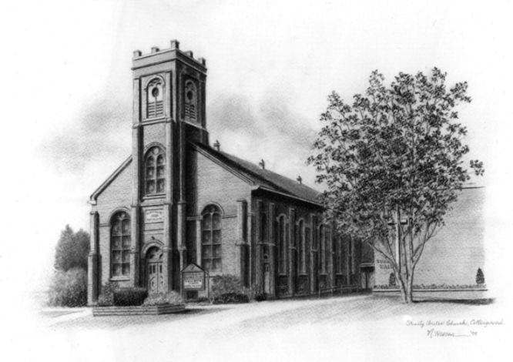

Trinity United .Church: Collingwood
Minister: Rev. Beth Kerr, 204.872.2370 (cell)
Minister’s Email minister@collingwoodunitedchurch.ca
Ministry of Music: Paul Sloan, 705.730.3121 (cell)
Choir Director: Lesley Joosten, 705.984.3243
Handbell Director: Maryellen Burgess, 705.443.1422 (cell)
UCW President: Joy Barr 705.445.0726
Office Assistant: Lori Forsythe
Church Office: office@collingwoodunitedchurch.ca
Office Hours: Tuesday to Friday, 8:30 am-12:00 pm
140 Maple Street, Collingwood, ON L9Y 2P8
Telephone: 705.445.3901
Website: www.collingwoodunitedchurch.ca

