EAST FAIRFIELD UNITED METHODIST CHURCH
Pastor: Kristen Buchs
Organist: Ruth Rowley Ministers: The Congregation
Pianist: Nancy Setinsek Choir Director: Randy Hart
Sunday, September 6, 2026
Fifteenth Sunday after Pentecost

*Please stand in body or spirit as you are able

Welcome! We invite you to take this time to prepare for worship. In these
moments, quiet your inner voice, become aware of being in community with
others, and open your heart and mind to the leading of the Holy Spirit.

GATHERING “The Faithful Word” - Hughes
“Stand Up, Stand Up for Jesus” - Webb

CHRIST LIGHT ENTERS

MISSIONS AND MINISTRY UPDATES Cindy Wright, Liturgist

PREPARING OUR HEARTS AND MINDS FOR WORSHIP

WORDS OF PREPARATION AND CENTERING

PRELUDE “That Will Be Glory” - Gabriel

*CALL TO WORSHIP
L: What do you bring before the Lord this day?
P: We bring our hopes and our dreams to the Lord.
L: What do you seek?
P: We seek peace for our weary souls.
L: You will find it in this place, for this is the house of the Lord.
P: Open our hearts and our spirits, O Lord, to hear Your words
of comfort and peace.

(Call to Worship #2, Ministry Matters-Worship Connection, Nov.7, 2021, by Nancy C. Townley)

*OPENING PRAYER
Lord, we have come to You this day bringing all that we have,
our lives, our hopes and dreams, our fears and sorrows. We
place these before You in faith and hope, knowing that no matter
what has happened You are with us and blessing us.

Open our hearts to receive Your words and Your spirit, that we
may find healing and comfort. Open our lives to the wondrous
possibilities for service and joy that You offer to us. Ease our
minds and spirits that we may hear Your words of encouragement
and peace this day. AMEN.

*OPENING HYMN “Only Trust Him” UMH #337

READING FROM THE PSALMS Psalm 149 (NIV) Page 510

CHILDREN’S MOMENT

OFFERING OURSELVES & OUR GIFTS
INVITATION
OFFERTORY “The Name of Jesus” - Lorenz
*DOXOLOGY UMH #95
*DEDICATION OF GIFTS

SEEKING GOD’S WORD

OLD TESTAMENT READING Exodus 12:1-14 (NIV) Page 53

SHARING OF JOYS & CONCERNS
SILENT PRAYER
PASTORAL PRAYER
THE LORD’S PRAYER

*HYMN “I Surrender All” UMH #354

SERMON TEXT Luke 12:32-34 and Mark 12:41-44 (NIV)

SERMON “Living Our Faith the 4-H Way: Pastor Kristen
I Pledge My Heart to Greater Loyalty”
Prayer of Dedication

RESPONDING TO GOD’S WORD

SACRAMENT OF HOLY COMMUNION UMH pg 12

COMMUNION PRAYER
Eternal God, we give you thanks for this holy mystery in which you
have given yourself to us. Grant that we may go into the world in
the strength of your Spirit, to give ourselves for others, in the
name of Jesus Christ our Lord. Amen.

*CLOSING HYMN “Take My Life, and Let It Be” UMH #399

SENDING FORTH WITH BLESSING
*BLESSING
LIGHT OF CHRIST GOES INTO THE WORLD
~ Go with joy to serve the Lord ~

As we conclude our service, please join us downstairs for a time to relax, continue conversations, and enjoy coffee and refreshments.

Sound: Bill Rowley
Computer: Vicki Freeman
Livestream: Hannah Roberts

Next Sunday, Sept. 13: Grant Roberts, Liturgist
Please keep in mind that the service is live-streamed and
recorded for public access. Please keep prayer requests
brief and do not use last names or identifying details.

PRAYER REQUESTS SEPTEMBER 6, 2026
To submit a prayer request call Denise at 330-457-2465 or 330-727-9832
If you desire a home or hospital visit call Pastor Kristen (216-559-9893)
Prayer Blankets: call Joyce Ward (330-692-3346)

Amy (Jim & JoAnne’s daughter) – surgery
Claudia (Amy’s mother-in-law) fell and broke eight ribs.
Deb B – was injured in an accident. Pray for healing.
Jay C – fell and is now in rehab.
Pastor Kristen – minor surgery Sept. 9. Back in the office Sept. 14.

Walt DeRhodes. – Passed away on Friday, August 21. Pray for family.
Matt S. – heart ablation August 31.
Holly (teacher at Southern) – colon cancer.
Amy W (Elaine) – cancer
Cy (Shawn’s son) - at Akron General with stomach issues.
Jerry M – knee surgery on August 24 went well.
Bob D - was hospitalized but is now back at Whispering Pines.
Joe S. (Charlie’s son) – in need of prayers.
Jon E – has been dealing with cancer. Now under hospice care.
Dorothy F – hospice care.
Marcia M – health issues. Continued prayers.
Blake (Elaine’s grandson) – has some improvement in his hearing.

HOMEBOUND
Dolly K. Anita M. Bob D (Whispering Pines)
Tom & Marie Linda S. Zelda C. (Whispering Pines)
Dorothy F. Esther C. Bill H. (Christian House)

IN MINISTRY
Kristen Buchs Edie Boles Jeff Pellin

Church: 330-457-2465 Pastor Kristen: 216-559-9893
Ch Email:efumc@comcast.net Email: pastorkristen0712@gmail.com
Web: www.eastfairfieldumc.com
CCLI # 1994841 CVLI #504 011 134

East Fairfield
United Methodist Church

September 6, 2026
9:30 AM

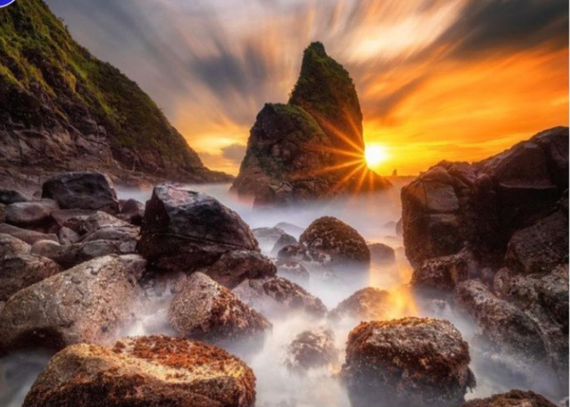

Pastor Kristen Buchs
216-559-9893
45675 State Route 558
New Waterford, OH 44445

“Working, playing, and praying together on our
faith journey, to share Jesus Christ with everyone.”

Sun | Mon | Tue | Wed | Thu | Fri | Sat
Sept 6  Communion  9:30 Worship  10:30 Coffee  10:45 Sunday  School | Sept 7  Labor Day (Office Closed) | Sept 8  8:00 Men’s  Coffee  - Ladies’ Day  at Dale Wilhelm’s cabin | Sept 9  7:00 Scripture & Suds at  VINEYARDS  Pine Lake | Sept 10 | Sept 11  Pastor’s Day Off  Office Closed  Pastor Kristen is on leave Sept. 8 through Sept. 14 | Sept 12  Fellowship  Hall in Use  (Marriner)
Sept 13  9:30 Worship  10:30 Coffee  10:45 Sunday  School  11:00 Mt. Zion First Responder Sunday followed by a  covered dish  lunch | Sept 14  1:30-4:00  Prayer  Blankets  6:00 Cub  Scout  Meeting  4:00-6:00  Quilting at  Elkton UMC | Sept 15  8:00 Men’s  Coffee | Sept 16  6:00 Worship Committee | Sept 17  7:00 Faith United Consult with DS Bill Liming at Lisbon UMC | Sept 18  Pastor’s Day Off  Office Closed | Sept 19  2:00  Creamed Chicken Drive Thru Dinner at Emmanuel  UMC
Sept 20  9:30 Worship  10:30 Coffee  10:45 Sunday  School  6:30 Faith United Leadership Board | Sept 21  1:30-4:00  Prayer  Blankets  6:00 Cub  Scout  Meeting  7:00  Leadership  Board | Sept 22  8:00 Men’s  Coffee  newseltter  deadline | Sept 23  6:00 Choir  Picnic  7:00 Choir  Practice | Sept 24  9:00  Mailing  committee  7:00  Scripture  & Suds – Sundog Cider at  Firestone  Farms | Sept 25 | Sept 26  8:30-10:00  Caring for God’s Lambs at  Trinity
Sept. 27  9:30 Worship  10:30 Coffee  10:45 Sunday  School  5:00 Potluck Fellowship at Emmanuel UM | Sept. 28  12:00  Joy Circle  Lunch  1:30-4:00  Prayer  Blankets  6:00 Cub  Scouts | Sept. 29  8:00 Men’s  Coffee | Sept. 30  7:00 Choir  Practice

Choir Picnic & Practice ~ Wednesday, Sept. 23
6:00 Choir Picnic
7:00 Choir Practice

We welcome new members.
Bring a covered dish, your table service, and a beverage.

Pastoral Leave
Pastor Kristen will be on leave Sept. 8 through Sept. 14.
In case of pastoral needs, call Pastor Jeff (330) 953-8797.



4C’s Item
Pancake Mix and Syrup

Update on Mission Giving for 2026
FUND | NAME OF FUND | NEED | RECEIVED | STILL NEED
2 | General Mission Fund | 5,099 | 6,142 | 0
33 | 4C’s | 125 | 1,175 | 0
32 | Cub Scouts | 150 | 605 | 0
37 | Way Station | 150 | 160 | 0
22 | Flat Rock | 175 | 265 | 0
64 | Farmer to Farmer – Liberia | 300 | 360 | 0
13 | UMCOR Sunday | Any  Donation | 75
21 | UMCOR – U.S. Disasters | Any  Donation | 20
14 | Blanket Sunday | Any  Donation | 65
15 | Peace With Justice | Any  Donation | 0
16 | World Communion | Any  Donation | 20
17 | Student Day | Any  Donation | 45
46 | Heroes & Halos | Any  Donation | 100
63 | InStep Program | Any  Donation | 35
38 | Operation Christmas Child Shoeboxes |  | 118 plus 90

Fund Balances as of end of JULY
Fund # 1 Ministry Operating -12,447
Fund # 2 Mission Fund 3,021
Fund # 3 Building Fund 36,885
Fund # 28 Elevator Fund 7,633

Last Week’s Attendance (August 30)
In-Person: 66 Online: 24

