
The Beacon
a monthly newsletter publication of Burton Memorial UMC
April 2026

Brothers and Sisters,

May God’s grace give us the necessary joy, peace, and patience to love our neighbors.

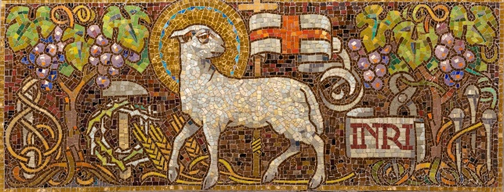

All Christians believe that the life, death, and resurrection of Jesus saves us from our sins and reconciles us to God. However, there are many explanations as to how the life, death, and resurrection of Jesus does this. We call these explanations ‘theories of atonement’. Two months ago (February), I provided a chart briefly explaining the five theories. Last month (March), I explained the Ransom theory. This month (April), I explain the Chrit as Victor theory. Then, in May, I will explain the Satisfaction/penal substitution theory. In June, I will explain the Recapitulation/Divinization theory. Finally, in July, I’ll describe the Moral example/Scapegoat theory.

So, the Christ as Victor Theory of Atonement.

During sermons, I often say, “Jesus willingly experienced death so He could defeat death on our behalf” This is a reference to the ‘Christ as Victor’ theory of atonement. According to it, the resurrection provides two cosmic size victories.

The first victory that the resurrection provides is the triumph of the Kingdom of God over the worldly kingdom of sinful corruption. The Kingdom of God triumphs, not with might, power, and oppression, but with sacrificial love. Jesus went to the cross out of love for us. When Jesus died on the cross, the Roman Emperor, religious leaders, Satan, and all the forces of evil thought they defeated God and God’s kingdom. But, when Jesus rose from the dead, he showed that no one could defeat him or his kingdom! Let’s remember this the next time we face a crisis or feel the weight of oppression. We may sometimes lose a battle, but we’ll never lose the war!!

The second victory provided by the resurrection is the defeat of death and this guarantees our eternal life. To understand this, we must first realize that we are all sinners. Every one of us has thought, said, or done something that is unloving. Sin separates us from God, who is the originator & sustainer of life. Therefore, the consequence of sin is death. The Lord, however, still loves us. It’s God’s nature to love us. First John, chapter 4 states that God literally is love. Our loving God does not want to see any of us get what we deserve – death. So, God offers us forgiveness and destroys death. Jesus, as fully God and fully human, allowed the religious leaders and Roman authorities to murder him so he could face death and defeat death on our behalf. With death defeated, we can receive God’s forgiveness and enjoy an eternal and loving relationship with God.

To take advantage of Jesus’ victories over the worldly kingdom of sinful corruption and death, we must receive God’s forgiveness with repentance. Once we receive God’s forgiveness, we begin an eternal, loving relationship with God. Repentance is the Holy Spirit empowered desire to change. We open our hearts to God’s grace so that God’s grace can change the attitudes and motivations deep within our hearts. In this way, we become more like Christ and God uses us to spread God’s love and proclaim God’s kingdom.

The following Bible passages emphasize “Christ as Victor”. Take the time to slowly meditate on these passages: 1 Corinthians 15:1-58, Hebrews 2:9 &14-15, Romans 6:9, and 1 John 5:4.

Remember, there is no ‘correct’ theory of atonement. Thay all have their strengths and weaknesses. Just trust the mystery and know that the grace we receive through faith in Jesus saves us from sin. As we contemplate each theory, may the Holy Spirit bring us into a deeper appreciation of what Christ has done for us.

In Christ Jesus,

David L. Charlton
Pastor

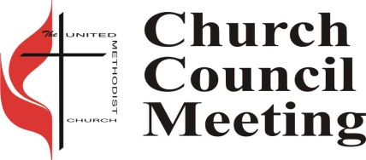
Church Council
Next church council meeting is Tuesday, April 7 , 2026 at 5:30 PM.

Easter Potluck Luncheon
 Burton will be having Potluck on Sunday, April 5 at 11:30 am in the Fellowship Hall, following the 10:00 am service. Bring your favorite dish or dessert to share. If you do not cook, just bring yourselves. There is always more than enough food.


Ringing News
We are always looking for new ringers. If you are interested in joining our handbell choir, please see any ringer for more information.

United Methodist Men
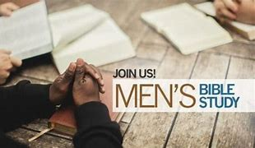
The next meeting of the United Methodist Men will be April 28, 2026 at 6:00 pm. If you have any questions, please contact me a at 443-623-8554 or email me at famrem5@aol.com. – John Remmell

Green Team Book Review Jack Grove, Green Team
Climate Church, Climate World: How People of Faith Must Work for Change Paperback – March 23, 2023 by Jim Antal (Author), Bill McKibben (Foreword)

Rev. Jim Antal contends that climate change is the greatest moral challenge humanity has ever faced. Hunger, refugees, poverty, inequality, deadly viruses and war. Climate change multiplies all forms of global social injustice. Environmental advocate The author calls on the church to meet this moral challenge, to embrace a new vocation so that future generations might live in harmony with God’s creation. Antal proposes how people of faith can embrace new approaches to worship, preaching, witnessing, and other spiritual practices that honor creation and cultivate hope. This revised and updated edition includes a new chapter on government policy shifts, and the current science of climate change. Published by Rowman & Littlefield Publishers, 2023.

God’s Kitchen/Food Pantry

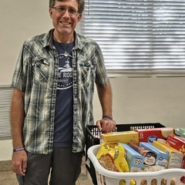
Burton is still in need of help with our Food Pantry Ministry. We can use extra hands in the pantry to help with deliveries on Wednesday and Thursday mornings, and to serve our guests Wednesdays from 9 am to 12 pm and Thursday evenings from 5 pm to 7 pm. Please call the office at 305-852-2581 for info or to volunteer.

We are still looking for groups or individuals to help with our God’s Kitchen Free Dinner on Thursdays, helping to cook, serve and clean up. If you can help, please call or text Mary Lou Wilkinson at 305-394-3878, or call the office, 305-852-2581.

Child Development Center (CDC)

Our CDC children doing the preparation of St Patrick’s day and celebrating by attending the parade!
Two-year-old preparing their hats!
One-year-old all smiles and ready get set go to the parade!
Three-year-old wearing their hand made hats!
Four-year-old crating their hand printed clover leaf
Boys are boys with their mustache and glasses!
Waiting for the parade!

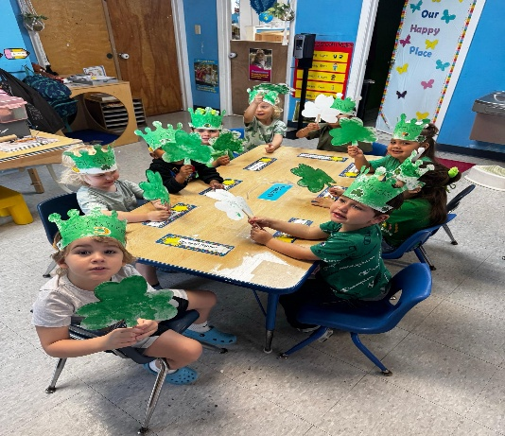

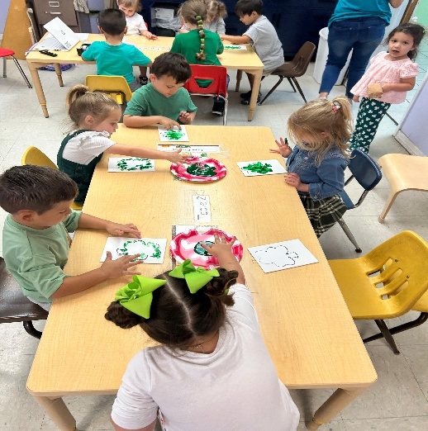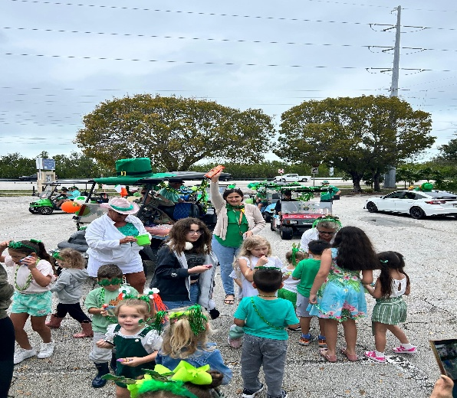



Prayer Shawl Ministry
"Prayer shawls are made for all occasions, happy times as well as sickness and distress. Join us Thursday 6:30 PM in the Joy classroom. We have supplies and we teach. A great time for fellowship. For information call Virginia Spear 305 522 2978

Tai Chi Open House Weekly Classes
Strength, Flexibility, and Stillness all in one exercise class? At Burton? Yes, once a week!

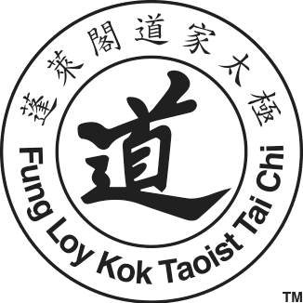
We are blessed that Tai Chi is being offered here at Burton in the Fellowship Hall Monday nights from 6:30 pm to 8:00 pm, for all levels of ability. All teachers are volunteers and class costs are by donations to cover the costs of the class location. You can start any time. The benefits are amazing and the history is facinating. I hope you will check out their web site and the classes they have to offer. https://www.taoisttaichi.org/ Why not start out the new year by joining this group?

Lent/Easter Worship



Thursday, April 2, 6:00 PM - Maundy Worship at Coral Isles Church

Friday, April 3 9:30 AM - Cross walk starts at Venetian Shores

Friday, April 3, 12PM - Cross walk ends at Matecumbe Methodist Church
with Good Friday Worship.


Fri., April 3 Good Friday Worship
6PM – Soup and bread dinner in
Fellowship Hall
6:30 PM – Go to outdoor sanctuary and
contemplate the 7 phrases spoken
by Jesus while suffering on the
cross.

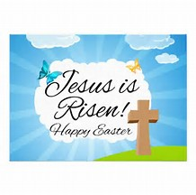 Easter – Celebrate the resurrection!!!!
6:30 AM – Sunrise Service at Harry Harris
10 AM – Celebration Service at BMUMC

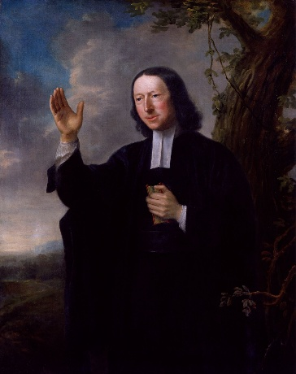
Notes/Commentaries from the Wesley Study Bible

Wesley Core Term: Grace
(Wesley Study Bible, Page 1151, Jonah 4:1-11)

Consider Ephesians 2:8-10 - For it is by grace you have been saved, through faith—and this is not from yourselves, it is the gift of God— not by works, so that no one can boast. For we are God’s handiwork, created in Christ Jesus to do good works, which God prepared in advance for us to do.

Grace is a relational concept: God’s active presence and transformative power in our lives. The name Emmanuel speaks to this reality – “God with us.” We perceive the divine presence by the results of the divine energy working within us, enlightening, convicting, forgiving, liberating, assuring, chasing, empowering, strengthening, comforting – assisting us to become what God intended humankind to be, faithful creatures whose love for God and their neighbors is manifest through works of piety and mercy.
Grace is a Trinitarian concept, grounded in the love and mercy of God the Father; especially manifest in the life, death, and resurrection of God the Son; and experienced through the work of God the Holy Spirit in our lives.

Notes/Commentaries from the Wesley Study Bible

Wesley Core Term: Means of Grace
(Wesley Study Bible, Page 1198, Malachi 3:1-18)

John Wesley taught that our becoming and growing as Christians is enabled by grace. Through grace we are invited into a transforming relationship with God, which largely takes place as we participate in the means of grace. (Also known as Spiritual Disciplines). The means of grace are practices that the Holy Spirit uses to draw us to God (prevenient grace), enable us to know our sins are forgiven (justifying grace), and mature us in our love for God and our neighbor (sanctifying grace). The means of grace include the devotional reading of Scripture, prayer, fasting, the Lord’s Supper, Christian conversation, and acts of compassion and service to our neighbors. It is in the means of grace that we encounter the presence of God in all its transforming and loving power. As we faithfully participate in the means of grace through worship, sacraments, daily devotions, fellowship, and service, God enables us to increasingly recover the divine image of love in which we were created.

Sunday Sermon Themes and Scriptures

Date: April 5, 2026 (Easter)  Sermon Title: Living within the resurrection  Old Testament: Isaiah 53:10-11  New Testament: John 11:25 | Date: April 12, 2026  Sermon Title: Social Holiness  Old Testament: Isaiah 11:1-9  New Testament: Matthew 6:33 and Luke 17:20-21
Date: April 19, 2026  Sermon Title: Earth Day Sunday  Old Testament: Psalms 24:1-2 and Psalm 8:1-9  New Testament: Matthew 25:14-30 | Date: April 26, 2026  Sermon Title: Jesus Proclaims Justice  Old Testament: Isaiah 42:1-4  New Testament: Matthew 12:15-21

Church Contacts
Phone: 305-852-2581, Fax: 305-852-4917
Pastor: pastordavidc12@yahoo.com
Church Secretary: bmumc_office@yahoo.com Web Site: www.BMUMC.net
Office Hours: Monday – Thursday: 9:00 am to 4:00 pm. Friday – Office Closed.

Newsletter and Bulletin Deadlines

We have a lot of ministries and events going on at Burton and it is important to get the word out regarding them. So, please remember the deadline for getting information into the weekly bulletin is on Wednesdays. The deadline for monthly Beacon articles is the twentieth of each month. Please send all information that you want placed in the bulletin or in the Beacon to the office at
bmumc_office@yahoo.com.

April Birthdays: April Anniversaries:
DAY DAY

John Baxter 1 David & Donna Charlton 4
Blair Ellis 5 Larry & Sharron Albury 21
Mary Harris 12
Dawson Ellis 16
Anita Simpson 16
Claude Bullock 17
Sue Hulsbeck 19
Ken Mills 23

