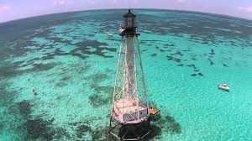
The Beacon
A monthly newsletter publication of Burton Memorial UMC
July 2026

A New Chapter At Burton Memorial UMC

Welcoming Rev. Dr. Charles Fisher:
With grateful hearts and great anticipation, Burton Memorial United Methodist Church joyfully welcomes Rev. Dr. Charles Fisher as our new Pastor beginning July 1, 2026. This is more than the arrival of a new pastor, it is the beginning of a new season of faith, fellowship, vision, and spiritual growth for the church and community. With hearts full of gratitude, expectation, and prayer, the congregation looks ahead to a renewed season of worship, fellowship, outreach, and faithful service together. Originally from Cape Charles, Virginia, Rev. Dr. Fisher has devoted his life to ministry, education, mentorship, and leadership. Throughout his journey, he has served faithfully in churches, schools, youth ministries, and communities, helping people discover hope, purpose, and the love of Jesus Christ. His ministry is known for being Christ-centered, Spirit-led, encouraging, practical, and community-focused. Rev. Dr. Fisher comes with a heart for people, a passion for preaching and teaching God’s Word, and a deep commitment to building strong

Rev. Dr. Fisher and his wife, Shirelle Fisher, along with their children Chauncie, Charles Jr., and Chanelle, are excited to become part of the Burton Memorial family and the Florida Keys community. As he steps into this new appointment, Pastor Fisher brings a vision of worship that uplifts, discipleship that transforms lives, outreach that touches the community, and ministry that strengthens every generation. Known as an uncommon church for common people, Burton Memorial UMC has long been a place where neighbors are welcomed without boundaries and where lives are touched through meaningful worship, study, compassion, and outreach. The arrival of Rev. Dr. Fisher brings fresh anticipation as the church family prepares to continue that mission with renewed energy, compassionate leadership, and a strong sense of purpose as the congregation, ministries, and community move forward together in faith. I believe God has great things ahead for Burton Memorial United Methodist Church, Rev. Dr. Fisher shared. My prayer is that we grow together spiritually, love one another deeply, and become a shining light of hope and encouragement throughout this community.

His first day, July 1, 2026, will mark more than a date on the calendar, it will be the beginning of a shared journey. For members, friends, and visitors alike, this moment offers an opportunity to come together in faith, extend a warm Burton Memorial welcome, and celebrate what God will do in the days ahead through Rev. Dr. Fisher’s ministry and the church’s ongoing witness in the community. The church family is invited to join in prayer, encouragement, and celebration as we welcome Rev. Dr. Fisher into this exciting new chapter. Together, we look forward to what God will do through worship, service, fellowship, and faithful ministry in the months and years ahead. As plans begin for the June Beacon, this is wonderful news to share: a powerful new chapter is beginning at Burton Memorial UMC, and the future is bright with faith, hope, and expectation.
Please join us Sunday, July 5, 2026, as we officially welcome Rev. Dr. Charles Fisher to the pulpit of Burton Memorial United Methodist Church.
Behold, I will do a new thing… (Isaiah 43:19)

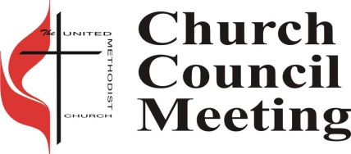
Church Council
Next church council meeting is Tuesday, July 7, 2026, at 5:30 PM.

Potluck Luncheon
 Burton will be having Potluck on Sunday, July 5 at 11:30 am in the Fellowship Hall, following the 10:00 am service. In honor of welcoming Rev Dr Charles Fisher and his wife Shirelle Fisher. Bring your favorite dish or dessert to share. If you do not cook, just bring yourselves. There is always more than enough food.

Ringing News
We are always looking for new ringers. If you are interested in joining our handbell choir, please see any ringer for more information.

UWF Prayer Bead Ministry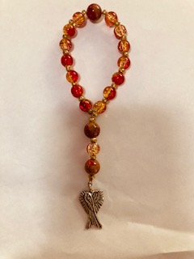

The United Women in Faith have been handcrafting Prayer Beads since 2016. We continue to make and sell them and are currently offering a Summer Super Sale. Our Christian Sister Sue Peacock lovingly crafted beautiful chaplets adorned with angel wings for the wounded veterans who came to kayak in Key Largo. These special gifts were given for them to take home as a heartfelt reminder of the love and kindness they found here in the Florida Keys. Blessings, Prayers, Love & comfort to all. Call, Text or Email Mrs. Kim Youngblood Cell 443-207-4000, kyoungblood528@yahoo.com if you would like to purchase or learn how to string.
Dear Ladies of the church and United Women of Faith
Our July meeting is being canceled as a few of us will be at Mission U but we still have some wonderful books to read in our library which is now at my house 38 E Beach Rd. I live right next door to Harry Harris Park. If I am home the library is open call me 305-394-3978 to see if you can pop over to get one of our many wonderful books they are broken down into categories-Education for Missions, Leadership Development, Nurturing Community, Social Action and Spiritual Growth. Barbara Koch has been making the selection of what is available and she has really picked some good books to read. Some when I start I can’t stop until I am finished, that is how good some are. So, if you are wondering what do to inside the AC here is something that doesn’t require housework. Give me a call.
We will be meeting in August. Details in the next President Message 😇
Love in action is unstoppable,
Mary Lou Wilkinson, President of UWF

Green Team Jack Grove, Green Team
The Burton Green Team is pleased to announce the success of the THIRD ANNUAL UPPER KEYS EARTH DAY FESTIVAL. Our church family partnered with the Coral Isles congregation and nearly $2000 were raised for solar panels and other environmentally friendly projects. On Saturday, July 11, at 9AM, we will be meeting in the fellowship hall to plan for next year's event. All are welcome to attend. Please join us and help ensure that next year’s festival be even better.


God’s Kitchen/Food Pantry
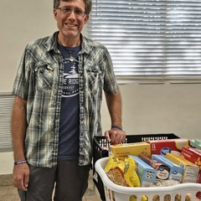
Burton is still in need of help with our Food Pantry Ministry. We can use extra hands in the pantry to help with deliveries on Wednesday and Thursday mornings, and to serve our guests Wednesdays from 9 am to 12 pm and Thursday evenings from 5 pm to 7 pm. Please call the office at 305-852-2581 for info or to volunteer.

We are still looking for groups or individuals to help with our God’s Kitchen Free Dinner on Thursdays, helping to cook, serve and clean up. If you can help, please call or text Mary Lou Wilkinson at 305-394-3878, or call the office, 305-852-2581.

Child Development Center (CDC)

The CDC staff had great time with the Charlton on “farewell party”.
Thank you, Pastor David and Donna!
From All of Us at the CDC!

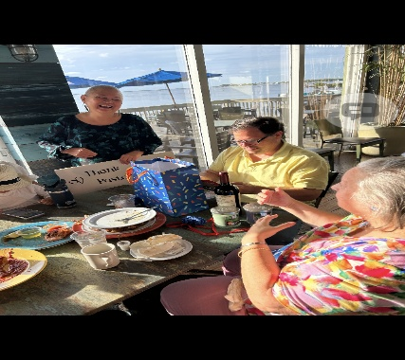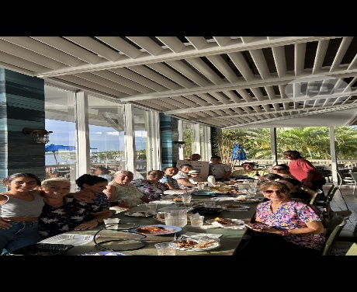
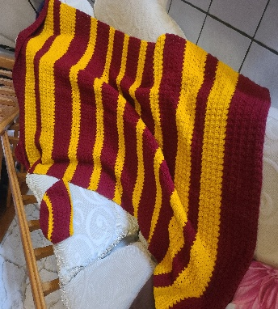 Prayer Shawl Ministry
Beautiful collage dorm bed cover- football wrap and hat in college colors
crocheted by Viola in Pennsylvania for one of our college student. Join us
Thursday evenings 6:30 in the Joy classroom for crocheting and knitting
fellowship making items for all occasions. call Virginia Spear 305-522-2978
for more information.

Tai Chi Open House Weekly Classes
Strength, Flexibility, and Stillness all in one exercise class? At Burton? Yes, once a week!


We are blessed that Tai Chi is being offered here at Burton in the Fellowship Hall Monday nights from 6:30 pm to 8:00 pm, for all levels of ability. All teachers are volunteers and class costs are by donations to cover the costs of the class location. You can start any time. The benefits are amazing and the history is facinating. I hope you will check out their web site and the classes they have to offer. https://www.taoisttaichi.org/ Why not start out the new year by joining this group?

-To The Burton Congregation-

We wish to express a deep gratitude to everyone for their love and concern shown to me and our family during the unexpected loss of Michael, our beloved son, nephew, and cousin.

We thank you, our church family and Pastor, for your continued prayer and ministering unto us with calls, visits, cards, and food. Because of you, you proved His word when He said, "When you pass through the waters, I will be with you; and when you pass through the rivers, they will not sweep over you. When you walk through the fire, you will not be burned; the flames will not set you ablaze. For I am the Lord your God; the Holy One of Israel, your Savior."

With love and thanksgiving we remember you and there will always be a special place in our hearts for all.

Thank you for loving us,

Julie and the family
of Michael Ratliff

Up Coming Events
Saturday July 11 – 9:00 AM Meeting Green Team Earthday 2027
Tuesday July 14 – 8:00 AM – 5:30 PM Life Line Screening (Fellowship Hall)
Sunday, February 7, 2027 –United Woman In Faith Annual Call to Prayer & Self Denial Program time TBD (Fellowship Hall) Sunday, March 14, 2027 – 2:30 PM – 4:30 PM United Women in Faith 20th Tea (Fellowship Hall)

Sunday Sermon Themes and Scriptures

Date: July 5, ,2026  Sermon Title: We Are Better Together  Old Testament: Proverbs 27:17  New Testament: Hebrews 10:24-25 | Date: July 12, 2026  Sermon Title: The Table Still Has Room  Old Testament: Psalm 34:8  New Testament: Romans 3:23
Date: July 19, 2026  Sermon Title: Keep Walking By Faith  Old Testament: Proverbs 3:5-6  New Testament: Romans 12:1 | Date: July 26, 2026  Sermon Title: Do Not Let The Fire Go Out  Old Testament: Deuteronomy 6:5  New Testament: Romans 12:11

Church Contacts
Phone: 305-852-2581, Fax: 305-852-4917
Pastor: revdrcharlesfisher@yahoo.com
Church Secretary: bmumc_office@yahoo.com Web Site: www.BMUMC.net
Office Hours: Monday – Thursday: 9:00 am to 4:00 pm. Friday – Office Closed.

Newsletter and Bulletin Deadlines

We have a lot of ministries and events going on at Burton and it is important to get the word out regarding them. So, please remember the deadline for getting information into the weekly bulletin is on Wednesdays. The deadline for monthly Beacon articles is the twentieth of each month. Please send all information that you want to place in the bulletin or in the Beacon to the office at bmumc_office@yahoo.com

