Sunday August 23, 2026

Liturgist Cierra Cox

Welcome and Announcements
Sunday, September 13 – Special offering supporting all of our UMC Campus Ministries.

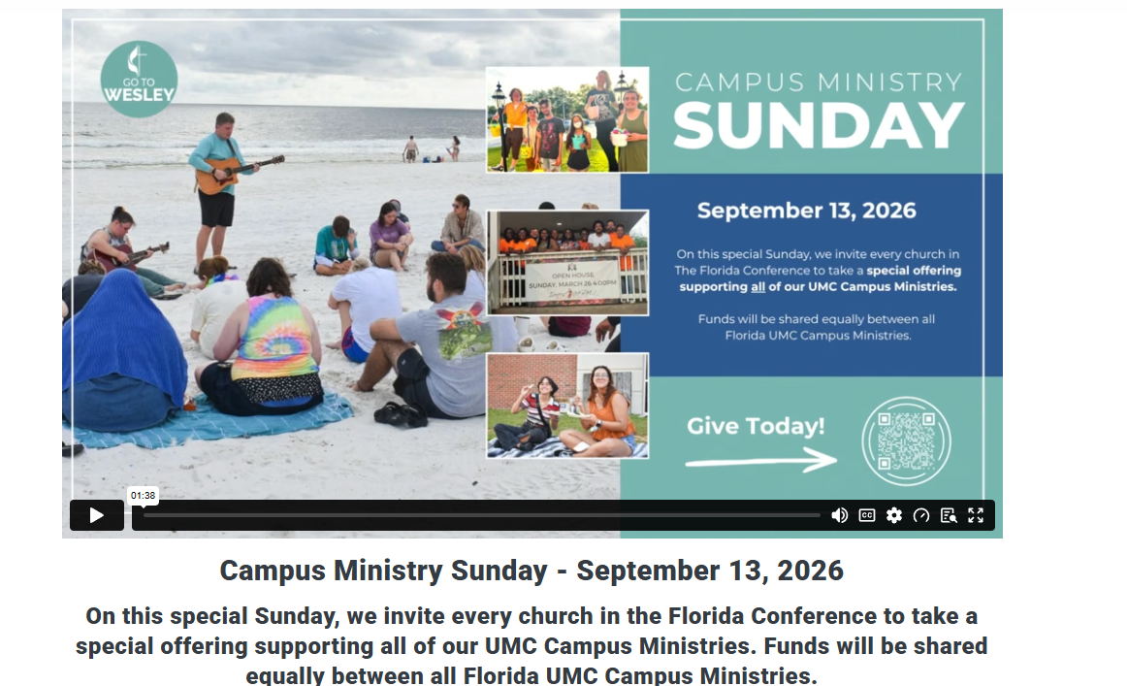
Bible Study Every Monday Night 6:00PM at Burton Memorial Sanctuary
Theme: WHO ARE WE BECOMING?
Topic: Living a Life That Makes a Difference
Scriptures: Matthew 5:13–16, Micah 6:8, James 2:14–17

Pastors Comments Rev. Dr. Charles Fisher

Prelude Instrumental

Call to Worship: Call to Worship
Psalm 46:1–3, 10 (NKJV)

Leader: God is our refuge and strength, a very present help in trouble.
People: Therefore, we will not fear, even though the earth be removed and the mountains be carried into the midst of the sea.
Leader: Though its waters roar and be troubled, though the mountains shake with its swelling—
People: We will trust the Lord, for He is with us through every storm.
Leader: "Be still and know that I am God."
People: We come to worship the One who calms every storm, strengthens every weary heart, and never leaves His children alone.
All: Let us worship the Lord with gladness and confidence, for Jesus is still in the boat! Amen.

Opening Song* Come, Now is the Time to Worship On Screens

Invocation Rev. Dr. Charles Fisher

The Lord’s Prayer On Screens

Affirmation of Faith (A Modern Affirmation UMH #885) On Screens

Gloria Patri* UMH #70 / On Screens

Old Testament Isaiah 43:1–3a (NKJV)
“This is the word of God for the people of God"
"Thanks be to God”

New Testament Mark 4:35–41 (NKJV)
“This is the word of God for the people of God"
"Thanks be to God”

Song Revelation Song by The Burton Praise Team

Intercessory Prayer Lisa Wetzel

Tithes and Offerings

Offertory Instrumental

Doxology* UMH #95 / On Screens

Song of Preparation Christ the Sure and Steady Anchor On Screens

Message Amazing Grace, How Sweet the Sound, That Saved a Wretch Like Me! Rev Dr Charles Fisher Scripture: Ephesians 2:8-9

Closing Song* Amazing Grace, My Chains Are Gone On Screens

Benediction

(*) Indicates to stand if able.

Welcome!
We are glad you are here! May you experience the transforming power of God’s love as you worship with us.

The following is our mission statement:
We are an uncommon church for common people offering a love of neighbor without boundaries. We share the gospel of love when we gather to celebrate a faith relationship with Christ. We serve both God and his children through our ongoing prayers, talents, gifts, and dedication of time until he comes again in glory.

I would love to sit down with you over coffee or a meal. If you would like that, please let me know. My contact info is:
305-335-0891
Email: revdrcharles@yahoo.com

Rev. Dr. Charles Fisher



August 23, 2026
10 am

93001 Overseas Hwy MM 93
Tavernier, FL 33070
(305) 852-2581 / (fax) 852-4917
Office hours:
Mon. – Thurs. 9:00 am – 4:00 pm
Fri. office closed

Rev. Dr. Charles Fisher

Email : revdrcharles@yahoo.com
Web Page: www.BMUMC.net
Church Email:
bmumc_office@yahoo.com

We are the church on the curve.
This Week
Sunday (08/23):
10:00 am – Worship Service (Sanctuary)
Burton Memorial
Monday (08/24):
4:30 pm – 5:00 pm – United Women In Faith Meeting (Fellowship Hall) & 5:00 pm – 6:00 pm – Meet & Greet Dinner before Bible Study (Fellowship Hall)
6:00 pm - Bible Study (Sanctuary)
6:30 pm – Tai Chi Class (Fellowship Hall)
Tuesday (8/25):
6:00 pm – Board of Trustee Meeting (Fellowship Hall)
Wednesday (08/26):
9:00 am – Food Pantry (Fellowship Hall)
4:30 pm - Burton Bells Practice
Thursday (08/27)
5:00 pm – Food Pantry (Fellowship Hall)
5:00 pm – God’s Kitchen (Fellowship Hall)
A United Methodist Church
Burton Memorial
6:30 pm – Prayer Shawl Meeting (Joy Classroom)
Friday (08/28): Office Closed

Upcoming Events
Sunday, September 13 – Special offering supporting all of our UMC Campus Ministries
Sunday, February 7, 2027 –United Woman In Faith Annual Call to Prayer & Self Denial Program time TBD (Fellowship Hall)
Sunday, March 14, 2027 – 2:30 PM – 4:30 PM United Women in Faith 20th Tea (Fellowship Hall)

