Unity Northwest Region Board of Trustees Candidate
(3-year Term)
Rev. Frank Castro-Wehr

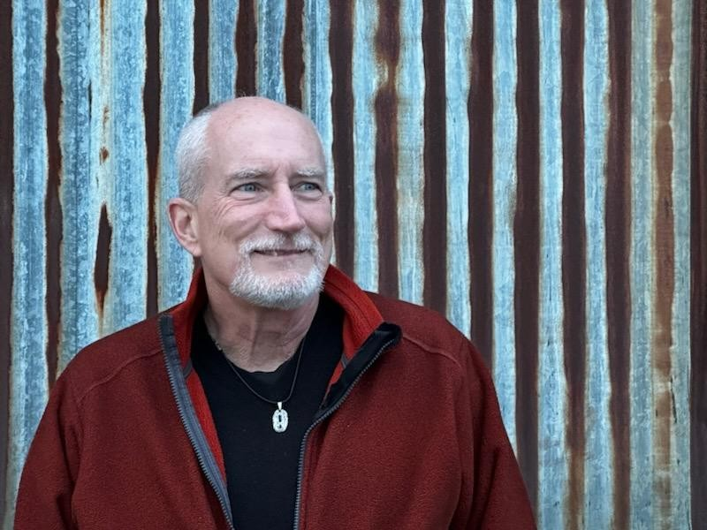
Rev. Frank is a New Thought minister, ordained through Unity Worldwide Spiritual Institute, and now the Minister at the Unity Spiritual Center of Bellingham. Rev. Frank’s passion is inviting and connecting people into community, and sharing joy, wholeness, wonder, and the unfolding of our sacred journeys. Frank leads from a perspective that begins with the inner path of awakening to our true Selves, where we all get to marvel at the myriad ways our lives out-picture into wholeness, joy and living authentically.
Frank loves to weave lessons from Spiritual works, Unity teachings, the mystics, science, consciousness studies, and world traditions in a way that enriches and informs our daily lives in practical, sacred, and useful ways. He looks to experience the unfolding fullness of the Christ essence in each person, in society, and in the evolving energies of Mother Earth.
Having served as Secretary of the Unity NW Region Board of Trustees for the past two years, he would be honored to serve a second term. His care for the environment has led him to serve with Unity’s Earthcare Ministry. Frank brings varied experience from his years serving as a Unity minister, his previous career as an engineer, and previous experience studying with the Dominican brothers.
Rev. Frank and his wife Dyann have lived in Bellingham since 2021 – and arrived here with great enthusiasm for the good, beautiful, and sacred experience this community and place offers!

