
For more information about this
Our mailing address is Oasis Youth Ministries PO Box 445, Holbrook, AZ 86025
For more information about this
ministry or to join our prayer
and support team,
you can go online to
www.oasisyouthministries.com

Dear Friends and Family, August 2026

Hello! We pray this finds you well! As we told you in our last newsletter, we (the Burgess family) have moved from Arizona to Florida, and the Susag’s have taken the lead over Oasis Youth Ministries in Arizona. Jerad is continuing to work for Oasis in an advisory role and will continue to do so through December.

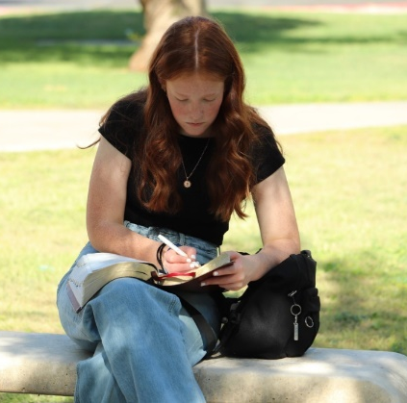
Oasis was able to take 12 teens to Arizona Christian University for Worldview Academy from June 21 to June 26. This is the fourth year we’ve been able to raise the money to send a group, and it has always been a wonderful time of spiritual growth and learning for our young people. This year was no different. What was different this year is that Levi (the new executive director of Oasis) and Jerad were able to go and spend the night and experience the first evening and day of the camp firsthand. We were very impressed with what we heard. We got to meet some of the speakers and have lunch with the head of the program. We were also pleased at the quality of questions that the students asked. It is obvious that there are young people out there who take their faith in Christ seriously; they have thought a good deal about it, and have been taught what they believe and how to defend it. It is always positive for our students to be reminded that Christianity is much larger than Holbrook—they are not alone in following Jesus in their teens.

In July, as we have done the previous three years, we joined with the youth group of Winslow First Baptist and took a group of young people to Jake’s Unlimited. It is a large indoor video game arcade near Phoenix with a pizza buffet, several rides, laser tag, and a bowling alley. The teens had a great time. On the way back, however, Arizona’s “monsoon season” showed up! The rain was torrential, with a great deal of thunder, lightning, and wind. It was almost to the point of not being able to see to drive. Farther north, (Holbrook is 3 hours northeast of Phoenix) huge storms were dumping water that caused flooding in Holbrook and in the areas we had planned to drive through; we ended up changing our route and getting back much later than planned, but thankfully getting back! Holbrook was still flooded in areas, but the kids were all able to get home. People later described that storm as a hurricane that hit the desert.

As always, THANK YOU so very much for your part in this ministry; we truly could not do it without your prayers and giving!

Prayer Requests:
- Please pray for Levi and Abbey Susag as they settle into their new roles as leaders of Oasis Youth Ministries.
- Please pray for students coming to the Well, the Next Chapter, and the events, that God will use His word and the testimonies of our pastors and leaders this semester to grow them closer to Him.
- Please pray for more godly volunteer leaders to join Oasis.

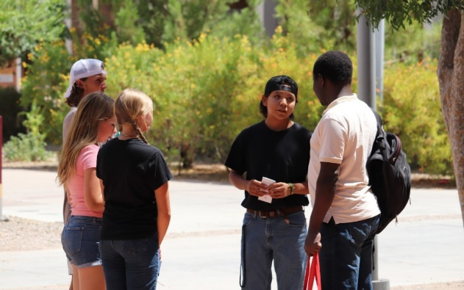
Grace and Peace,

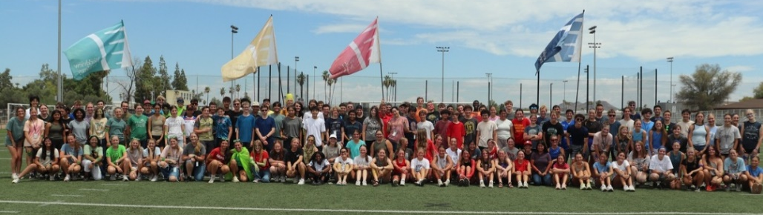
Jerad and Carrie Burgess, Abi, Naomi & Sarah

