

A monthly newsletter publication of Burton Memorial UMC
September 2026

A Season of New Beginnings
A September Message from Pastor Charles

Dear Burton Memorial Family,

Grace and peace to you in the name of our Lord and Savior Jesus Christ! As we enter September, I am grateful for what God has already done and excited about where He is leading Burton Memorial. Isaiah 43:19 declares, “Behold, I will do a new thing.” I believe God is doing a new thing among us! September is a season to renew our faith, reignite our passion for God, and recommit ourselves to His work. Let us worship faithfully, pray continually, serve joyfully, invite others, and love our neighbors without boundaries.

Burton Memorial, God has placed us in this community for a purpose. We are called to be a church where people find hope, healing, belonging, and the love of Jesus Christ.

Galatians 6:9 reminds us not to grow weary in doing good, because “in due season we shall reap if we do not lose heart.” So, church, keep praying. Keep serving. Keep loving. Keep believing. God is not finished with us yet! As your pastor, I believe our best days are ahead. Let us move into September united in faith and expectation, remembering: We are an uncommon church for common people, offering a love of neighbor without boundaries. May September be a month of renewed faith, renewed passion, and renewed purpose.

We Are Better Together!

With love and blessings,
Pastor Charles
Burton Memorial United Methodist Church

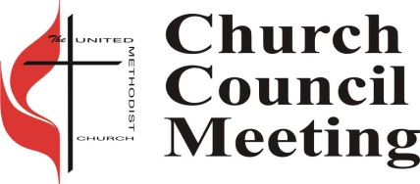
Church Council
Next church council meeting is Tuesday, September 1,2026 at 6:00 PM.

Potluck Luncheon
 Burton will be having Potluck on Sunday, September 6th at 11:30 am in the Fellowship Hall, following the 10:00 am service. Bring your favorite dish or dessert to share. If you do not cook, just bring yourselves. There is always more than enough food.

Ringing News
We are always looking for new ringers. If you are interested in joining our handbell choir, please see any ringer for more information.
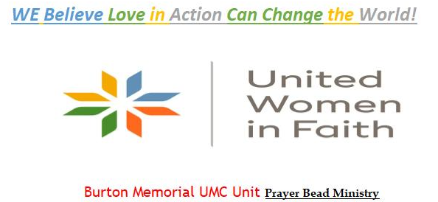

The Unit has been handcrafting Prayer Beads since 2016. The money we receive from donations to this ministry are specifically to help local needs that closely align with our Purpose “Improving the lives of women, children, and youth”.

Recently the members of the Prayer Bead Ministry donated $200.00 to the Community Foundation of the FL Keys for the Pascal’s Way Scholarship Fund. As most of you know Pascal’s father Ariel Poholek serves as the Church Food Pantry Coordinator. We cannot thank him enough for all his time, talent and treasures to our cause and the churches.

We are currently offering a Super Summer Inventory Reduction Opportunity. Acquire a Prayer Bead Strand or Prayer Chaplet for any donation amount.

Blessings, Prayers, Love & Comfort to all. Call, Text or Email Mrs. Kim Youngblood- Cell 443-207-4000, kyoungblood528@yahoo.com if you would like to purchase or learn how to string.

Dear United Women of Faith and the Ladies of Burton,
Our next meeting will be held September 28th at 4::30pm at my house 38 E Beach Rd, Tavernier just around the corner from Harry Harris Park. We will have some snacks on the table and Kim will be finishing up the program from August. I want to thank everyone who brought something to the table to share we had plenty of food for everyone that attended and those that missed it you can come to our next meeting.
Faith, hope and love,
Mary Lou Wilkinson, President



Green Team Jack Grove, Green Team
The recent planning session for the 4th Annual Earth Extravaganza was well attended, exciting, productive and fun. We met with our partners from Coral Isles Church of Christ and made plans for the on March 13, 2027. Unlike the first three years, we are scheduling our event during the week of earth day (April 22). Thanks to the suggestion of Dr. Shirelle Fisher, we will be calling or event Earth Extravaganza. Our mission is to raise funds for solar power at Burton, and promote environmental awareness; educating and empowering the community. We are looking for more participants. If you would like more information, or if you have suggestions for next year's event, don't hesitate to contact me directly 305-393-2817.

Did you know that one billion people, across approximately 190 to 200 countries participated in Earth Day on April 22, 2026. Senator Gaylord Nelson (former senator and governor in Wisconsin) is said to invent Earth Day in 1970. This is when he deployed students to protest and demonstrate against air and water pollution. Events like rallies and many others were organized across the whole country. It opened the public eye to environmental issues and political agenda for perhaps the first time in America.

God’s Kitchen/Food Pantry
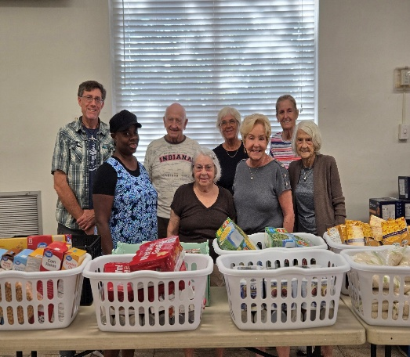
Burton is still in need of help with our Food Pantry Ministry. We can use extra hands in the pantry to help with deliveries on Wednesday and Thursday mornings, and to serve our guests Wednesdays from 9 am to 12 pm and Thursday evenings from 5 pm to 7 pm. Please call the office at 305-852-2581 for info or to volunteer.

We are still looking for groups or individuals to help with our God’s Kitchen Free Dinner on Thursdays, helping to cook, serve and clean up. If you can help, please call or text Mary Lou Wilkinson at 305-394-3878.

Child Development Center (CDC)
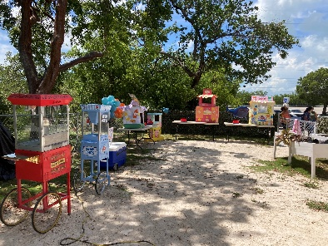! 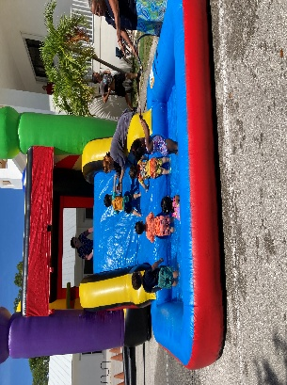 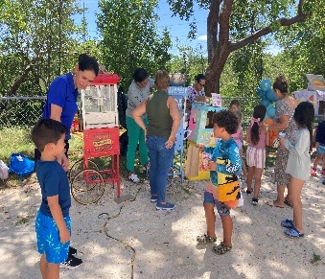

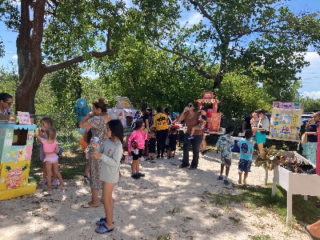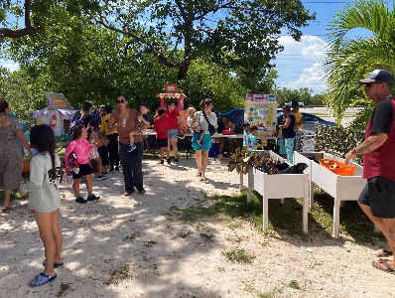

Summer End Bonanza 2026
Water slide, Popcorn, Hotdog, Grilled Cheese Sandwich, Free Movie “Finding Nemo”!

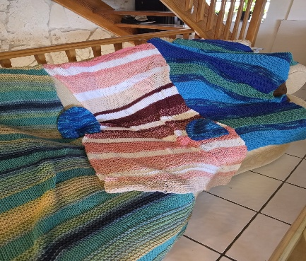
Prayer Shawl Ministry
Three prayer shawls and two hats made by Betty in North Carolina. A neighbor gave her yarn and she put them together to make beautiful shawls and hats for cancer children. Thank you Bette.

Join us Thursday 6:30 in the Joy classroom for a social time knitting and crocheting. We have supplies and will also teach. For more information call Virginia Spear 305-522-2978.

Tai Chi Open House Weekly Classes
Strength, Flexibility, and Stillness all in one exercise class? At Burton? Yes, once a week!


We are blessed that Tai Chi is being offered here at Burton in the Fellowship Hall Monday nights from 6:30 pm to 8:00 pm, for all levels of ability. All teachers are volunteers and class costs are by donations to cover the costs of the class location. You can start any time. The benefits are amazing and the history is facinating. I hope you will check out their web site and the classes they have to offer. https://www.taoisttaichi.org/ Why not start out the new year by joining this group?

Up Coming Events
Sunday, February 7, 2027 –United Woman In Faith Annual Call to Prayer & Self Denial Program time TBD (Fellowship Hall) Sunday, March 14, 2027 – 2:30 PM – 4:30 PM United Women in Faith
20th Tea (Fellowship Hall)

Date: September 6, ,2026 - Communion  Sermon Title: REMEMBER WHAT JESUS DID  Luke 22:19–20 | Date: September 13, 2026  Sermon Title: GOD SPECIALIZES IN NEW BEGINNINGS  Isaiah 43:18–19
Date: September 20, 2026  Guest Speaker: Minister Stan Belyeu | Date: September 27, 2026  Sermon Title: YOU ARE STRONGER THAN YOU THINK  Philippians 4:13

Church Contacts
Phone: 305-852-2581, Fax: 305-852-4917
Pastor: revdrcharles@yahoo.com
Church Secretary: bmumc_office@yahoo.com Web Site: www.BMUMC.net
Office Hours: Monday – Thursday: 9:00 am to 4:00 pm. Friday – Office Closed.

Newsletter and Bulletin Deadlines

We have a lot of ministries and events going on at Burton and it is important to get the word out regarding them. So, please remember the deadline for getting information into the weekly bulletin is on Wednesdays. The deadline for monthly Beacon articles is the twentieth of each month. Please send all information that you want to place in the bulletin or in the Beacon to the office at bmumc_office@yahoo.com

