
The Beacon
A monthly newsletter publication of Burton Memorial UMC
August 2026

Dear Burton Memorial Family,
Grace and peace to you in the name of our Lord and Savior, Jesus Christ.

It is hard to believe that my first month as your pastor has already come and gone. Thank you for the warm welcome, heartfelt prayers, kind encouragement, and Christ-like love you have shown me and my family. From the very beginning, you have made us feel at home, and I thank God for each of you.

On my first Sunday, the Lord placed a message on my heart entitled "We Are Better Together." That sermon continues to reflect my vision for Burton Memorial. God has called us to worship together, grow together, serve together, and reach our community together. When we unite around Christ, there is no limit to what God can accomplish through His Church. Over the past month, I have been blessed to worship with you, meet many of our faithful members, participate in community events, and build relationships throughout the Upper Keys. I was also honored to be interviewed by The Upper Keys Weekly and The Free Press, giving us the opportunity to share the story and mission of Burton Memorial with our community.

I hear people talking about Burton Memorial. There is a growing excitement within our congregation and throughout the community. Many have shared that they sense something is happening at Burton Memorial. I believe what they are seeing is not about a pastor, but about the Holy Spirit moving among God's people. When a church prays, loves, serves, and welcomes others in the name of Jesus Christ, people notice.

I truly believe Burton Memorial's best days are still ahead. Together, let us continue to live our mission: "We are an uncommon church for common people offering a love of neighbor without boundaries."

As we enter this new month, I invite you to pray, worship, serve, and invite someone to join you on Sunday. God is opening new doors, and I believe He has wonderful things in store for our church and our community. Thank you for allowing me the privilege of serving as your Pastor. I look forward with great hope and anticipation to all God will do through Burton Memorial United Methodist Church.
"Being confident of this very thing, that He who has begun a good work in you will complete it until the day of Jesus Christ." - Philippians 1:6 (NKJV)

Serving Christ with you,

Pastor Charles Fisher

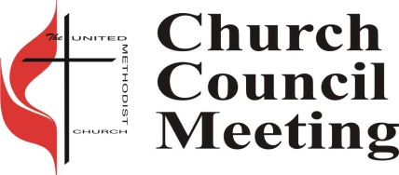
Church Council
Next church council meeting is Tuesday, August 4,2026 at 5:30 PM.

Potluck Luncheon
 Burton will be having Potluck on Sunday, August 2 at 11:30 am in the Fellowship Hall, following the 10:00 am service. Bring your favorite dish or dessert to share. If you do not cook, just bring yourselves. There is always more than enough food.

Ringing News
We are always looking for new ringers. If you are interested in joining our handbell choir, please see any ringer for more information.

UWF Prayer Bead Ministry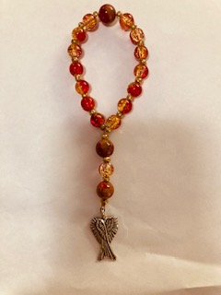

The United Women in Faith have been handcrafting Prayer Beads since 2016. We continue to make and sell them and are currently offering a Summer Super Sale. Our Christian Sister Sue Peacock lovingly crafted beautiful chaplets adorned with angel wings for the wounded veterans who came to kayak in Key Largo. These special gifts were given for them to take home as a heartfelt reminder of the love and kindness they found here in the Florida Keys. Blessings, Prayers, Love & comfort to all. Call, Text or Email Mrs. Kim Youngblood Cell 443-207-4000, kyoungblood528@yahoo.com if you would like to purchase or learn how to string.

Dear Ladies of the Church,
It is definitely summertime and lot of our members have gone north for the summer, but there are a handful of us still here. So, even though our numbers are small we are still going to meet during the summer. This month we will be meeting at Burton Church on August 24, 4:30pm-5pm to discuss our monthly meetings. From 5-6pm we will have a meet & Greet dinner will be served with a portion of our program periodically as people arrive for the Bible Study at 6pm. If you need a ride or more information, call me, Mary Lou, at 305-394-3878. Remember the reading books for the UWF are at my house and I found three older books at Burton and brought them home to be with the rest of our reading books. Summer is definitely a good time to read a book.
Blessings,
Mary Lou Wilkinson, President

Green Team Jack Grove, Green Team
On behalf of the Burton Green Team, I am pleased to report that we had a very inspiring meeting focused on a review of the 2026 Earth Day Festival, which raised nearly $2000 for our church and Coral Isles Church of Christ.
We celebrated the success of this fourth annual event, and established a plan to make next year's event, even more successful. During the meeting we reviewed the mechanisms that will help us make next year's event influential to bring Science and Faith together to celebrate our reverence for the creation. Special thanks to Dr. Shirelle Fisher for suggesting that we promote next year's festival as EARTH EXTAVAGANZA.


God’s Kitchen/Food Pantry
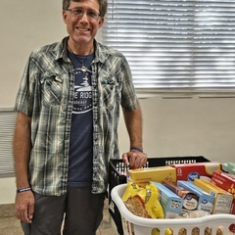
Burton is still in need of help with our Food Pantry Ministry. We can use extra hands in the pantry to help with deliveries on Wednesday and Thursday mornings, and to serve our guests Wednesdays from 9 am to 12 pm and Thursday evenings from 5 pm to 7 pm. Please call the office at 305-852-2581 for info or to volunteer.

We are still looking for groups or individuals to help with our God’s Kitchen Free Dinner on Thursdays, helping to cook, serve and clean up. If you can help, please call or text Mary Lou Wilkinson at 305-394-3878, or call the office, 305-852-2581.

Child Development Center (CDC)

Summer activities for school age children include field trips twice a week through the generosity of the Ocean Reef Community Foundation!

Burton Memorial are truly grateful!
!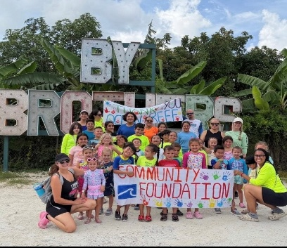 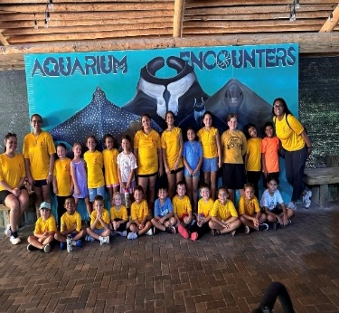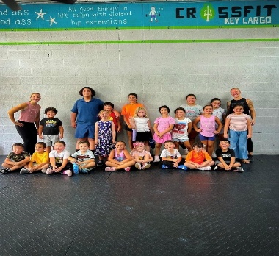 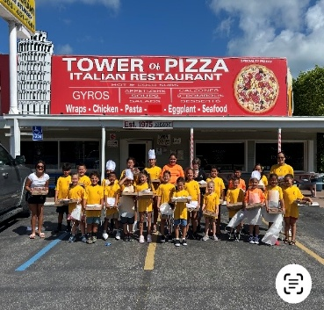

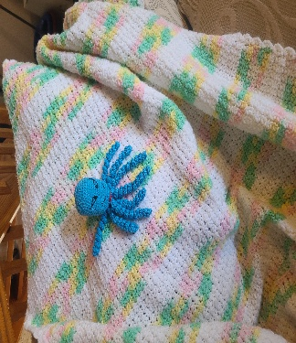
Prayer Shawl Ministry

"Beautiful baby blanket and octopus for a new baby. Join us to make knitted and crocheted items for all occasions. If you prefer to knit or crochet at home that would be a big help or join us Thursday 6:30 pm in the Joy classroom. We have fun. For more information call Virginia Spear 305-522-2978.

Tai Chi Open House Weekly Classes
Strength, Flexibility, and Stillness all in one exercise class? At Burton? Yes, once a week!

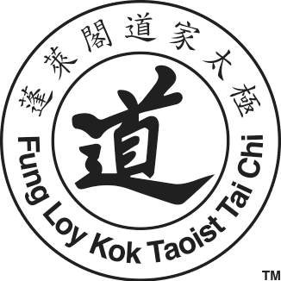
We are blessed that Tai Chi is being offered here at Burton in the Fellowship Hall Monday nights from 6:30 pm to 8:00 pm, for all levels of ability. All teachers are volunteers and class costs are by donations to cover the costs of the class location. You can start any time. The benefits are amazing and the history is facinating. I hope you will check out their web site and the classes they have to offer. https://www.taoisttaichi.org/ Why not start out the new year by joining this group?

Up Coming Events
Monday, August 24, 2026 – 4:30 PM – 5:00 PM -United Women In Faith Meeting (Fellowship Hall)
Monday, August 24, 2026 – 5:00 PM – 6:00 PM United Women In Faith Meet & Greet Dinner before Bible Study (Fellowship Hall)
Saturday, August 15, 2026 – 6:00 PM – 7:00 String Quartet
Sunday, February 7, 2027 –United Woman In Faith Annual Call to Prayer & Self Denial Program time TBD (Fellowship Hall) Sunday, March 14, 2027 – 2:30 PM – 4:30 PM United Women in Faith
20th Tea (Fellowship Hall)
Sunday Sermon Themes and Scriptures

Date: August 2, ,2026  Sermon Title: Who Would not Serve a God Like This?  Old Testament: Psalm 103:1–5  New Testament: Romans 8:31-35 | Date: August 9, 2026  Sermon Title: When God Meets Us in the Wilderness  Old Testament: Isaiah 43:18–19 (NKJV)  New Testament: James 1:2–4
Date: August 16, 2026  Sermon Title: When You Feel Like Giving Up  Old Testament: Isaiah 40:28–31 (NKJV)  New Testament: Galatians 6:9–10 (NKJV) | Date: August 23, 2026  Sermon Title: Jesus Is Still in the Boat  Old Testament: Isaiah 43:1–3a (NKJV)  New Testament: Mark 4:35–41 (NKJV)
Date: August 30, 2026
Sermon Title: God Can Still Use You
Old Testament: Psalm 71:17–19
New Testament: 2 Corinthians 4:7–10

Church Contacts
Phone: 305-852-2581, Fax: 305-852-4917
Pastor: revdrcharles@yahoo.com
Church Secretary: bmumc_office@yahoo.com Web Site: www.BMUMC.net
Office Hours: Monday – Thursday: 9:00 am to 4:00 pm. Friday – Office Closed.

Newsletter and Bulletin Deadlines

We have a lot of ministries and events going on at Burton and it is important to get the word out regarding them. So, please remember the deadline for getting information into the weekly bulletin is on Wednesdays. The deadline for monthly Beacon articles is the twentieth of each month. Please send all information that you want to place in the bulletin or in the Beacon to the office at bmumc_office@yahoo.com

