THE ORDER OF WORSHIP
August 30, 2026/14th Sunday of Pentecost
Greeter: Dale Dixon and Rachel Hawk
Please fill out your Prayer & Praise Cards. Announcements are on the screens. Please come to the front pews to meet with a member of our Prayer Team before or after the service.
Gathering
Prayer of Consecration: Pastor John
One: Wake up, sleeper, rise from the dead,
All: and Christ will shine on you. Jesus, I belong to you. I lift up my heart to you. I set my mind on you. I fix my eyes on you. I offer my body to you
as a living sacrifice. Jesus, we belong to you. Praying in the name of the Father, and the Son, and the Holy Spirit, amen.

Opening Chorus: “Awesome God” No. 2040 TFWS
Prelude: “Contentment” Charles Overholt
Bringing In the Light of Christ: Barbara Austin

Welcome and Announcement: Nancy Henry

*Call to Worship: Nancy Henry
One: Welcome to this place of love and grace,
All: Welcome to this place of hope and perseverance.
One: God invites all of us to be a part of the beloved community,
All: God invites all of us to share in the good news:
One: We are welcome, just as we are. We are loved, just as we are.
All: In gratitude for all of this, let us worship God. Amen.

Greeting Our Brothers and Sisters in Christ

Proclamation and Response
*Opening Hymn: “God Is So Good” No. 52
(Collection of Prayer & Praise Cards)
Joys and Concerns: Pastor John
Prayer Chorus: “Breathe on Me Breath of God” No. 304- V. 1
Silent Prayer & Pastoral Prayer /Lord’s Prayer: Pastor John

Anthem: “Soul on Fire” Third Day/Solo by Phil Deane

Collection of Tithes and Offerings: Stuart Walton & Dale Dixon
*The Doxology: “My Tribute” On the Screen
*The Apostles’ Creed: No. 691

Scripture Reading: Series: Letters of John
1 John 2:28-29
One: The word of God for the people of God.
All: Thanks be to God and I believe it.

Sermon: “No Shame” Pastor John

Sending Forth
*Closing Hymn: “I Need Thee Every Hour” No. 340
Postlude: “Joyous Postlude” Chester Nordman

Please be seated. You are invited to close your eyes and use the few moments of music at the end of our service to practice Listening Prayer. This is a time to expect God to speak to you before you leave the sanctuary. In John 10:17, Jesus tells us; “My sheep hear my voice, and I know them, and they follow me.” Let’s try listening as we are silent and still. Members of the prayer team will remain on the front pews after the service. Feel free to come forward.
Benediction: Pastor John
ANNOUNCEMENTS

TO OUR VISITORS: We welcome you to Laurel Hill and hope that you feel at home. We invite you to join Laurel Hill if you do not have a church home. Please call our church office at 804-795-2772. You will find our Laurel Hill family both warm and eager to welcome you into our fellowship. Please fill out a visitor’s card and place it in the offering plate. The password for our public WiFi is LivingHope - feel free to connect with us.

OPERATION CHRISTMAS CHILD SHOEBOXES…As we continue to collect for our shoeboxes this month, please consider giving school items like pens, pencils, sharpeners, crayons, markers, small notebooks and coloring books. Thank you.

THE CHURCH PICNIC will be held on Sunday, September 20th starting at 3pm at Osborne Landing Pavilion #2. This is a change from last year. Pavilion #2 is at the top of the hill next to the playground. The church will provide hot dogs, hamburgers, rolls, mustard, relish and ketchup, and paper products. Please bring a side to share and your own beverage. Thank you, The Fellowship Team

CHANCEL CHOIR AND HANDBELL CHOIR…We want you! We need you! Here’s an opportunity for you to share your talents! The choir needs you!! Come praise God and have fun singing. The choirs (Bells and Chancel) will start back on Wednesday, September 2nd. Bells will ring at 6:45 P.M. and Chancel Choir will sing at 7:30 P.M. Let’s make every Wednesday our “Joyful Noise to the Lord Day”. We really do have a great time of fellowship and laughter while singing and ringing!

THE MONDAY NIGHT BIBLE STUDY will begin a new series on Isaiah. It will begin
on September 14th at 7:00 P.M., on zoom and in person. If you have not joined a study before, now is a good time to begin. If you have questions, call the office or ask Pastor John.

OUR BABY BOTTLE CAMPAIGN to bless the East End Pregnancy Resource Center will continue throughout the month of September. The baby bottles for you to use are on the table in the extended hallway by the double doors to the patio. Instructions are in the bottles. Thank you for your support of this very important ministry.

FISH NEWS…If you have some time to donate to help price items for FISH, please call Pam Wilson and let her know when you are available. They need help!
SICK AND SHUT-INS – Kim Davis, Jean Miller, Evelyn Steele, Kathleen McKinsey, Sara Nelson, Regina Humphrey, David Torrence, Dot Gay, Sharon Loving & Family, Debra Deane, Agnes Stevenson and ML Yuhas.

KEEP IN OUR PRAYERS
- Our Weekday School – Margo Keeles (Director), our teachers, students and families.
- Our community of Varina and all the residents, our churches in our neighborhoods, schools, students, teachers, administrators and all employees.
- Our state of Virginia, our residents and leaders.
- The United States of America, our citizens and leaders, the countries of the world, their people and leaders. May God bless us all and His will be done.
- Those affected by war in Israel and Ukraine

WEEKLY CALENDAR

Monday 10:00 AM New Life House Church today. (804) 303-4828
No Bible Study/New Study on Isaiah begins September 14th @ 7 PM
Come join us in person or on Zoom.

Wednesday 9:00 AM Prayer Time with Communion
10:30 AM Bible Study today.

6:45 PM Handbell Choir Rehearsal

7:30 PM Chancel Choir Rehearsal

Thursday 7:00 PM PTL House Church at the Wilson’s (804) 795-7723

Friday 10:00 Thankful Hearts House Church (804) 737-7450

Saturday 9:00 AM Prayer Station at Dorey Park.

Sunday 10:00 AM Sunday School
10:30 AM Chancel Choir
11:00 AM Sunday Worship Service (also online)

Stewardship in the Bible
By Joshua Godon, https://theleadpastor.com/ (adapted)

Ten Fundamentals of Biblical Stewardship
4. Being Trustworthy in Big & Small Things (Faithfulness)
Our faithfulness in minor details reflects our overall character and reliability. By being trustworthy in all things, we build a foundation of integrity that prepares us for greater responsibilities and honors God.

In Luke 16:10, Jesus explains the faithfulness principle: “He who is faithful in a very little thing is faithful also in much; and he who is unrighteous in a very little thing is unrighteous also in much.”
Jesus teaches that faithfulness in the everyday, mundane things is a requirement prior to gaining more responsibilities.

“Faithfulness in little things leads to faithfulness in great things.” Charles Spurgeon

How can you give at Laurel Hill GMC?

1 – Cash and checks may be placed in the offering plate. Please contact the church office for offering envelopes.
2 - You may also give online. The QR code below will take you to our website’s giving page: https://laurelhill.tithelysetup.com/give

3 – Planned giving – including the LHGMC in your will is a wonderful way to ensure the ministries we are called to provide for Varina will continue into the future.

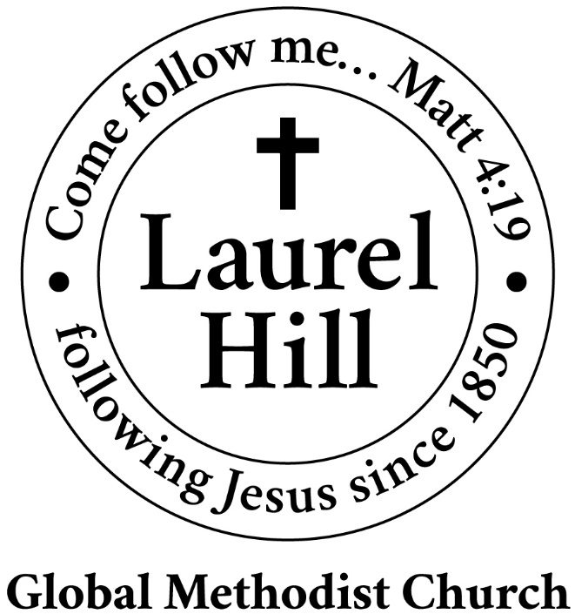
Our Mission: The Global Methodist Church exists to make disciples
of Jesus Christ and spread scriptural holiness across the globe.

1919 New Market Road, Henrico, VA 23231
On the web @ laurelhillchurch.org
Email to laurelhillchurch.varina@gmail.com
Phone: Office/804.795.2772 Pastor/804.437.0937

STAFF
Pastor: Rev. John Bright Organist/Choir Director: Pam Wilson
Secretary: Barbara Wendel School Director: Margo Keeles
Communications Assistant: Ben Wilson

that we you in thought, word, and deed.

