All Saints Anglican Church
6904 Lougheed Highway, Agassiz, B.C. V0M 1A0
Bulletin August 24th, 2026 – August 30th, 2026



‘The ground we walk does not belong to us; for thousands of years it has been - and remains - the territory of the Stó:lō. We are grateful for their sharing.

Phone: 604-796-3553
Website: www.allsaints-agassiz.ca
https://www.facebook.com/groups/AllSaintsFamily
OUR DOOR IS OPEN AND ALL ARE WELCOME
August 30th, 2026, Fourteenth Sunday After Pentecost
Priest in Charge: The Reverend Philip Barker
Hosts: Graham Featherstone/Jennifer Pinlac
Intercessor: Sheila Barker
Lay Administrator: Dorothy Cresswell
Announcer: Virginia Jennings
Organ/Piano: Francesca Froehlich
Readers: Andrea Hansen/Greg Veltman
Coffee Time: Parish Potluck

Vicar’s cell phone: Revd. Philip Barker. 778-867-2461

Vicar’s Warden: Ginny Jennings. 604-796-2206
People’s Warden: Lynn Laughlin. 604-799-5131
Parish email: revpb1950@gmail.com
Please contact either warden if you have an issue that needs to be brought to the attention of the Vicar - or contact the Vicar direct (see above for details).

All Saint’s Calendar/Announcements:

- Book Club – On August 19th Book Club will be starting "Two Steps Forward" by Sharon Garlough Brown, an experienced leader of spiritual formation retreats in the UK and US. The 4 women from Sensible Shoes are taking their next steps in the spiritual formation journey. But each of them is finding roadblocks along the way.
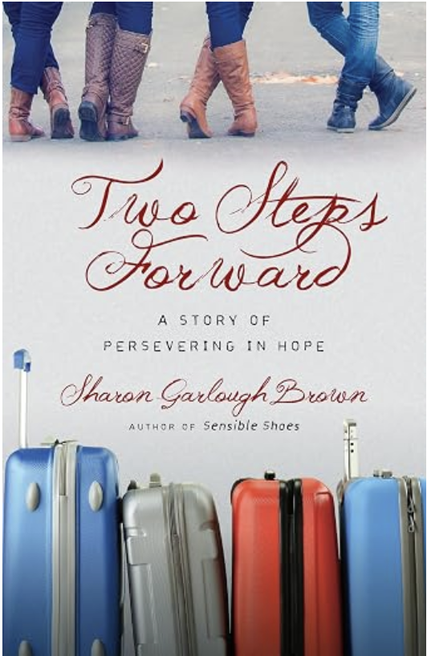

Please contact Sheila Barker at sjbarker0379@gmail.com
if you would like an invitation to the Zoom meetings
at 5.00 pm on Wednesdays or a copy of the book.
The book is available on amazon for $31.43 including tax.

- Bible Study is every Saturday morning 0830-0900 on Zoom. All are welcome to preview and discuss the readings for the Sunday service. Please ask Valerie to add your email address to the invitation list.

- Prayer Requests can be given on a piece of paper to either of the Wardens or the Vicar or entered in the Prayer Request Book on the lectern. Alternatively, you can contact Anthea Lewis at antheamlewis@shaw.ca for Pray First Prayer Circle, which is a confidential online prayer circle.

- Music Requests may be given to the Wardens or the Vicar.

- AA meets in the hall every Tuesday and Friday at noon.

- Every Thursday in the hall 1100-1200 we have a social time with coffee, games if you like or just talk.

- At 1000-1100 on Thursdays there is an Interactive Bible Study on the day’s Lectionary readings. All are welcome – discover the treasures in this amazing book!

- 5th Sunday of each month will be a potluck lunch after the service – Parish Potluck is Sunday August 30th. Please bring something to share.


A note of thanks and recognition

The All Saints 130th celebration was an amazing success, and that type of event doesn’t happen without lots of time, energy and tons of volunteer hours. The following is a list of the many people that we need to recognize…

- Maria Martin and staff at the Agassiz Harrison Museum
- Charlotte Leonard, the Diocesan Archivist
- Agassiz Library for help with printing
- The Men’s Shed for making much-needed repairs inside and out, and acting as excellent parking attendants
- All in the church who worked so hard at cleaning, decorating, catering etc.


Ministerial Meandering
Paws for thought

It’s strange; I had thought about writing on the subject of dogs - a topic close to my heart - and was mulling over how to approach it, when my phone rang. Someone has a problem dog - could I come and help?

This is always a privilege and an exercise in trust, from all sides of the puzzle. First, the owner has to trust me, and believe at least some of what they have heard about my work, or seen on my website. Second, I have to trust them to tell me the truth about their dog. You might be surprised at how many owners ‘bend’ the truth about how they handle or treat their dogs, so that I don’t get a bad impression of them. Then the dog has to trust me - and that can take a little time to earn.

Much as I admire some of Cesar Milan’s work with dogs, I do not subscribe to his ‘dominance’ approach. Cesar finds it essential to mentally overpower the animals he works with. He wants them in submission. I do not believe that is the right way to deal with dogs. I don’t want a subservient, cowering cur, I want a willing partner, where we understand each other’s language.
That can take time. I can remember sitting on the floor in a room with a very frightened little dog who was trembling in the far corner. To approach such an animal directly, would be to increase its fear, almost certainly earning you not trust, but a puddle on the floor. It was nearly twenty minutes before the little guy came over to sniff me, and I still hadn’t made any eye contact with him at all.

My first visits to a new client (the owner) and patient (the dog) take me around an hour or more. I need to get a full history of the animal since it was born - if possible - and information on its parents and their characteristics too. This is not going to happen with rescue dogs, but sometimes - if they have been in a shelter a long time - information from the staff of the shelter may be forthcoming.
I always go to the home of the dog. Dogs do not like coming to surgeries, and I don’t think it is fair to my own animal(s) to introduce a new patient into my dog’s home. Furthermore, in the dog’s own home, I can get a good idea of the environment in which my patient is living, and how the family or owner interacts with the dog.

During the time that I am talking to the client, I like to have the dog running around free in the same room - so long as aggression is not the issue! - so that I can see how it reacts to new people coming into its territory. I can also begin to win its confidence, as most dogs will want to come and inspect the newcomer, and so I can demonstrate, by not interacting with it at all, that I am not a threat.

Within most behaviour problems, I have found that feeding is almost always a problem. Proprietary kibble is rarely adequate - even the top of the range (and hugely expensive) ‘specialised’ brands. One of the things that researchers have found over recent years - in the human population as well - is that our gut is a much more important organ than we ever imagined. Certainly, it absorbs our foodstuffs, but it is also an essential endocrine organ. That is, it produces important hormones. In addition, the nature of the bacterial flora within the gut is key to both food absorption, and the adequate production of those unexpected hormones. And hormones - as we all know - influence behaviour. Thus, when addressing a dog with a behavioural problem, a full dietary history is crucial. Many of my dogs with behaviour problems have had them disappear with the introduction of probiotics or some other nutrient - like raw food - into their diets.

When I feel I have got to the bottom of the problem, my plan is to teach the client how to train their own animal. It is pointless for me to be able to handle the dog, if it is not going to live with me. Many owners do not realize that they are going to have to treat their dogs. Why this should come as a surprise still baffles me. But I still love this job.
Philip+

A Little Chuckle

You don't need a parachute to go skydiving.
You need one to go skydiving twice.

Birthdays in the August 

Pam Evans – 8 Leroy Burden – 14
Virginia Jennings – 14 Monica Gibson-Pugsley – 28

Diocesan Cycle of Prayer: We Pray for the Clergy and Congregation:

Episcopal Diocese of Northern Philippines, Bishop Benny Lang-akan and our Companion Parish Partnerships; Church of the Holy Trinity, White Rock - The Revd Joseph Dirbas, The Revd Paul Richards

Anglican Church of Canada Cycle of Prayer – We Pray for:

The Rt. Rev. Chad McCharles, Bishop, and the clergy and people of the Diocese of Saskatoon

Collect

Author and Giver of all good things, graft in our hearts the love of your name, increase in us true religion, nourish us in all goodness, and of your great mercy keep us in the same; through Jesus Christ our Lord, who lives and reigns with you and the Holy Spirit, one God, now and for ever.

Exodus 3:1-15 Andrea Hansen

¹Now Moses was tending the flock of Jethro his father-in-law, the priest of Midian, and he led the flock to the far side of the wilderness and came to Horeb, the mountain of God. ² There the angel of the Lord appeared to him in flames of fire from within a bush. Moses saw that though the bush was on fire it did not burn up. ³ So Moses thought, “I will go over and see this strange sight—why the bush does not burn up.”

⁴When the Lord saw that he had gone over to look, God called to him from within the bush, “Moses! Moses!”

And Moses said, “Here I am.”

⁵ “Do not come any closer,” God said. “Take off your sandals, for the place where you are standing is holy ground.” ⁶ Then he said, “I am the God of your father, the God of Abraham, the God of Isaac and the God of Jacob.” At this, Moses hid his face, because he was afraid to look at God.

⁷ The Lord said, “I have indeed seen the misery of my people in Egypt. I have heard them crying out because of their slave drivers, and I am concerned about their suffering. ⁸ So I have come down to rescue them from the hand of the Egyptians and to bring them up out of that land into a good and spacious land, a land flowing with milk and honey—the home of the Canaanites, Hittites, Amorites, Perizzites, Hivites and Jebusites. ⁹ And now the cry of the Israelites has reached me, and I have seen the way the Egyptians are oppressing them. ¹⁰ So now, go. I am sending you to Pharaoh to bring my people the Israelites out of Egypt.”

¹¹ But Moses said to God, “Who am I that I should go to Pharaoh and bring the Israelites out of Egypt?”

¹² And God said, “I will be with you. And this will be the sign to you that it is I who have sent you: When you have brought the people out of Egypt, you will worship God on this mountain.”

¹³ Moses said to God, “Suppose I go to the Israelites and say to them, ‘The God of your fathers has sent me to you,’ and they ask me, ‘What is his name?’ Then what shall I tell them?”

¹⁴ God said to Moses, “I am who I am”. This is what you are to say to the Israelites: ‘I am has sent me to you.’”

¹⁵ God also said to Moses, “Say to the Israelites, ‘The Lord, the God of your fathers—the God of Abraham, the God of Isaac and the God of Jacob—has sent me to you.’

“This is my name forever,
the name you shall call me
from generation to generation.

Psalm 26:1-8

¹ Vindicate me, Lord,
for I have led a blameless life;
I have trusted in the Lord
and have not faltered.
² Test me, Lord, and try me,
examine my heart and my mind;
³ for I have always been mindful of your unfailing love
and have lived in reliance on your faithfulness.

⁴ I do not sit with the deceitful,
nor do I associate with hypocrites.
⁵ I abhor the assembly of evildoers
and refuse to sit with the wicked.
⁶ I wash my hands in innocence,
and go about your altar, Lord,
⁷ proclaiming aloud your praise
and telling of all your wonderful deeds.

⁸ Lord, I love the house where you live,
the place where your glory dwells.

Romans 12:9-21 Greg Veltman

⁹ Love must be sincere. Hate what is evil; cling to what is good. ¹⁰ Be devoted to one another in love. Honor one another above yourselves. ¹¹ Never be lacking in zeal, but keep your spiritual fervor, serving the Lord. ¹² Be joyful in hope, patient in affliction, faithful in prayer. ¹³ Share with the Lord’s people who are in need. Practice hospitality.

¹⁴ Bless those who persecute you; bless and do not curse. ¹⁵ Rejoice with those who rejoice; mourn with those who mourn. ¹⁶ Live in harmony with one another. Do not be proud, but be willing to associate with people of low position. Do not be conceited.

¹⁷ Do not repay anyone evil for evil. Be careful to do what is right in the eyes of everyone. ¹⁸ If it is possible, as far as it depends on you, live at peace with everyone. ¹⁹ Do not take revenge, my dear friends, but leave room for God’s wrath, for it is written: “It is mine to avenge; I will repay,” says the Lord. ²⁰ On the contrary:

“If your enemy is hungry, feed him;
if he is thirsty, give him something to drink.
In doing this, you will heap burning coals on his head.”

²¹ Do not be overcome by evil, but overcome evil with good.

Matthew 16:21-28 Vicar Philip Barker

²¹ From that time on Jesus began to explain to his disciples that he must go to Jerusalem and suffer many things at the hands of the elders, the chief priests and the teachers of the law, and that he must be killed and on the third day be raised to life.

²² Peter took him aside and began to rebuke him. “Never, Lord!” he said. “This shall never happen to you!”

²³ Jesus turned and said to Peter, “Get behind me, Satan! You are a stumbling block to me; you do not have in mind the concerns of God, but merely human concerns.”

²⁴ Then Jesus said to his disciples, “Whoever wants to be my disciple must deny themselves and take up their cross and follow me. ²⁵ For whoever wants to save their life will lose it, but whoever loses their life for me will find it. ²⁶ What good will it be for someone to gain the whole world, yet forfeit their soul? Or what can anyone give in exchange for their soul? ²⁷ For the Son of Man is going to come in his Father’s glory with his angels, and then he will reward each person according to what they have done.

²⁸ “Truly I tell you, some who are standing here will not taste death before they see the Son of Man coming in his kingdom.”

Odds and Ends

~Save the Date~

Saturday October 3rd

All Saints Anglican Church
Garage Sale


~Save the Date~

Saturday October 24th

All Saints Anglican Church
Fall Craft Sale

