Colington United Methodist Church
We are a Lighthouse Congregation, committed to offering safety and stability to United Methodists who have been displaced or wounded through disaffiliation.



August 30, 2026
Fourteenth Sunday after Pentecost

welcome and announcements
centering
prelude and lighting of altar candles
Jesus Is My Lord Besig/Price
call to worship
Canticle of Covenant Faithfulness ǀ UMH 125
introit
This Is the Day
opening prayer
†opening hymn
Stand Up and Bless the Lord ǀ UMH 662
prayers of the people
the first lesson
Jeremiah 15:15-21
hymn of preparation
Do, Lord, Remember Me ǀ UMH 527
the psalter
Psalm 26:1-8
the gospel lesson
Matthew 16:21-28
sermon
“The Way of the Cross” ǀ Stephanie Beasley
†affirmation of praise
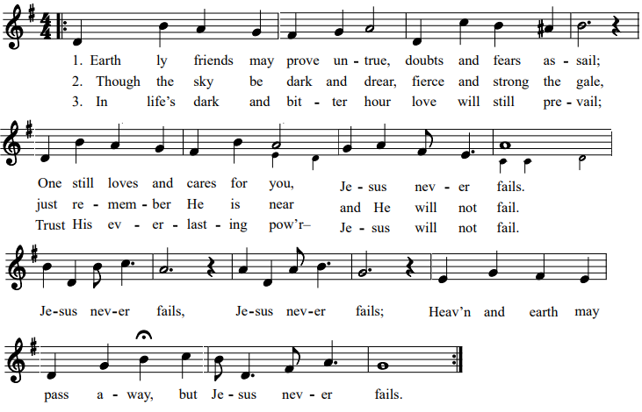
Jesus Never Fails

†creed
Affirmation from 1 Timothy ǀ UMH 889
call to confession
confession and pardon ǀ UMH 891
†doxology
Praise God, from Whom All Blessings Flow ǀ UMH 95
†prayer of thanksgiving
†closing hymn
O How I Love Jesus ǀ UMH 170

this week at colington
These opportunities to serve as the Body of Christ are available.
Today – Manna meal following worship.
Tuesday – 9 am – Prayer Group
6:15 pm – Beach fellowship
Wednesday – 12pm – Veterans’ lunch at Spring Arbor.

coming up
Next Sunday – Next Sunday – 8:30am – choir practice
9:30 am – Worship, in-person and Facebook Live
Wed., Sept. 9 – 7:30am – FCA breakfast at FFHS.
10am – Knitters and crocheters meet.
Thurs., Sept. 10 – 4pm – Mobile Food Pantry at FFES
Sat., Sept. 12 – 9am – UWF breakfast meeting.
Thurs. Sept. 17 – 7:30am - FCA breakfast at FFMS.
Sat., Sept. 19 – 9am - Men’s ministry breakfast meeting.
Wed., Sept.23 – 10am – Knitters and crocheters meet.
1:45pm – Volunteers to Beach Food Pantry.
Mon., Sept. 28 – 8:00am – Student of the Month at FFES.

Thanks to today’s volunteers!
Ushers – Steve Knowles/Ozzie Gray
Scripture Reader – Lynn Brooks
The flowers on the altar are given by Sherry Rollason in memory of her Mom, Vera Gallop’s birthday.

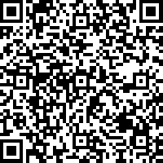
To make an electronic donation via Zelle, please use this QR code. You’ll need to provide the last four digits of your phone number.

