Birthday in a Box
Ingredients
- 1 cake mix
- 1 can Sprite or lemon/lime soda
- 1 can frosting
- 1 disposable cake pan
- 1 box birthday candles
Directions
- Mix per directions on cake box. Substitute can of soda for oil and eggs.
- Bake according to directions on cake box in disposable pan.
- Decorate with frosting.
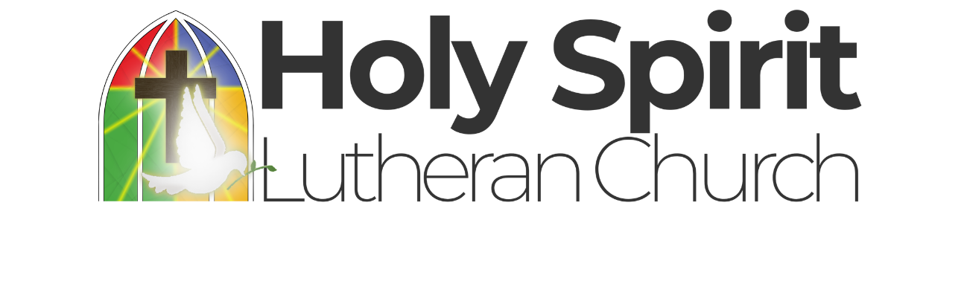
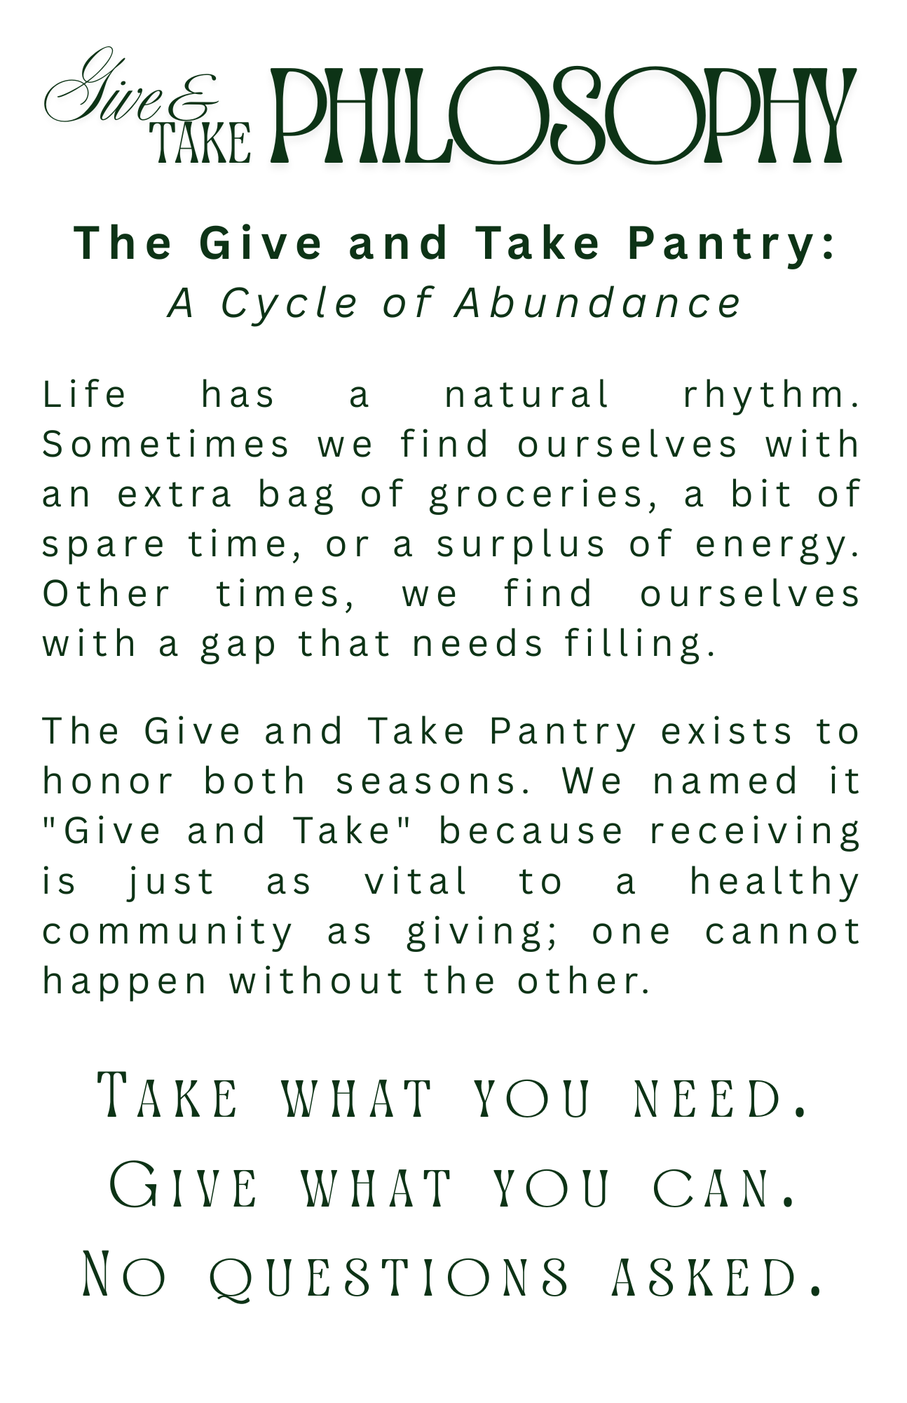

Birthday in a Box | Chicken and Biscuit Bake
Ingredients | Ingredients
- 1 cake mix  - 1 can Sprite or lemon/lime soda  - 1 can frosting  - 1 disposable cake pan  - 1 box birthday candles | - 2 cans chicken  - 1 can cream of chicken soup  - 1 can mixed vegetables  - 1 can evaporated milk  - 1 pkg biscuit mix
Directions | Directions
- Mix per directions on cake box. Substitute can of soda for oil and eggs.  - Bake according to directions on cake box in disposable pan.  - Decorate with frosting. | - Mix first four ingredients together and place into greased casserole dish.  - Mix biscuits according to directions and place on top,  - Bake in 350 degree oven.

