Creamy Chicken Chowder
Ingredients
- 1 can whole kernel corn, gently drained
- 1 can cream style corn
- 1 can diced potatoes
- 1 can cream of chicken soup
- 1-2 chicken bouillon cubes
Directions
- Combine cans of corn, potatoes, cream of chicken soup, and bouillon cube in a pot.
- Heat and serve.
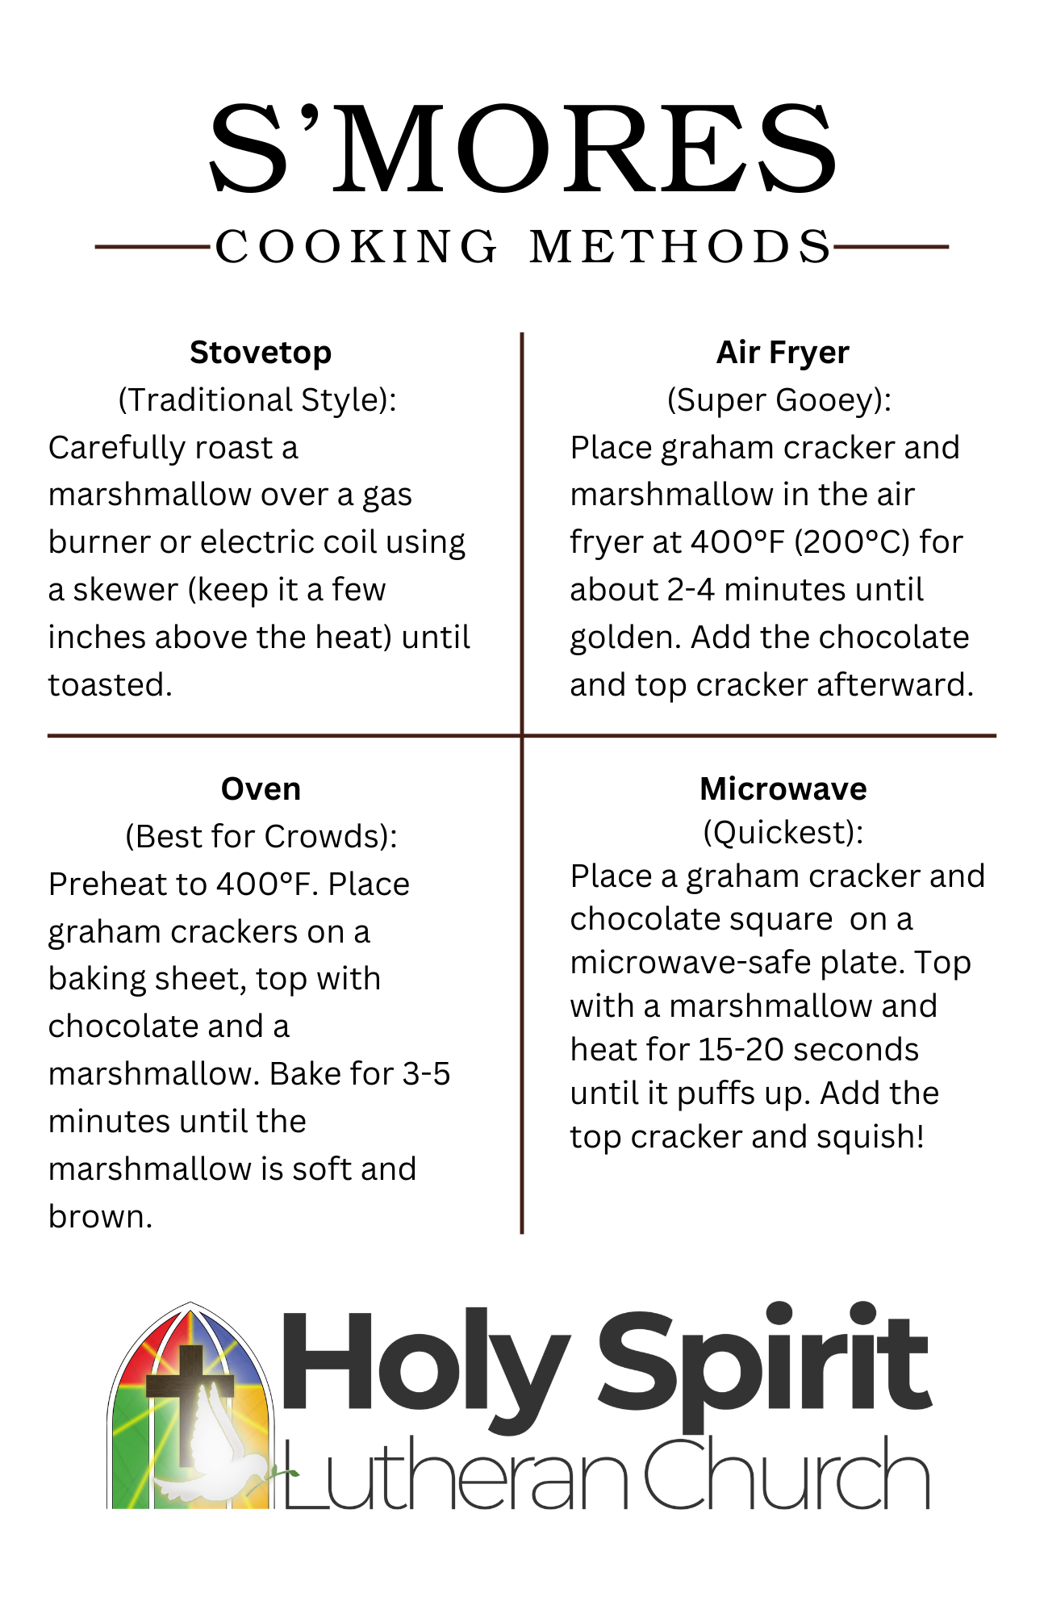


Creamy Chicken Chowder | Chicken and Biscuit Bake
Ingredients | Ingredients
- 1 can whole kernel corn, gently drained  - 1 can cream style corn  - 1 can diced potatoes  - 1 can cream of chicken soup  - 1-2 chicken bouillon cubes | - 2 cans chicken  - 1 can cream of chicken soup  - 1 can mixed vegetables  - 1 can evaporated milk  - 1 pkg biscuit mix
Directions | Directions
- Combine cans of corn, potatoes, cream of chicken soup, and bouillon cube in a pot.  - Heat and serve. | - Mix first four ingredients together and place into greased casserole dish.  - Mix biscuits according to directions and place on top,  - Bake in 350 degree oven.

