Ham and Bean Soup
Ingredients
- 1 can diced ham
- 1 can great northern beans
- 1 can mixed vegetables
- 1 bouillon chicken or vegetable cube
Directions
- Combine all ingredients in a pot. Add 1-2 cups water.
- Simmer for 10-15 minutes.
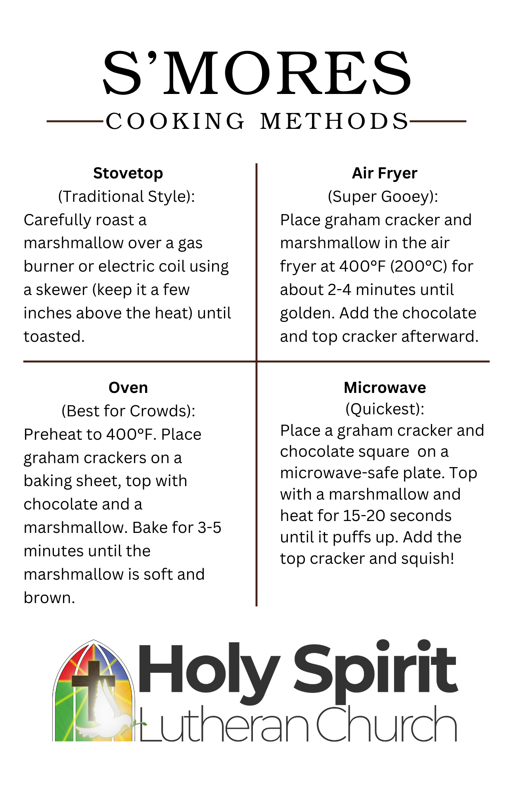
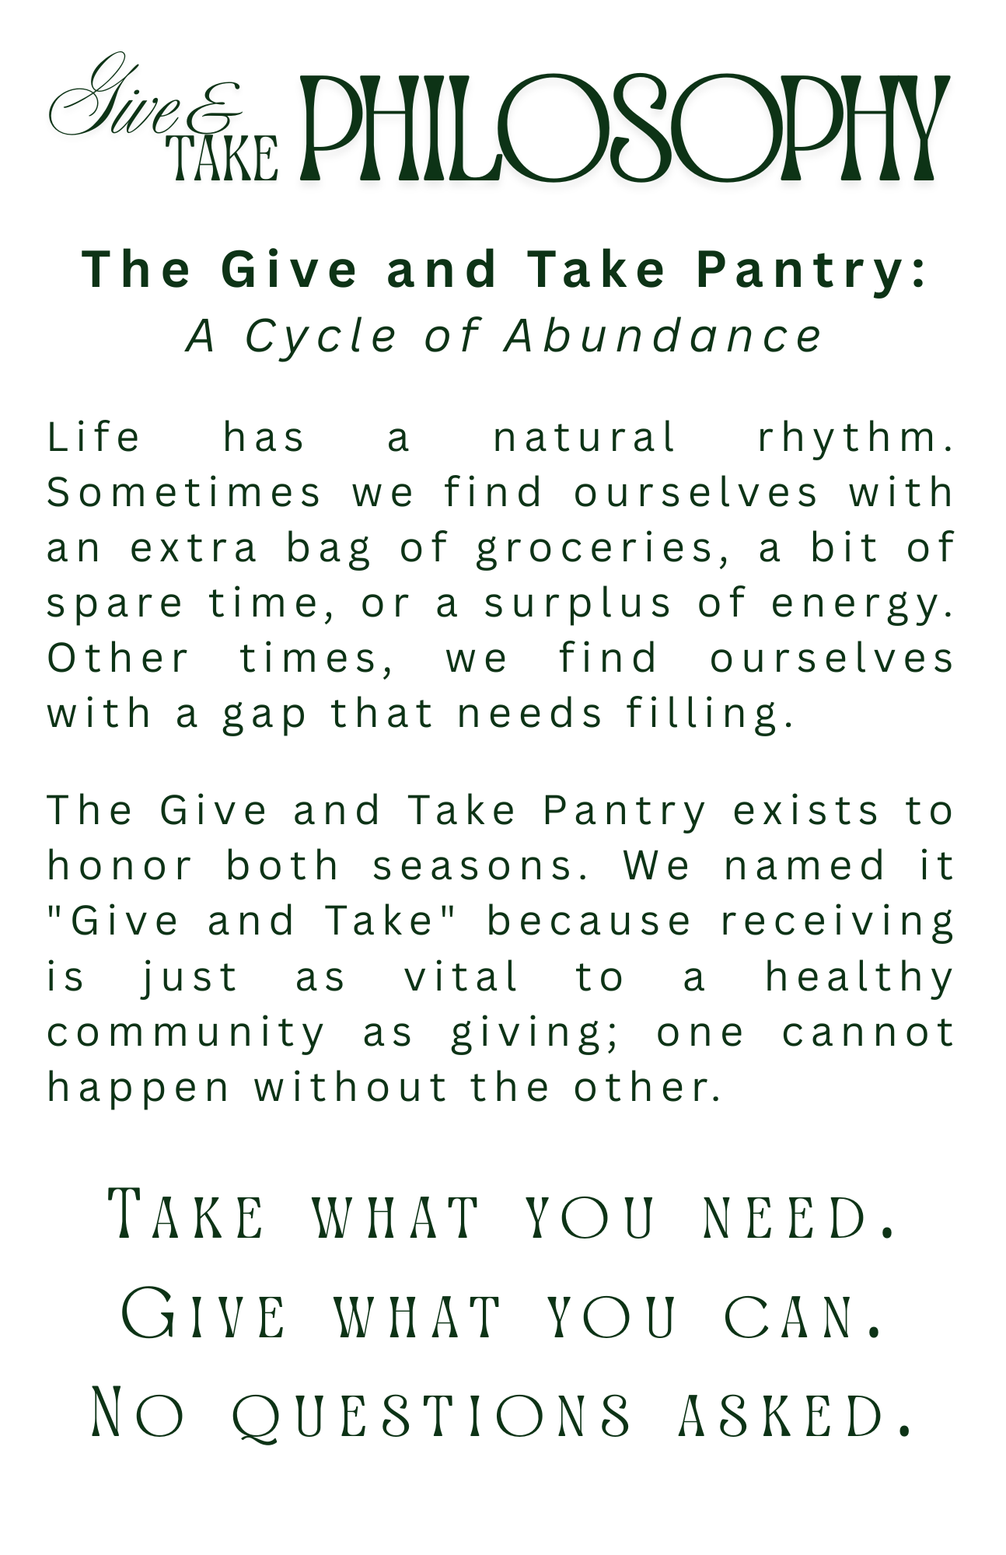

Ham and Bean Soup | Chicken and Biscuit Bake
Ingredients | Ingredients
- 1 can diced ham  - 1 can great northern beans  - 1 can mixed vegetables  - 1 bouillon chicken or vegetable cube | - 2 cans chicken  - 1 can cream of chicken soup  - 1 can mixed vegetables  - 1 can evaporated milk  - 1 pkg biscuit mix
Directions | Directions
- Combine all ingredients in a pot. Add 1-2 cups water.  - Simmer for 10-15 minutes. | - Mix first four ingredients together and place into greased casserole dish.  - Mix biscuits according to directions and place on top,  - Bake in 350 degree oven.

