Asian Inspired Dish
Ingredients
- 1 bag rice
- 1 cam stir fry vegetables
- 1 can water chicken
- teriyaki sauce
Directions
- Mix together ingredients and heat.
- Teriyaki sauce is added per your taste.
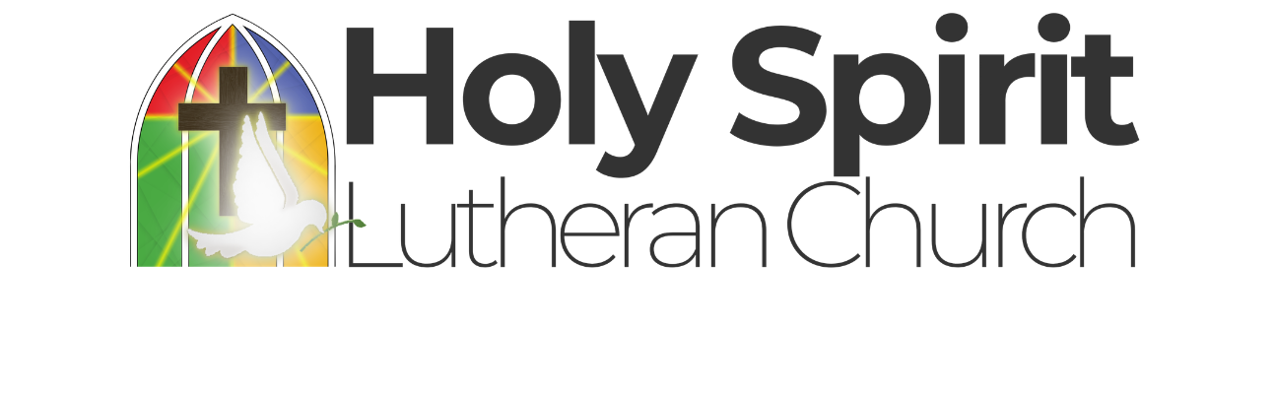


Asian Inspired Dish | Chicken and Biscuit Bake
Ingredients | Ingredients
- 1 bag rice  - 1 cam stir fry vegetables  - 1 can water chicken  - teriyaki sauce | - 2 cans chicken  - 1 can cream of chicken soup  - 1 can mixed vegetables  - 1 can evaporated milk  - 1 pkg biscuit mix
Directions | Directions
- Mix together ingredients and heat.  - Teriyaki sauce is added per your taste. | - Mix first four ingredients together and place into greased casserole dish.  - Mix biscuits according to directions and place on top,  - Bake in 350 degree oven.

