Turkey Dinner in a Bag
Ingredients
- 2 cans of turkey
- 1 box stuffing mix
- 1 can green beans
- 2 pkgs of instant mashed potatoes
- 1-2 pkgs turkey gravy mix
- dried cranberries
Directions
- Mix mashed potatoes per directions on package. Spread on bottom of a casserole dish.
- Layer drained green beans on top of mashed potatoes.
- Drain turkey, reserving broth. Place shredded turkey over green beans.
- Make turkey gravy, using broth in place of water. Pour over layered ingredients.
- Prepare turkey stuffing per directions on box. Add cranberries, if desired.
- Distribute stuffing over top as the final layer. Add pat of butter, if desired.
- Bake at 400 degrees for 30-40 minutes.
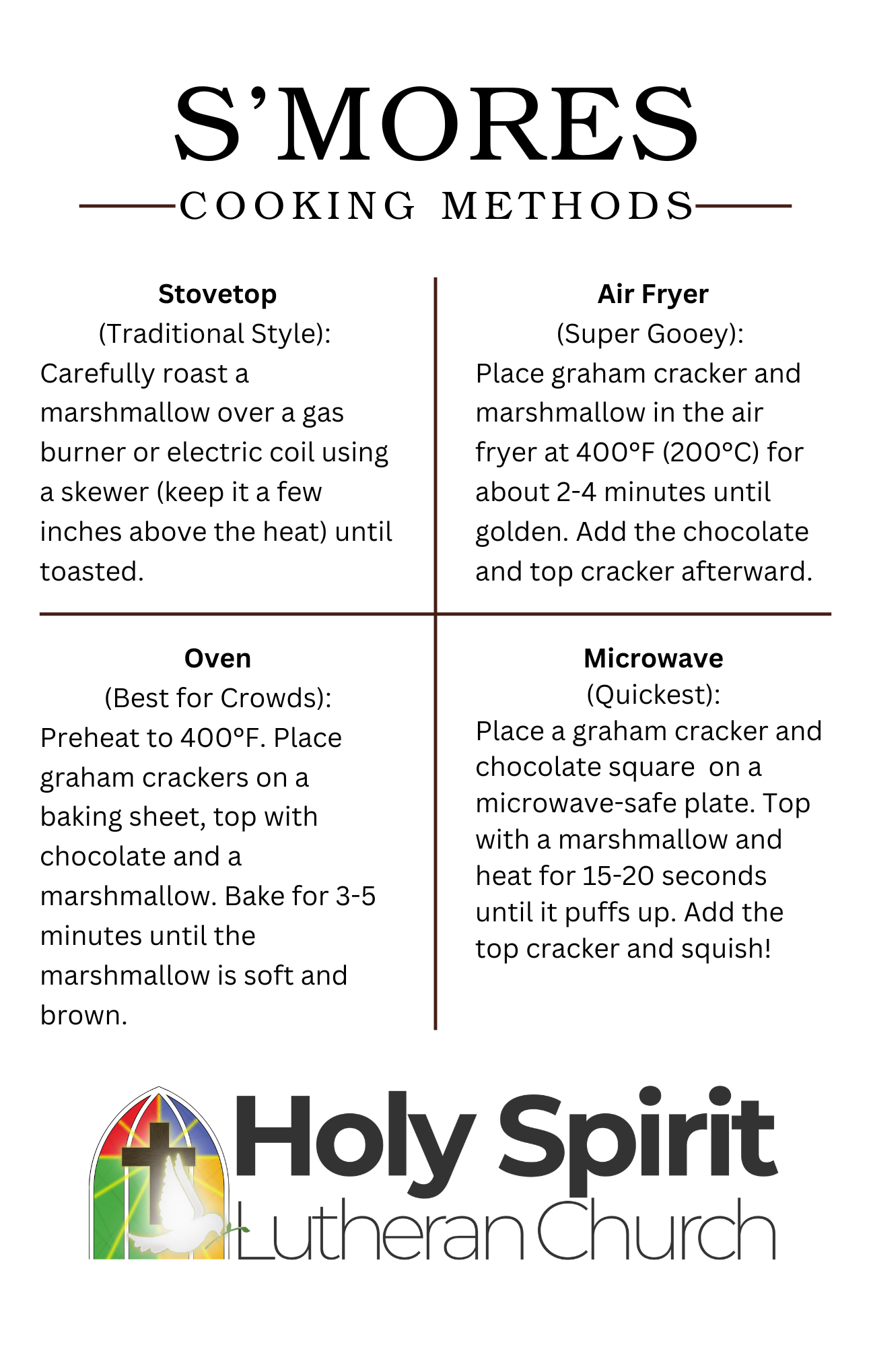
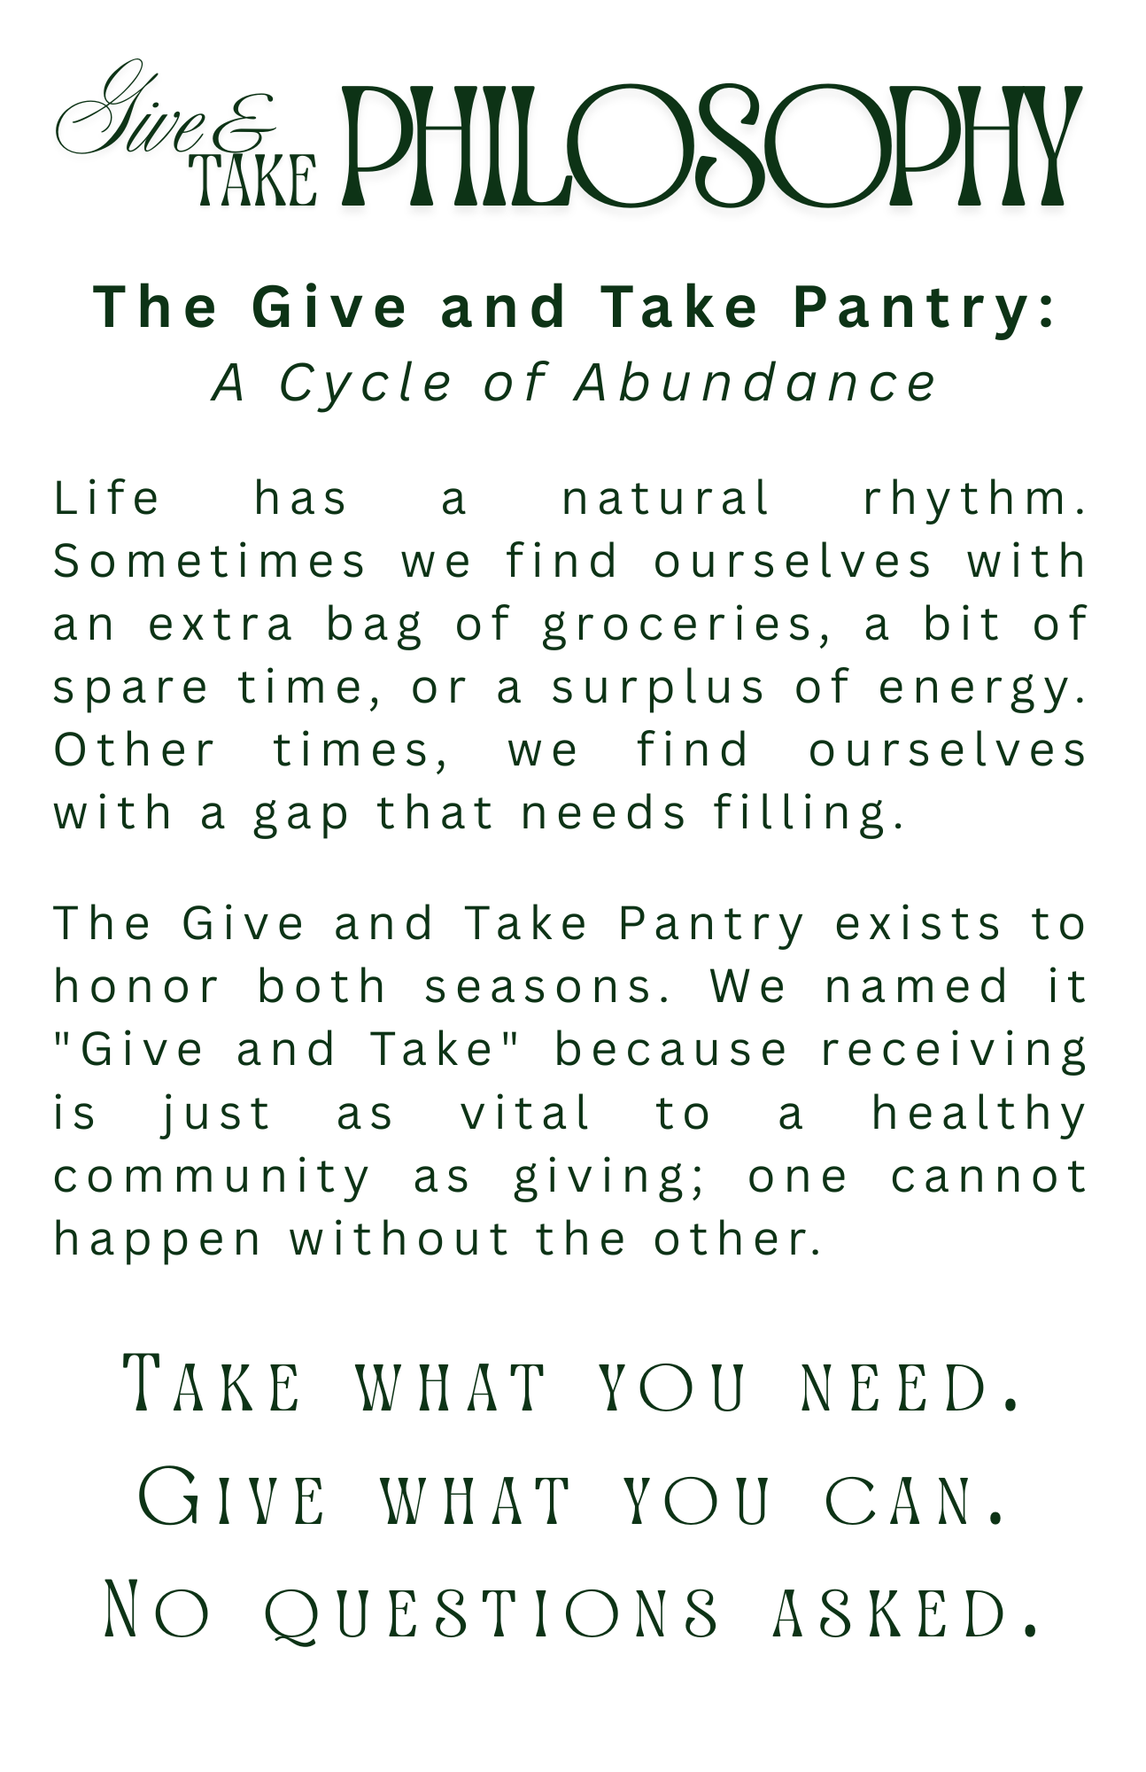

Turkey Dinner in a Bag | Chicken and Biscuit Bake
Ingredients | Ingredients
- 2 cans of turkey  - 1 box stuffing mix  - 1 can green beans  - 2 pkgs of instant mashed potatoes  - 1-2 pkgs turkey gravy mix  - dried cranberries | - 2 cans chicken  - 1 can cream of chicken soup  - 1 can mixed vegetables  - 1 can evaporated milk  - 1 pkg biscuit mix
Directions | Directions
- Mix mashed potatoes per directions on package. Spread on bottom of a casserole dish.  - Layer drained green beans on top of mashed potatoes.  - Drain turkey, reserving broth. Place shredded turkey over green beans.  - Make turkey gravy, using broth in place of water. Pour over layered ingredients.  - Prepare turkey stuffing per directions on box. Add cranberries, if desired.  - Distribute stuffing over top as the final layer. Add pat of butter, if desired.  - Bake at 400 degrees for 30-40 minutes. | - Mix first four ingredients together and place into greased casserole dish.  - Mix biscuits according to directions and place on top,  - Bake in 350 degree oven.

