Tuna Noodle Casserole
Ingredients
- 2 cans tuna
- 1 can cream of mushroom soup
- 1 can peas
- 1 bag noodles, or pasta
- 1 sleeve Ritz crackers
Directions
- Mix together tuna, peas, and soup, adding water to desired consistency.
- Cook noodles per directions on package.
- Mix noodles with tuna mix. Place into buttered casserole dish. Put crushed crackers on top of mixture.
- Heat and serve.
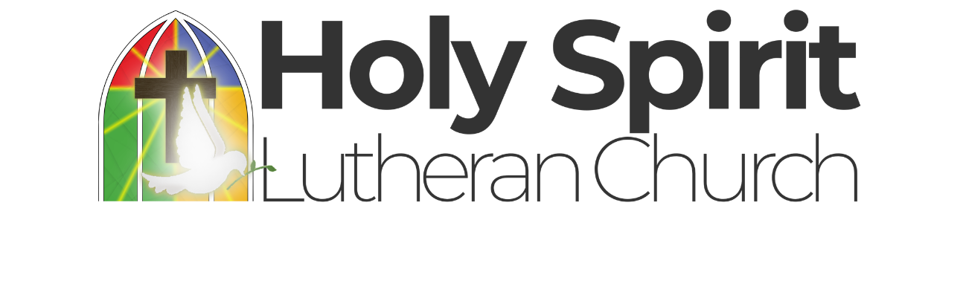


Tuna Noodle Casserole | Chicken and Biscuit Bake
Ingredients | Ingredients
- 2 cans tuna  - 1 can cream of mushroom soup  - 1 can peas  - 1 bag noodles, or pasta  - 1 sleeve Ritz crackers | - 2 cans chicken  - 1 can cream of chicken soup  - 1 can mixed vegetables  - 1 can evaporated milk  - 1 pkg biscuit mix
Directions | Directions
- Mix together tuna, peas, and soup, adding water to desired consistency.  - Cook noodles per directions on package.  - Mix noodles with tuna mix. Place into buttered casserole dish. Put crushed crackers on top of mixture.  - Heat and serve. | - Mix first four ingredients together and place into greased casserole dish.  - Mix biscuits according to directions and place on top,  - Bake in 350 degree oven.

