Chicken and Biscuit Bake
Ingredients
- 2 cans chicken
- 1 can cream of chicken soup
- 1 can mixed vegetables
- 1 can evaporated milk
- 1 pkg biscuit mix
Directions
- Mix first four ingredients together and place into greased casserole dish.
- Mix biscuits according to directions and place on top,
- Bake in 350 degree oven.
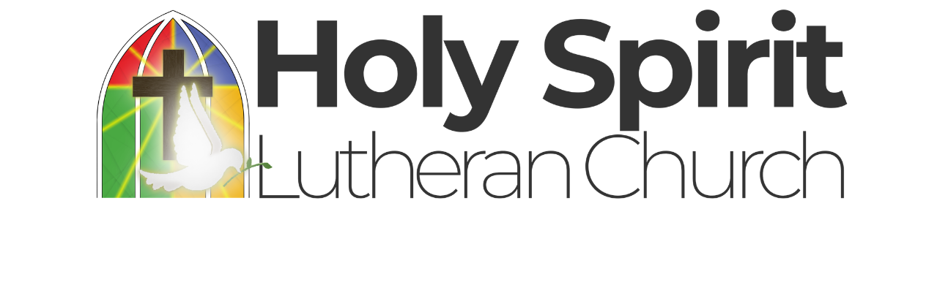


Chicken and Biscuit Bake
Ingredients
- 2 cans chicken
- 1 can cream of chicken soup
- 1 can mixed vegetables
- 1 can evaporated milk
- 1 pkg biscuit mix
Directions
- Mix first four ingredients together and place into greased casserole dish.
- Mix biscuits according to directions and place on top,
- Bake in 350 degree oven.

