Chili Mac
Ingredients
- 1 box deluxe mac and cheese
- 1 can chili (with or without beans)
- 1 can diced tomatoes with or without green chilis
Directions
- Prepare mac and cheese per directions on box.
- Stir in chili and diced tomatoes.
- Heat and serve.
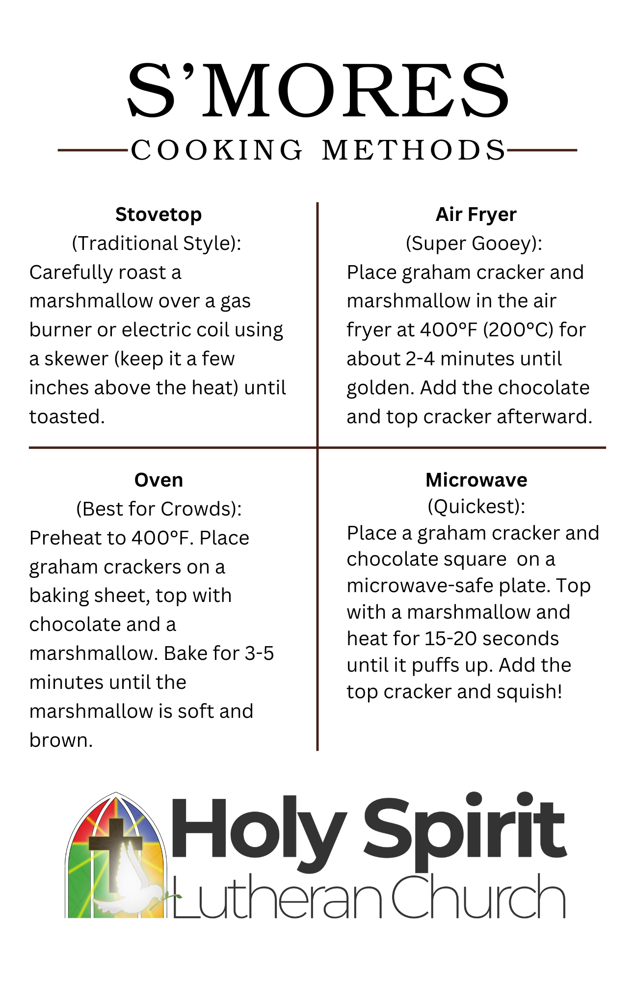


Chili Mac | Chicken and Biscuit Bake
Ingredients | Ingredients
- 1 box deluxe mac and cheese  - 1 can chili (with or without beans)  - 1 can diced tomatoes with or without green chilis | - 2 cans chicken  - 1 can cream of chicken soup  - 1 can mixed vegetables  - 1 can evaporated milk  - 1 pkg biscuit mix
Directions | Directions
- Prepare mac and cheese per directions on box.  - Stir in chili and diced tomatoes.  - Heat and serve. | - Mix first four ingredients together and place into greased casserole dish.  - Mix biscuits according to directions and place on top,  - Bake in 350 degree oven.

