Announcements

Monday, August 31
Repair café meeting Board room 1:00p.m.
Beaver Valley Band Banquet hall 5:30p.m.

Tuesday, September 1
Affirming Group Board room 4:00p.m.

Thursday, September 3
Thursday night group Banquet hall 7:00p.m.

Saturday, September 5
5th Street Creative Concert Sanctuary 7:00p.m.

Broadview subscriptions
Braodview group subscription renewal
We have a group subscription to Broadview magazine available to anyone who is interested in saving a few dollars on the annual subscription price.
The group rate for 2027 is $30.00 and is due September 1. Payment can be made by cash or cheque or e-transfer to piercy.ray@gmail.com
Should you have any questions, ask Ray!

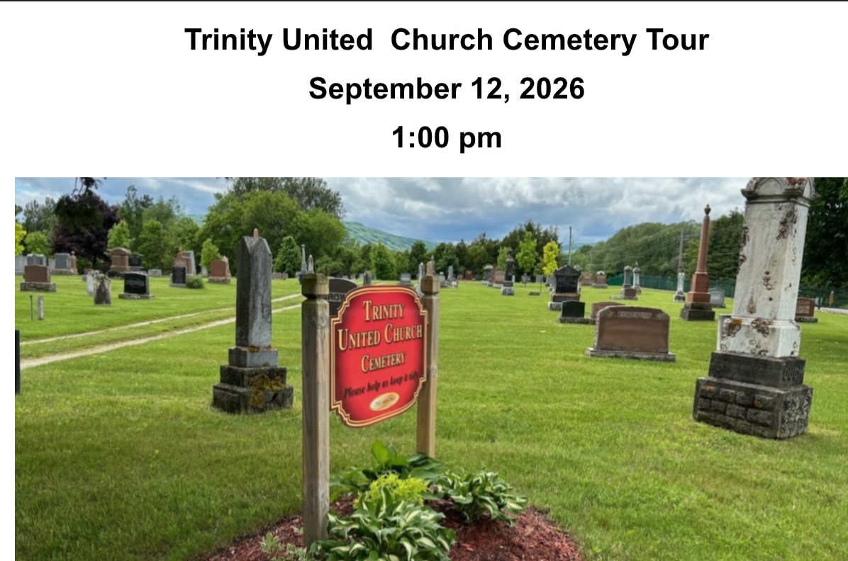

Join us for a thoughtful and informative afternoon as the Trinity United Church Cemetery Board invites you to explore the rich history resting beneath our grounds.

Ralph Sneyd, our resident historian, will guide you through stories of Collingwood’spast, highlighting the lives and legacies of some of our town’s most notable citizens.

Larry Hogarth will also be present to answer questions about burial plots, urns, thecolumbarium, and other end-of-life arrangements.
Whether you’re curious about local history or planning for the future, this tour offers ameaningful way to connect with our community’s heritage.

Note:
You may wish to bring a folding chair to be comfortable at the history sites.

Adult Book Study
Valley of the Birdtail an Indian reserve, a white town and the road to reconciliation.
Mondays from 10:00 – 11:30 September 14, 21, 28 and October 5
Through the tale of two towns ( Rossburn and Waywayseecapo) learn more about racism, the Indian Act, Residential Schools, and the way forward.
Contact Beth about getting a copy from the library book club kit and which chapters we are discussing each week.

Prayer Shawl ministry
Will meet on Monday September 14 and Monday September 28 @ 1:30p.m. in the board room

New Opportunity!
Come help lead the way, as a member of our new Affirming Ministry Committee. Further details to follow in September.
If you just can't wait for the details, please feel free to contact Beth Theis: 705-627-2606 or beth.theis2@alumni.utoronto.ca or Bev Mayberry: 705-606-0565 or mayberrybev@gmail.com

Church office hours
The office will be closed on Friday’s until the end of summer.



Please remember that if you are away during the summer but still want to catch our service, with the exception of our outdoor service on July 26, you can follow us on YouTube https://www.youtube.com/@collingwoodtrinityunitedch5278/streams

Rev. Beth Kerr (she/her)
Diaconal Minister
Trinity United Church
140 Maple Street,
Collingwood, ON L9Y 2P8
www.collingwoodunitedchurch.ca
705-445-3901 (church)
204-872-2370 (cell)
Please note: Friday and Saturday are my sabbath days. I will reply to emails received on those days on the following Monday. For emergencies, please contact my cell phone.

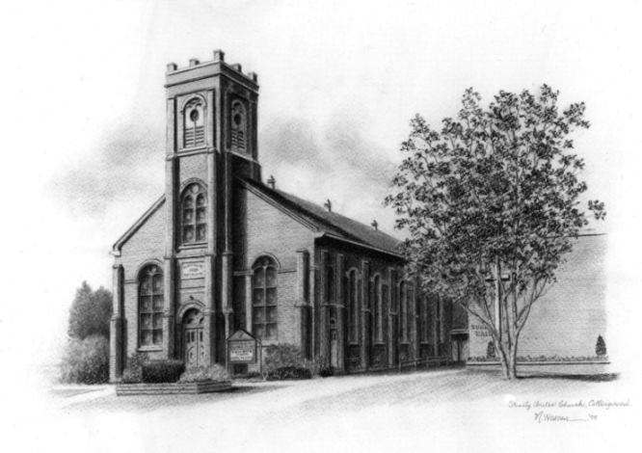

Trinity United Church: Collingwood
Minister: Rev. Beth Kerr, 204.872.2370 (cell)
Minister’s Email minister@collingwoodunitedchurch.ca
Ministry of Music: Paul Sloan, 705.730.3121 (cell)
Choir Director: Lesley Joosten, 705.984.3243
Handbell Director: Maryellen Burgess, 705.443.1422 (cell)
UCW President: Joy Barr 705.445.0726
Office Assistant: Lori Forsythe
Church Office: office@collingwoodunitedchurch.ca
Office Hours: Tuesday to Friday, 8:30 am-12:00 pm
140 Maple Street, Collingwood, ON L9Y 2P8
Telephone: 705.445.3901
Website: www.collingwoodunitedchurch.ca

