ENCOUNTERS WITH TRUTH

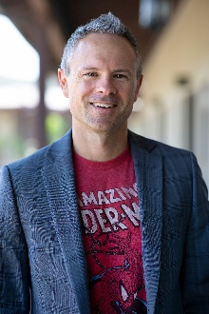
SEAN MCDOWELL
September 27th

Magnolia Baptist Church
720 S. Magnolia Avenue
Anaheim, CA 92804

9:30 AM: 9 LIES MASQUERADING AS THE GOSPEL TRUTH
The culture and church are filled with false gospels. They are literally everywhere. What are they and how do we identify them? In this message, Sean uses Galatians 1:8-9 as a springboard to discuss 9 of the most common false gospels appearing in the culture today. And he talks about the heart and power of the one true gospel.

11:00 AM: DID THE APOSTLES REALLY DIE AS MARTYRS?
One of the most common evidences given to trust the reliability of the apostolic testimony is their willingness to die as martyrs. And yet, what is the evidence for their fates? And what about others who have died for their beliefs? In this session, Sean examines the historical evidence for the deaths of the various apostles and shows how this helps confirm their sincere conviction that Jesus rose from the dead.
About Dr. Sean McDowell: Sean is a professor of Apologetics at Talbot School of Theology, Biola University. His Ph.D. is in Apologetics and Worldview Studies. He is the author, editor, or co-author of more than 20 books including More Than A Carpenter, Chasing Love, End the Stalemate, and The Fate of the Apostles. He is the co-host of the Think Biblically podcast. Learn more about him on his website www.seanmcdowell.org.


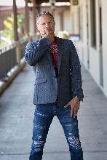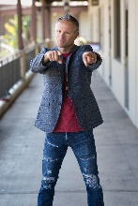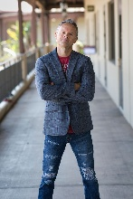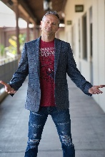

Magnolia: A place of Truth
Prayer, Praise, Community, New Life, Family, Learning,
Celebration, Truth, Service, Mission, Thankfulness, Joyl
(714) 827-0553 www.magnoliabaptist.church
ENCOUNTERS WITH TRUTH
SEAN MCDOWELL
September 27th

Magnolia Baptist Church
720 S. Magnolia Avenue
Anaheim, CA 92804

9:30 AM: 9 LIES MASQUERADING AS THE GOSPEL TRUTH
The culture and church are filled with false gospels. They are literally everywhere. What are they and how do we identify them? In this message, Sean uses Galatians 1:8-9 as a springboard to discuss 9 of the most common false gospels appearing in the culture today. And he talks about the heart and power of the one true gospel.
11:00 AM: DID THE APOSTLES REALLY DIE AS MARTYRS?
One of the most common evidences given to trust the reliability of the apostolic testimony is their willingness to die as martyrs. And yet, what is the evidence for their fates? And what about others who have died for their beliefs? In this session, Sean examines the historical evidence for the deaths of the various apostles and shows how this helps confirm their sincere conviction that Jesus rose from the dead.
About Dr. Sean McDowell: Sean is a professor of Apologetics at Talbot School of Theology, Biola University. His Ph.D. is in Apologetics and Worldview Studies. He is the author, editor, or co-author of more than 20 books including More Than A Carpenter, Chasing Love, End the Stalemate, and The Fate of the Apostles. He is the co-host of the Think Biblically podcast. Learn more about him on his website www.seanmcdowell.org.

Magnolia: A place of Truth
Prayer, Praise, Community, New Life, Family, Learning,
Celebration, Truth, Service, Mission, Thankfulness, Joyl
(714) 827-0553 www.magnoliabaptist.church

