THE ORDER OF WORSHIP
August 23, 2026/13th Sunday of Pentecost
Greeter: Dale Dixon and Rachel Hawk
Please fill out your Prayer & Praise Cards. Announcements are on the screens. Please come to the front pews to meet with a member of our Prayer Team before or after the service.
Gathering
Prayer of Consecration: Pastor John
One: Wake up, sleeper, rise from the dead,
All: and Christ will shine on you. Jesus, I belong to you. I lift up my heart to you. I set my mind on you. I fix my eyes on you. I offer my body to you
as a living sacrifice. Jesus, we belong to you. Praying in the name of the Father, and the Son, and the Holy Spirit, amen.

Opening Chorus: “Awesome God” No. 2040 TFWS
Prelude: “A Blessing” Gerald Peterson
Bringing In the Light of Christ: Rachel Hawk
Welcome and Announcement: Joanne Corley

*Call to Worship: Joanne Corley
One: We see light, hope, and joy;
All: We bring heart, soul, mind, and body;
One: We share blessings and fears;
All: We bring faith and doubt. With all that we are and
all that we have, let us worship God.

Greeting Our Brothers and Sisters in Christ

Proclamation and Response
*Opening Hymn: “Be Thou My Vision” No. 49
(Collection of Prayer & Praise Cards)
Joys and Concerns: Pastor John
Prayer Chorus: “Jesus Be Praised” No. 2079
Silent Prayer & Pastoral Prayer /Lord’s Prayer: Pastor John

Anthem: “Trust and Obey/I Will Trust in the Lord” Men’s Chorus

Collection of Tithes and Offerings: Buddy and Kathie Whitlow
*The Doxology: “My Tribute” On the Screen
*The Nicene Creed: No.693

Scripture Reading: Series: Letters of John
1 John 2:24-27
One: The word of God for the people of God.
All: Thanks be to God and I believe it.

Sermon: “Orthodoxy” Pastor John

Sending Forth
*Closing Hymn: “Standing in the Need of Prayer” No. 444
Postlude: “Theme for Flute” Carl Simone

Please be seated. You are invited to close your eyes and use the few moments of music at the end of our service to practice Listening Prayer. This is a time to expect God to speak to you before you leave the sanctuary. In John 10:17, Jesus tells us; “My sheep hear my voice, and I know them, and they follow me.” Let’s try listening as we are silent and still. Members of the prayer team will remain on the front pews after the service. Feel free to come forward.
Benediction: Pastor John

ANNOUNCEMENTS

TO OUR VISITORS: We welcome you to Laurel Hill and hope that you feel at home. We invite you to join Laurel Hill if you do not have a church home. Please call our church office at 804-795-2772. You will find our Laurel Hill family both warm and eager to welcome you into our fellowship. Please fill out a visitor’s card and place it in the offering plate. The password for our public WiFi is LivingHope - feel free to connect with us.

OPERATION CHRISTMAS CHILD SHOEBOXES…As we continue to collect for our shoeboxes this month, please consider giving school items like pens, pencils, sharpeners, crayons, markers, small notebooks and coloring books. Thank you.

PLEASE TAKE AN UPDATED CHURCH DIRECTORY from the table as you leave today. If you see something that needs to be changed in your entry, please let us know in the office so we can keep a good update. Thanks to Ben Wilson for all his diligence in making us this new directory. We will update every six months to stay current.

FISH is collecting pasta and noodles for August.

CHANCEL CHOIR AND HANDBELL CHOIR…We want you! We need you! Here’s an opportunity for you to share your talents! The choir needs you!! Come praise God and have fun singing. The choirs (Bells and Chancel) will start back on Wednesday, September 2nd. Bells will ring at 6:45 P.M. and Chancel Choir will sing at 7:30 P.M. Let’s make every Wednesday our “Joyful Noise to the Lord Day”. We really do have a great time of fellowship and laughter while singing and ringing!

THE MONDAY NIGHT BIBLE STUDY will begin a new series on Isaiah. It will begin on September 14th at 7:00 P.M., on zoom and in person. We will have a little vacation for the next two Monday evenings before we begin the new study. If you have not joined a study before, now is a good time to begin. If you have questions, call the office or ask Pastor John.

NEWSLETTER ARTICLES are due at the beginning of this week. Thank you!

SICK AND SHUT-INS – Kim Davis, Jean Miller, Evelyn Steele, Kathleen McKinsey, Sara Nelson, Regina Humphrey, David Torrence, Dot Gay, Sharon Loving & Family, Debra Deane, Agnes Stevenson and ML Yuhas.

KEEP IN OUR PRAYERS
- Our Weekday School – Margo Keeles (Director), our teachers, students and families.
- Our community of Varina and all the residents, our churches in our neighborhoods, schools, students, teachers, administrators and all employees.
- Our state of Virginia, our residents and leaders.
- The United States of America, our citizens and leaders, the countries of the world, their people and leaders. May God bless us all and His will be done.
- Those affected by war in Israel and Ukraine

WEEKLY CALENDAR

Monday 10:00 AM New Life House Church today. (804) 303-4828
No Bible Study/New Study on Isaiah begins September 14th @ 7 PM
Come join us in person or on Zoom.

Tuesday 7:30 AM “Listening to God”

Wednesday 9:00 AM Prayer Time with Communion
10:30 AM Bible Study today.

Thursday 7:30 AM “Listening to God”
7:00 PM PTL House Church at the Wilson’s (804) 795-7723

Friday 10:00 Thankful Hearts House Church (804) 737-7450

Saturday 9:00 AM Prayer Station at Dorey Park.

Sunday 10:00 AM Sunday School
10:30 AM Chancel Choir
11:00 AM Sunday Worship Service (also online)

Stewardship in the Bible
By Joshua Godon, https://theleadpastor.com/ (adapted)

Ten Fundamentals of Biblical Stewardship
3. We Will Give An Account of Our Stewardship (Accountability)
We will be held accountable for how we manage our resources. Stewardship includes accountability (Romans 14:12, Matthew 25:14-30, 2 Corinthians 5:10).

Do you prioritize the things that are most important to Jesus, or the things that are most urgent? Do you coast on your natural strengths, or do you work diligently to build healthy habits? It is the hope and joy of every believer and every pastor that one day they will hear the Lord say, “Well done, good and faithful servant". Taking good care of the time, energy, and relationships we've got - that's part of stewardship.

Stewardship is so much bigger than just 'trust God with your money' (aka: give the church your money)... it's about intimacy with Jesus, a close relationship of trust, where HE guides our action, not some misplaced sense of guilt or obligation.
How can you give at Laurel Hill GMC?

1 – Cash and checks may be placed in the offering plate. Please contact the church office for offering envelopes.
2 - You may also give online. The QR code below will take you to our website’s giving page: https://laurelhill.tithelysetup.com/give

3 – Planned giving – including the LHGMC in your will is a wonderful way to ensure the ministries we are called to provide for Varina will continue into the future.

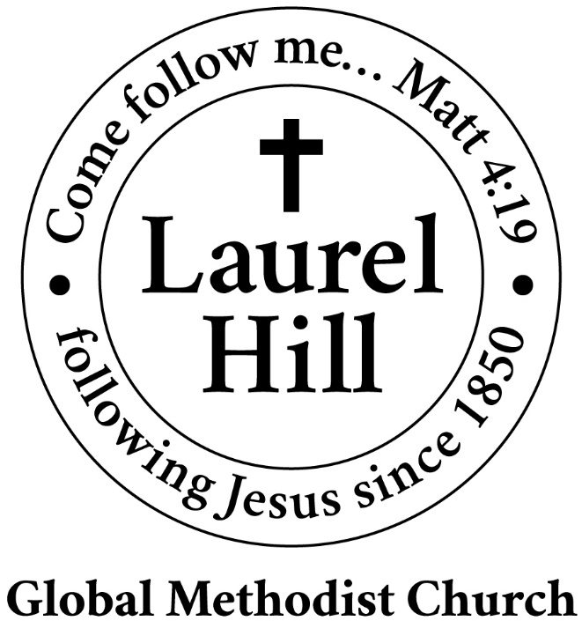
Our Mission: The Global Methodist Church exists to make disciples
of Jesus Christ and spread scriptural holiness across the globe.

1919 New Market Road, Henrico, VA 23231
On the web @ laurelhillchurch.org
Email to laurelhillchurch.varina@gmail.com
Phone: Office/804.795.2772 Pastor/804.437.0937

STAFF
Pastor: Rev. John Bright Organist/Choir Director: Pam Wilson
Secretary: Barbara Wendel School Director: Margo Keeles
Communications Assistant: Ben Wilson

that we you in thought, word, and deed.

