EAST FAIRFIELD UNITED METHODIST CHURCH
Pastor: Kristen Buchs
Organist: Ruth Rowley Ministers: The Congregation
Pianist: Nancy Setinsek Choir Director: Randy Hart

Sunday, August 23, 2026
Thirteenth Sunday after Pentecost

*Please stand in body or spirit as you are able

Welcome! We invite you to take this time to prepare for worship. In these
moments, quiet your inner voice, become aware of being in community with
others, and open your heart and mind to the leading of the Holy Spirit.

GATHERING “Give Ear Unto Our Prayer” - Dillon
“Blessed Jesus at Your Word” - Birchwood

CHRIST LIGHT ENTERS

MISSIONS AND MINISTRY UPDATEs Jeannie Arnoto, Liturgist

PREPARING OUR HEARTS AND MINDS FOR WORSHIP

WORDS OF PREPARATION AND CENTERING

PRELUDE “My Savior’s Love” - Gabriel

*CALL TO WORSHIP
L: Come, all who feel alone, forgotten, or unsure.
P: God is here – faithful in every moment.
L: Come, all who rejoice and give thanks.
P: God rejoices with us and receives our praise.

L: In all seasons, through all things.
P: We worship the One who never leaves us.

*OPENING PRAYER
Dear Lord, in this sacred space, we come as individuals, each with
our unique joys and burdens, but we also come as a family bound
by our faith in you. We pray for unity and fellowship as we gather
for this church service. Let your love flow through us, binding us
together in a spirit of togetherness and support.

May our differences enrich our worship, and may we find strength
in our shared belief in your divine presence. Lord, help us grow
closer as a church family, supporting one another on our journey
of faith. Amen.

*OPENING HYMN “Here I Am, Lord” UMH #593

FIRST READING Mark 11:24 (NIV) Page 823

CHILDREN’S MOMENT

SPECIAL MUSIC “My Redeemer Lives” Jeannie Arnoto

OFFERING OURSELVES & OUR GIFTS
INVITATION
OFFERTORY “Sweet By and By” - Webster
*DOXOLOGY UMH #95
*DEDICATION OF GIFTS

SEEKING GOD’S WORD

SECOND READING James 1:6 (NIV) Page 977

SHARING OF JOYS & CONCERNS

SILENT PRAYER
PASTORAL PRAYER
THE LORD’S PRAYER

*HYMN “It Is Well with My Soul” UMH #377

SERMON TEXT John 6:35

SERMON “Faith Requirements” Pastor Jeff Pellin

RESPONDING TO GOD’S WORD

*CLOSING HYMN “How Great Thou Art” UMH #77

SENDING FORTH WITH BLESSING
*BLESSING
LIGHT OF CHRIST GOES INTO THE WORLD
~ Go with joy to serve the Lord ~

As we conclude our service, please join us downstairs for a time to relax, continue conversations, and enjoy coffee and refreshments.

Sound: Bill Rowley
Computer: Vicki Freeman
Livestream: Hannah Roberts

Next Sunday, August 30: David Vollnogle, Liturgist
Please keep in mind that the service is live-streamed and
recorded for public access. Please keep prayer requests
brief and do not use last names or identifying details.

PRAYER REQUESTS AUGUST 23, 2026
To submit a prayer request call Denise at 330-457-2465 or 330-727-9832
If you desire a home or hospital visit call Pastor Kristen (216-559-9893)
Prayer Blankets: call Joyce Ward (330-692-3346)

Jerry M – knee surgery on Monday, August 24.
Bob D
Kara V.
Kelly L (Alice Peppel) – prayers for safe delivery of baby Rosa.
Calli (Joni’s daughter) had a baby, Anthony Michael.
Joe S. (Charlie’s son) – in need of prayers.
Ian & Katie MacGillivray - had a baby girl, Norah, on May 29.
Jon E – has been dealing with cancer. Now under hospice care.
Dorothy F – hospice care.
Walt D. – hospice care.
John V ( Cindy Wright) – had triple bypass surgery. On a ventilator.
Jim (Kathy Mikesell’s friend) – seizures.
Matt (Grant’s friend) - cancer.
Angel F – medical issues.
Marcia M – health issues.
Cameron – deployed to Middle East. Has a wife and 2 children.
Blake (Elaine’s grandson) – Still not hearing well after ear surgery.
Melissa (Grant & Missy’s niece) – cancer. Continued prayers appreciated.

HOMEBOUND
Dolly K. Anita M. Bob D (Whispering Pines)
Tom & Marie Linda S. Zelda C. (Whispering Pines)
Dorothy F. Esther C. Bill H. (Christian House)
Walt D. (Christian House)

IN MINISTRY
Kristen Buchs Edie Boles Jeff Pellin

Church: 330-457-2465 Pastor Kristen: 216-559-9893
Ch Email:efumc@comcast.net Email: pastorkristen0712@gmail.com
Web: www.eastfairfieldumc.com
CCLI # 1994841 CVLI #504 011 134


East Fairfield
United Methodist Church

August 23, 2026
9:30 AM



Pastor Kristen Buchs
216-559-9893
45675 State Route 558
New Waterford, OH 44445

“Working, playing, and praying together on our
faith journey, to share Jesus Christ with everyone.”

Sun | Mon | Tue | Wed | Thu | Fri | Sat
Aug. 23  9:30 Worship  10:30 Coffee  10:45 Sunday  School | Aug. 24  12:00 Joy  Circle  Women’s  Luncheon | Aug. 25  8:00 Men’s  Coffee  Newsletter Deadline  2:30 -3:00  District Strategy with DS Liming  at E. Fairfield | Aug. 26 | Aug. 27  9:00  Newsletter  Mailing | Aug. 28  Pastor’s Day Off  Office Closed  5:30 PM  Making  ice cream | Aug. 29  4:30-7  Ice Cream  Festival
Aug. 30  9:30 Worship  10:30 Coffee  10:45 Sunday  School | Aug. 31  6:00 Cub  Scout  Meeting | Sept 1  8:00 Men’s  Coffee | Sept 2  6:00  Mt. Zion Comforting Cards | Sept. 3 | Sept 4  Pastor’s Day Off  Office Closed | Sept 5
Sept 6  Communion  9:30 Worship  10:30 Coffee  10:45 Sunday  School | Sept 7  Labor Day (Office Closed) | Sept 8  8:00 Men’s  Coffee  - Ladies’ Day  at Dale Wilhelm’s cabin | Sept 9  7:00 Scripture & Suds at  VINEYARDS  Pine Lake | Sept 10 | Sept 11  Pastor’s Day Off  Office Closed | Sept 12  Fellowship  Hall in Use  (Marriner)
Sept 13  9:30 Worship  10:30 Coffee  10:45 Sunday  School  11:00 Mt. Zion First Responder Sunday followed by a  covered-dish  lunch | Sept 14  6:00 Cub  Scout  Meeting | Sept 15  8:00 Men’s  Coffee | Sept 16  6:00 Worship Committee | Sept 17  7:00 Faith United Consult with DS Bill Liming at Lisbon UMC | Sept 18  Pastor’s Day Off  Office Closed | Sept 19  2:00  Creamed Chicken Drive Thru Dinner at Emmanuel  UMC


Ice Cream Festival
Saturday August 29 | 4:30 – 7:00 PM

Making Ice Cream Friday August 28 | 5:30 PM
Potluck - Bring a Side or Dessert to Share

Sign Up for Pie and Cake Donations in Foyer

Pre-Sale To Go Orders
Pre-packed to go orders of sandwich meat, sides, and vanilla ice cream. Single to go meals, buns, baked goods, and flavored ice cream available for carryout purchase at festival.

SANDWICHES | PINTS $12  Approx. 4 Sandwiches | QUARTS $18  Approx. 8 Sandwiches
Hot Turkey
Sloppy Joe

SIDES | PINTS $6  Approx. 4 Servings | QUARTS $10  Approx. 8 Servings
Cheesy Potatoes
Baked Beans
Pasta Salad

ICE CREAM | QUARTS $7  Approx. 8 Servings | GALLONS $20  Approx. 24 Servings
Vanilla

NAME _______________________________________________

PHONE ______________________________________________

TOTAL $________________ RETURN TO CHURCH OFFICE

Orders and payment due on Sunday Aug. 23. Make checks out to “East Fairfield UMC” and put “festival” in the memo.

All pre-sale orders available for pick up at the Festival
or during coffee time on Sunday August 30.
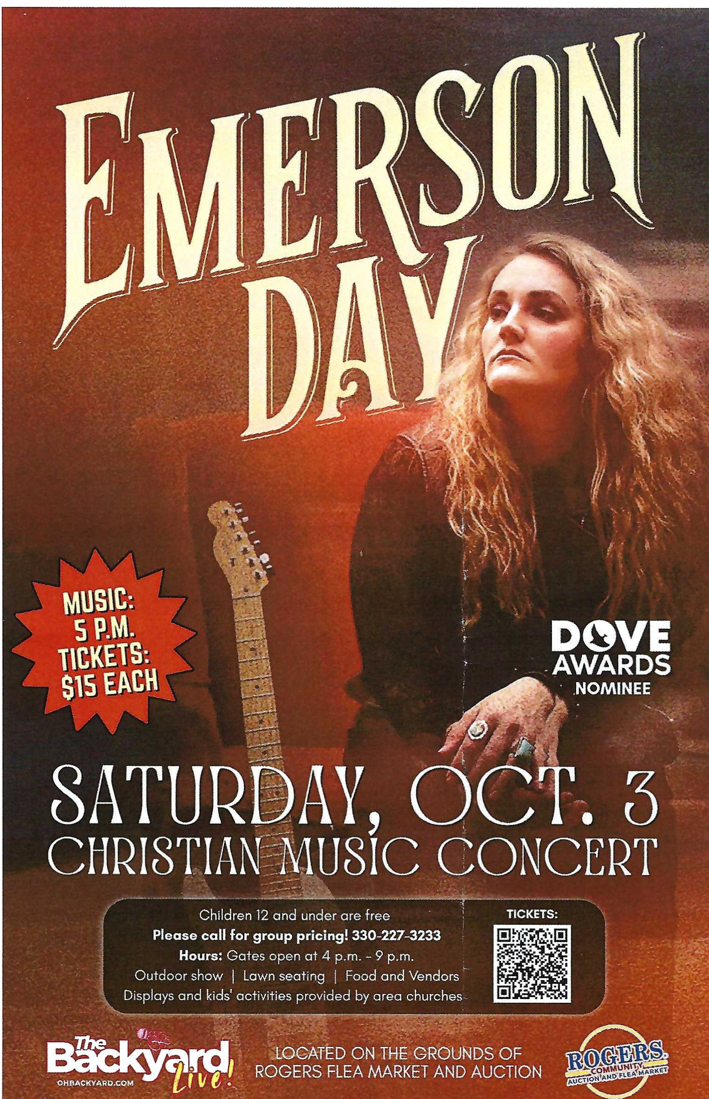

Choir Picnic & Practice
Wednesday, Sept. 23
6:00 Choir Picnic
7:00 Choir Practice

We welcome new members.
Bring a covered-dish, your table service, and a beverage.



4C’s Item
Pancake Mix and Syrup

Update on Mission Giving for 2026
FUND | NAME OF FUND | NEED | RECEIVED | STILL NEED
2 | General Mission Fund | 5,099 | 5,352 | 0
33 | 4C’s | 125 | 675 | 0
32 | Cub Scouts | 150 | 605 | 0
37 | Way Station | 150 | 160 | 0
22 | Flat Rock | 175 | 265 | 0
64 | Farmer to Farmer – Liberia | 300 | 360 | 0
13 | UMCOR Sunday | Any  Donation | 75
21 | UMCOR – U.S. Disasters | Any  Donation | 10
14 | Blanket Sunday | Any  Donation | 65
15 | Peace With Justice | Any  Donation | 0
16 | World Communion | Any  Donation | 20
17 | Student Day | Any  Donation | 0
46 | Heroes & Halos | Any  Donation | 100
63 | InStep Program | Any  Donation | 35
38 | Operation Christmas Child Shoeboxes |  | 118 plus 90

Fund Balances as of end of JULY
Fund # 1 Ministry Operating -12,447
Fund # 2 Mission Fund 3,021
Fund # 3 Building Fund 36,885
Fund # 28 Elevator Fund 7,633

Last Week’s Attendance ( August 16)
In-Person: 71 Online: 19

