Newsletter of l’Église Baptiste Évangélique de Ville d’Anjou (ÉBÉVA)

The Evangelical Baptist Church of Ville d’Anjou Teamed up with Child Evangelism Fellowship to organize a
5-Day Club with eternal results
In the week leading up to August 3-7, 2026, we went door-to-door in Ville d’Anjou, visiting parks, swimming pools, and the library, distributing invitations for the 5-Day Club. We knocked on many doors and posted flyers in several businesses. Everywhere there were children! Many children were already registered in other day camps, but by the grace of God, we managed to get 30 registrations!
The target age group was 5-12 years old, but we also invited any teenagers who were interested to help us prepare snacks, assist with games, and supervise the younger children. And it worked: 6 young people aged 13 to 16 participated! Thank you, Lord!
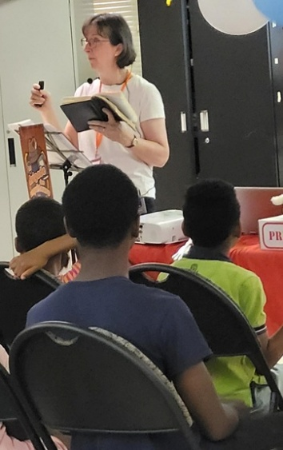
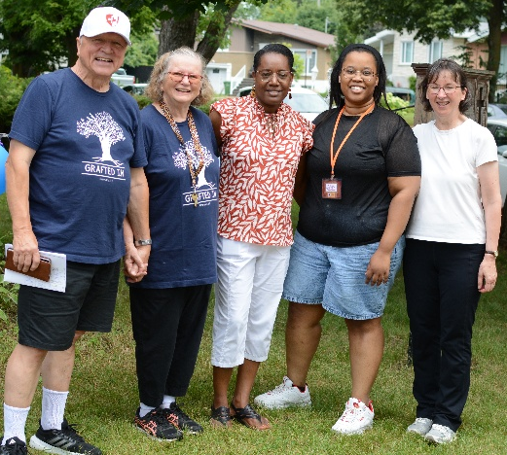
In the photo to the right, from right to left, are two CEF leaders, Sylviane and Ketura. Then, from our ÉBÉVA Church plant are Marie-Carmelle, Sharon, and René. The activities were varied and followed in rapid succession. CEF (Child Evangelism Fellowship) came with eight young adults who took turns teaching Bible verses, leading catchy gospel songs with lively gestures, doing crafts, and playing fun games both indoors and outdoors
But the most powerful, moving, and transformative part was the biblical story. On Monday, “Jesus is the Good Shepherd,” on Tuesday, “Jesus is the Light of the World,” on Wednesday, “Jesus is the Bread of Life.” But it was on Thursday that Sylviane told the story of Lazarus, whom Jesus called forth from his tomb four days after his burial. Then the Spirit of God powerfully used the message of “Jesus: Resurrection and Life” to touch young hearts.
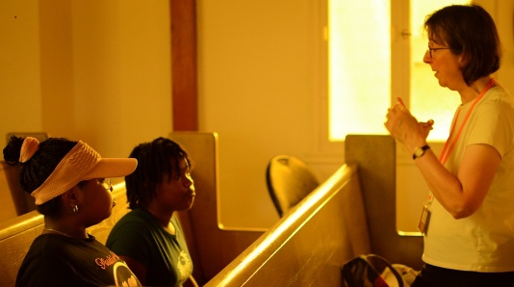
When Sylviane finished the story, she asked everyone to bow their heads and close their eyes. Then she asked if anyone wanted to receive Jesus as his Savior. Many raised their hands. Sylviane and I (René) accompanied them to another room. Since a few didn't seem to fully understand, we let the younger children go back. Three children and two teenagers remained. Sylviane explained how the Bible says we can be saved and invited them to pray aloud, declaring that they were asking Jesus to save them. She stayed with the two girls, Abygaëlle and Victoria.

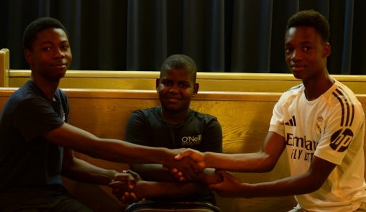
I went to another place with the three boys, Giovanni (9 years old), Samuel (14 years old), and Theo (15 years old). One after the other, they prayed. We read two verses that assure salvation. John 1:12 But to all who did receive him, who believed in his name, he (the living Word: Jesus) gave the right to become children of God. 1 John 5:12-13 Whoever has the Son has life; whoever does not have the Son of God does not have life. I write these things to you who believe in the name of the Son of God so that you may know that you have eternal life. On Friday, it was little Leah, 7 years old, who prayed to Jesus to save her.
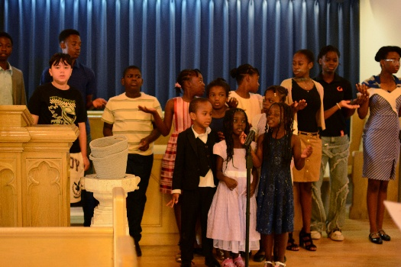
What a joy it is when children and young people want to follow Jesus! They have their whole lives to live for him. On Sunday after the Club, many children sang "Jesus is the light of the world." All the effort, expense, fatigue, meals, and cleanup are nothing compared to the blessing of seeing children and teenagers accept Christ. That is truly an integral part of Church planting!
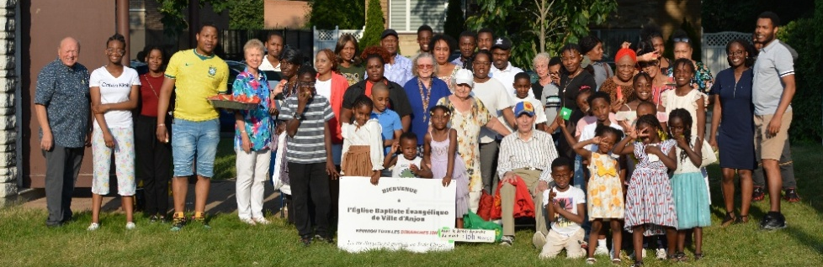
*************************************************************************************
Please continue to pray for and support the Evangelical Baptist Church of Ville d’Anjou, which is still in its planting phase. Pastor-in-training Wismy Thélus (far right) and his wife Rebca have agreed to take over the pastorate in September 2027, but we need to find two elders by the grace of God before then. PLEASE PRAY FOR THIS IMPORTANT REQUEST! THANK YOU!

