TLC Weekly: Sunday, August 16- – August 23
Vicar Angie DeSmith cell: 507-828-4941 email: angiedesmith316@gmail.com
The Radio Broadcast (KMHL 1400AM or 101.7FM) No sponsor
Sunday, Aug 16 10am Worship/Holy Communion at Painted Prairie Vineyards
Monday, Aug17 9am Men in Mission
Wednesday, Aug 19 9am Do Day Mission Work Day
Friday, Aug 21 OFFICE CLOSED
Saturday, Aug 22 10:30am Memorial Service for JoAnne Knutson
Sunday, August 23 9am Worship
10am Coffee Fellowship

August 16 - 10:00 AM - Ecumenical Worship at Painted Prairie Vineyard. Fellowship with coffee and bars begins at 9:30. Bring a lawn or folding chair if you have one. (If you don't have one, they do have some seating there). There will be NO Worship at TLC that Sunday. The Radio broadcast will air live from Painted Prairie at 10:00 AM that day.

Please continue to Remember in Prayer:
Please…
We are happy to include people in our prayer list, but we must have their permission to be included. Many folks are very private about what is happening in their lives and we want to honor that.
Peggy Isaacson – LaVerne Jessen’s daughter, cancer
Kim Mickelson – cancer-cousin of Kari Meyer & Kris Tiegs
Vicki Schaar – Cancer
Mike Hemish – son of Doris Hemish
Matt Olivier – Cancer, brother of Sue Magnuson
Sharalyn Hanson – Recovering at home from Open Heart Surgery – daughter in law of Laverne Jessen
Allen Wilkison – lung cancer, cousin of Sheila Helleson
Mari Perry – Friend of Sheila Helleson

August Acolytes: Neveah Timm, Kynlie Bornitz

August Altar Preparation: Shirley Johnson, Laverne Jessen

August Communion Servers: Pam Peterson, Gail Kropp, Sue Magnuson

Coffee Fellowship: Sunday, August 23 Breakfast Church
Sunday, August 30 OPEN

Scripture Readers: Sunday, August 23 Sheila Helleson
Sunday, August 30 Mary Kay Frisvold

Greeters: Sunday, August 23 OPEN
Sunday, August 30 Jason & April Lichty

Sunday Counters: Sunday, August 23 Kari Meyer
Sunday, August 30 Melody Caron

Ushers: Sunday, Aug 23 Chris Kamrud, Ronnie Dahl, Darrell Christian, Wayne Anderson
Sunday, Aug 30 Mark Peterson, Jim Julien, Mike Carlson, Larry Retzlaff
The church is in need of two ushers, you would serve approximately once every two months and rotate through the Easter and Christmas season. Contact the office if you are interested.
Openings for August radio are August 23rd.
Tracy Lutheran Church
Now Hiring: Part-Time Maintenance Person
Tracy Lutheran Church is seeking a dependable, self-motivated individual to serve as our Part-Time Maintenance Person.
Responsibilities include:
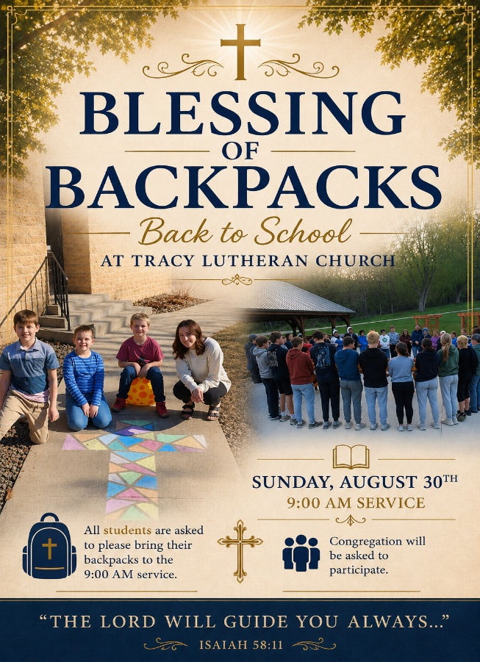
- Performing routine maintenance and minor building repairs Monitoring the condition of lighting, electrical, plumbing, heating, and cooling systems. Summer lawn mowing. Clearing snow from church sidewalks as needed during the winter Position Details: Approximately 5 hours per week. Flexible schedule. Qualifications: A Boiler/Special Engineer License and Pressure Vessel License required. Tracy Lutheran Church will pay for the required licensing and all renewal fees.
To Apply or Learn More:
Contact Linda Rykhus at 507-629-3563 or email tlc@iw.net

At the request of council president, Dennis Fultz, Tracy Lutheran Church is recognized as a Synod -Authorized Ministry site. Angie DeSmith has been authorized by Southwestern Minnesota Synod Bishop Dee Pederson to preach and preside for Holy Communion in the congregation . The authorization is granted in accord with the ELCA’s guiding statement, The Use of the Means of Grace , which recognizes the witness of the sacrament as a celebration of the Church, serving its unity and proclaiming the Gospel; and that where it is not possible to provide ordained pastoral leadership, a synod bishop may authorize a properly trained person to preside at a certain time.

