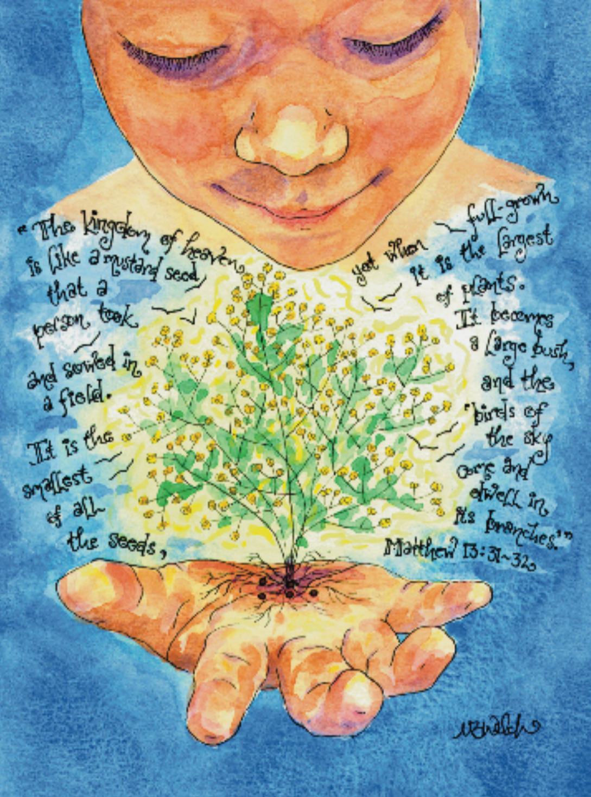
“The kingdom of God is like a mustard seed that a person took
and sowed in a field. It is the smallest of all seed, yet when full-
grown, it is the largest of plants. It becomes a large bush and the
birds of the sky come and dwell in its branches.” Matthew 31b-32

About the Artist

Monica Welch is an artist based in Texas. She began
drawing whimsical illustrations to help learn beautiful
prayers, and continues drawing to inspire others to do the same.


Trinity United Church
August 16, 2026

When Small Things Count

Land Acknowledgement
“We take this time to acknowledge the original peoples of this land. We acknowledge the past, current, and future presence of the peoples of the Lake Simcoe Nottawasaga Treaty 18 land. We worship on this land, and we acknowledge our shared history as we continue on our path towards healing and reconciliation.”

God Welcomes Each One of Us with Loving Grace

Lighting the Christ Candle
We light this candle to remember the presence of God amongst us. May its light guide us to truth talking and to travelling good paths. May we in turn share the light with those we meet.
Introit: VU 579 (verse 1 & 2) “The Church Is Wherever God’s People”
Announcements and Opportunities @Trinity
Gathering Words

We come to give thanks for the Spirit that draws us together:
In the refreshing breeze, the nourishing rain and the warmth of the summer sun.
We come to give thanks for the Faith that shows us the way:
In the melody of song, the words of prayer and the insight of scripture.
We come to celebrate the presence of the Sacred in all things.
We come to worship God with trust and joy!

Opening Prayer
Gracious God, Gentle Spirit, Christ among us, we come into this time of worship bringing our whole selves: hope and despair, laughter and tears, joy and sorrow. We come trusting that nothing can separate us from the gift of your unconditional love. God of promise, persist in opening our hearts and minds to your presence among us. Send your Spirit to increase our faith and our delight in your surprising ways. In the strong name of Jesus we pray, Amen.

Opening Hymn: VU 223 “Eternal, Unchanging, We Sing”

Prayer of Confession
Ever creating God of connection and promise, we desire to be good and honourable people yet we often have trouble balancing our lives.
We try to take our responsibilities seriously – work, family, community – but some days it’s hard to manage.
We try to make decisions that are life-giving, without upsetting or hurting others, but sometimes hurt happens.
We face moral dilemmas and struggle to find a way through them.
We face cultural differences and struggle to find common ground.
In the headlong rush for the next best thing, the spark of your joy in simple things can get lost.
In this time of silent prayer, please hear the challenges that are a weight in our own minds this day…

……Pause for silent reflection…….

Assurance of Pardon
Friends, hear the Good News! Nothing in all of creation can separate us from the Love of God, made known to us in Christ Jesus. In this love we are forgiven and set free to love others as we have first been loved.
Thanks be to God! Amen.

Theme Conversation (Children’s Time) – What is Bucket Filling?
(celebrating 20 years of “Have You Filled
a Bucket Today?” by Carol McCloud)

Hymn -VU 361 “Small Things Count”

God Speaks to Us with Peace and Assurance

Prayer for Illumination
O God, your word is a lamp to our feet, and a light to our path. May we hear your truth for us in our time and place with faith and love. Amen.

The Epistle Lesson: Romans 8:26-39
The Gospel Lesson: Matthew 13:31-33, 44-52

Message: “When Small Things Count”

Hymn - MU 157 “I Am a Child of God”

God Supports and Lifts Us

Prayers of the People and The Lord’s Prayer (spoken)

Acknowledging our Offerings in Support of Trinity United’s ministries
With gratitude we acknowledge the blessings of the many ways your gifts of time, talent, skills and money help support the ministries that Trinity can offer as we follow the way of Jesus to share the compassion, justice and care of God’s love both here and beyond these walls.

With gratitude we acknowledge the blessings of the many ways your gifts of time, talent, skills and money help support the ministries that Trinity can offer as we follow the way of Jesus to share the compassion, justice and care of God’s love both here and beyond these walls.
If you are able to support us financially, cash or cheques can be left in the offering plate at either entrance or mailed or dropped off at the church office.

You can also give by e-transfer to office@collingwoodunitedchurch.ca or by signing up to donate monthly through PAR. If this is your first donation, please make sure we have your name and address and email address (if available) for tax receipt purposes. Thank you for all the ways you support us with your time, your talents and financial resources.

Thank you for all the ways you support us with your time, your talents and your financial resources.
With grateful hearts we pray together:
Creator God, please bless these gifts and the hearts that give them. May they grow like the mustard seed and share the spice of your Spirit in places that reach far beyond ourselves in the world you love. In Jesus’ name we pray, Amen.

Closing Hymn - VU 416 “Forth in Your Name, O Christ”

Commissioning
May we go from this time of worship, in the certain knowledge that the love of God is ours to share, the peace of Christ is ours to extend and the light of the Holy Spirit is ours to offer, in the many simple ways we are both blessed and can be a blessing.

Benediction
And may the grace of Christ attend you,
The Love of God surround you,
And the fellowship of the Holy Spirit keep you,
This day and forever more,

Choral Blessing - VU 422 “God Be With You” (verse one)

As the candle is blown out, Christ’s light is given over to us,
that it may shine through us in all we say and do.
Blessings in your week. Amen.

Music to Inspire Our Serving ***************************************************************************

Thought for the Week

Listen to your life. See it for the fathomless mystery that it is…touch, taste, smell your way to the holy and hidden heart of it because in the last analysis all moments are key moments,

and life itself is grace.
Fredrick Buechner

