Announcements

Monday, August 17
Beaver Valley Band Banquet hall 5:30p.m.

Wednesday, August 19
Community dinner Banquet hall / Kitchen 5:00p.m.

Broadview subscriptions
Braodview group subscription renewal
We have a group subscription to Broadview magazine available to anyone who is interested in saving a few dollars on the annual subscription price.
The group rate for 2027 is $30.00 and is due September 1. Payment can be made by cash or cheque or e-transfer to piercy.ray@gmail.com
Should you have any questions, ask Ray!

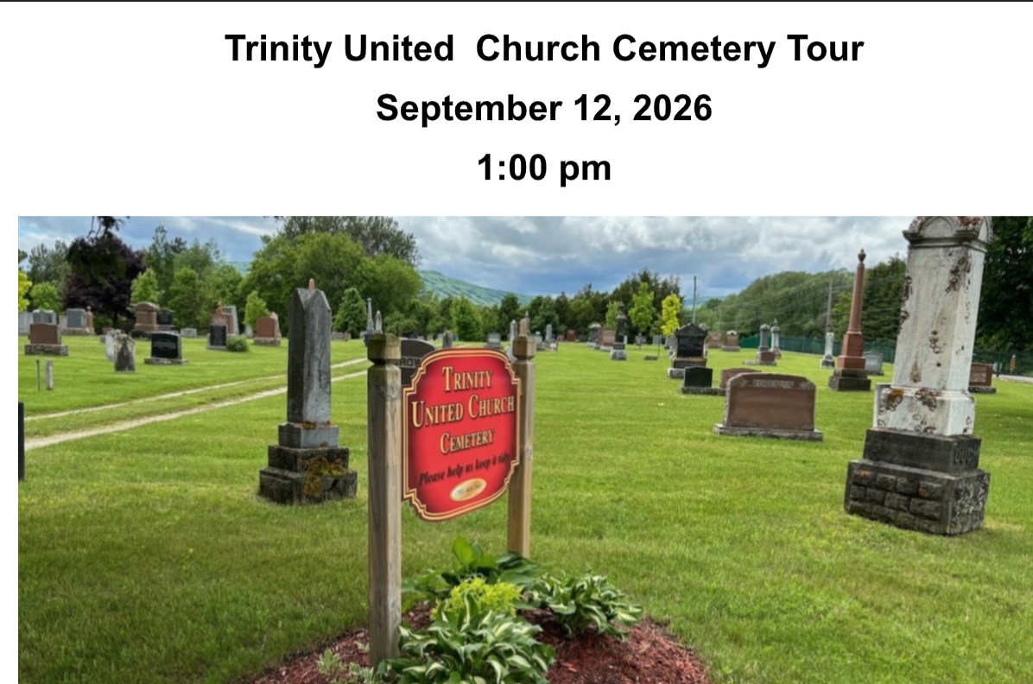

Join us for a thoughtful and informative afternoon as the Trinity United Church Cemetery Board invites you to explore the history of the Cemetery.
Ralph Sneyd, our resident historian, will guide you through stories of Collingwood’s past, highlighting some of the towns most notable citizens.

Larry Hogarth will also be present to answer questions about burial plots, urns, the columbarium and other end-of-life arrangements.

New Opportunity!
Come help lead the way, as a member of our new Affirming Ministry Committee. Further details to follow in September.
If you just can't wait for the details, please feel free to contact Beth Theis: 705-627-2606 or beth.theis2@alumni.utoronto.ca or Bev Mayberry: 705-606-0565 or mayberrybev@gmail.com

Rev. Beth Kerr Vacation time.
Beth will be away on a combination of vacation and study leave in the month of August. Mary Elizabeth Piercy is available for pastoral emergencies (maryelizabethpiercy@gmail.com or 705-445-4740). Our guest worship leaders in August will be:

August 23: Danielle York
August 30: Sarah Bruer

Church office hours
The office will be closed on Friday’s until the end of summer.

Please remember that if you are away during the summer but still want to catch our service, with the exception of our outdoor service on July 26, you can follow us on YouTube https://www.youtube.com/@collingwoodtrinityunitedch5278/streams

Rev. Beth Kerr (she/her)
Diaconal Minister
Trinity United Church
140 Maple Street,
Collingwood, ON L9Y 2P8
www.collingwoodunitedchurch.ca
705-445-3901 (church)
204-872-2370 (cell)
Please note: Friday and Saturday are my sabbath days. I will reply to emails received on those days on the following Monday. For emergencies, please contact my cell phone.

Rev. Beth Kerr Vacation time.
Beth will be away on a combination of vacation and study leave in the month of August. Mary Elizabeth Piercy is available for pastoral emergencies (maryelizabethpiercy@gmail.com or 705-445-4740). Our guest worship leaders in August will be:

August 23: Danielle York
August 30: Sarah Bruer
Church office hours
The office will be closed on Friday’s until the end of summer.

Please remember that if you are away during the summer but still want to catch our service, with the exception of our outdoor service on July 26, you can follow us on YouTube https://www.youtube.com/@collingwoodtrinityunitedch5278/streams

Rev. Beth Kerr (she/her)
Diaconal Minister
Trinity United Church
140 Maple Street,
Collingwood, ON L9Y 2P8
www.collingwoodunitedchurch.ca
705-445-3901 (church)
204-872-2370 (cell)
Please note: Friday and Saturday are my sabbath days. I will reply to emails received on those days on the following Monday. For emergencies, please contact my cell phone.

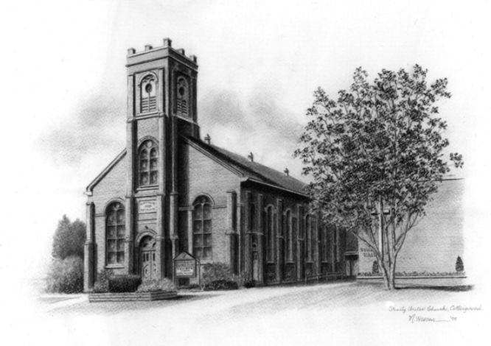

Trinity United Church: Collingwood
Minister: Rev. Beth Kerr, 204.872.2370 (cell)
Minister’s Email minister@collingwoodunitedchurch.ca
Ministry of Music: Paul Sloan, 705.730.3121 (cell)
Choir Director: Lesley Joosten, 705.984.3243
Handbell Director: Maryellen Burgess, 705.443.1422 (cell)
UCW President: Joy Barr 705.445.0726
Office Assistant: Lori Forsythe
Church Office: office@collingwoodunitedchurch.ca
Office Hours: Tuesday to Friday, 8:30 am-12:00 pm
140 Maple Street, Collingwood, ON L9Y 2P8
Telephone: 705.445.3901
Website: www.collingwoodunitedchurch.ca


Quote from Dorothy
Day (1897–1980) an
American journalist,
social activist, and
devout Catholic convert.
She co-founded the
Catholic Worker
Movement and its
newspaper in 1933 to
champion the poor,
advocate for
nonviolence, and
practice radical

Artist: Monica Welch

