St. Paul
UNITED CHURCH OF CHRIST

August 2, 2026 10:30am
Welcome! Whether you are a guest, friend or member, we are delighted that you are here. Large print bulletins are available at either door. Ask a greeter for any directions you may need.

“Please note that this service will be live-streamed on Facebook. If you do not wish to be visible on camera, please let an usher know so we can take appropriate measures to ensure
your privacy."

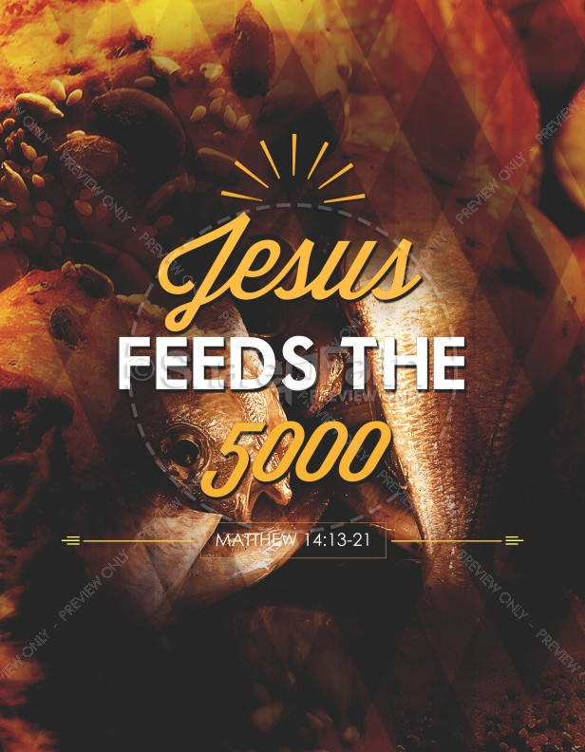

Rev. Jim Oleson, Pastor
Christopher Dickmeyer, Musician
Tenth Sunday after Pentecost
*Please rise in body or spirit
Ringing of the Bell
Welcome & Announcements
We welcome you today in the name of the One who frees us from every burden, renews our spirits and inspires hope and joy in our living. May this time of worship encourage and lift you up.
Prelude and Lighting of the Candles
*Call to Worship (Responsive)
ONE: The day breaks
MANY: And God does not let us go.
ONE: The hour calls
MANY: And God does not let us go.
ONE: The evening falls
MANY: And God holds us fast.
ONE: Let us turn to God in worship
MANY: God, who never turns from us.
*Invocation
God, you see us. You see our struggles, You see our difficulties.
You see our possibilities, You see our promise.
Connect the dots for us, O God.
Soften the hard spots with your blessing.
Call us in our wandering to hear you say our names. Satisfy our longings as with loaves and fishes and manna from heaven.
For you are a good God, a God present in the scramble, And in the end, you always, always have a blessing.
For this and so much more, we give you thanks, through Jesus Christ. Amen.
*Hymn of Praise #86 New Century When Morning Gilds the Skies
Prayer for Transformation and New Life
Gracious God, all we have and all we are is a gift from you, yet we often fail to acknowledge your presence and your grace in our lives. We prefer to take credit for what we do right, to blame others for what goes wrong, and to dismiss as insignificant our weaknesses, self-righteousness and pride. We want to be regarded as being strong, rather than relying on your strength. We want to avoid hardship and trials rather than endure the suffering that molds godly character. We want to be in control rather than yield to you. We ask for your forgiveness. We confess that our stubbornness reveals our mistrust of both your goodness and your love and desires for us. Grant us your mercy, we pray, and restore us to a right relationship with you, for the sake of Jesus Christ our Savior. Amen.
<pause for silent reflection >
Words of Grace
One: The God who gives, gives all.
Many: The God who loves, loves all.
One: The God who forgives, forgives all.
Many: Through Christ, our sins, every one of them:
the sins of commission,
the sins of omission,
One: the sins we confessed with contrition –
all are forgiven.
Many: By the grace of God, we are forgiven.
All: Alleluia!
*Response of Praise
Glory be to the Father, and to the Son, and to the Holy Ghost; As it was in the beginning, is now, and ever shall be, World without end. Amen. Amen.
Mission Moment
Written Word Genesis 32:22-31
Romans 9:1-5
Matthew 14:13-21
Hymn #321 New Century Break Now the Bread of Life
Message A Ministry of Interruptions Rev. Jim Oleson
Matthew 14:13-21
Church in Prayer
Pastoral Prayer
Lord’s Prayer (Debts, Debtors)
Offertory
Invitation to Generosity
*Doxology (Tune: Old Hundredth)
Praise God, from Whom all blessings flow; Praise Him, all creatures here below;
Praise Him above, ye heavenly host; Praise Father, Son, and Holy Ghost. Amen.
*Prayer of Dedication
God of increase and bounty, Source of all good things:
we offer these gifts as a portion of that which you have given us.
May this act of giving bring about change: change in our lives,
change in the lives we touch, change in the systems that harm.
Through Christ, who poured out his life to save us, Amen.
The Lord’s Supper
INVITATION TO CHRIST’S TABLE
COMMUNION PRAYER
WORDS OF INSTITUTION
SHARING OF THE BREAD AND CUP
(Please hold each of the elements as it is distributed so that we may partake each together. The inner ring of cups in each tray holds juice rather than wine.)
* THANKSGIVING PRAYER (unison)
Bountiful God, we give you thanks that you have refreshed us at your table by granting us the presence of Christ. Strengthen our faith, increase our love for one another and send us forth into the world in courage and peace, rejoicing in the power of your Holy Spirit. Amen.
*Closing Hymn #81 New Century God Be with You
*Commission and Benediction
*Christ’s Light Leads Us into the World
*Congregational Response #531 New Century God, Speak to Me, That I May Speak
(Verse 1) *Ringing of the Bell and Postlude

903 Meier Road, Old Monroe, Missouri 63369
stpauluccom@gmail.com
Website: stpauluccom.com
636-665-5329

OFFICE HOURS
Pastor Jim – Monday & Tuesday 8:00am to Noon
Church Office
Wednesday: 9:00am – 3:00pm
Friday: 9:00am - Noon
It Happens
Here St. Paul UCC
Weekly Calendar
August 2nd – August 9th

August 2nd Tenth Sunday after
Pentecost
10:30am Worship
11:30am Fellowship Hour – Pasta with
the Pastor

August 9th Eleventh Sunday after
Pentecost
10:30am Worship
11:30am Fellowship Hour

Looking Ahead

August 17th
5:15pm Council Meeting

________________________________________________________________________________________
OUR GIVING IN 2026
Needed weekly to meet our commitments $2190.29 $ 2190.29
General Fund Offering July 26th $ 265.00 July Average $ 1075.00 Stewardship Offering July 26th $ 0.00 June Average $ 1133.75
______ __________________________________________________ __ ____________________ ________

HAPPENING IN OUR COMMUNITY`

Sunday, August 9: Immaculate Conception Parish Picnic. Prime Beef and Chicken Dinners, Serving from 11am to 6pm. Carry outs available from 11:45am to 7:30pm.

Thank you to all our volunteers!

Greeters/Ushers
Joyce Noble & Janet Drown

Acolyte
Janet Drown

Liturgist

Fellowship Hour
Council


In our prayers …

This week we added Maura and Tara to our prayers.

Lynn and Ron D., Ernie M., Eileen T., Lyle R., Jamie, Nor, Rick C., Carolyn M., Jackie, Belinda D., Linda M., Brittany and Edward, Mary and Jerry, Pat G., Jack B., Randy M., David, Rick L., Bob S., and Billy.

We lift up in our prayers those who need prayers for their long-term circumstances: Carol Jean P. and Jane M.

