All Saints Anglican Church
6904 Lougheed Highway, Agassiz, B.C. V0M 1A0
Bulletin August 10th, 2026 – August 16th, 2026

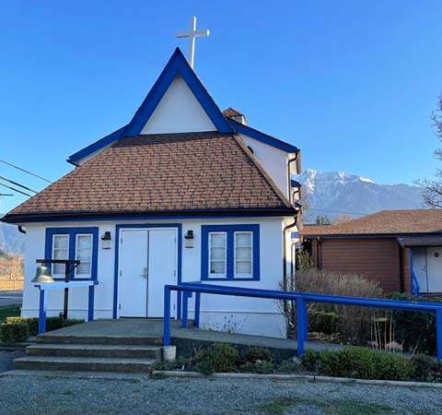

‘The ground we walk does not belong to us; for thousands of years it has been - and remains - the territory of the Stó:lō. We are grateful for their sharing.

Phone: 604-796-3553
Website: www.allsaints-agassiz.ca
https://www.facebook.com/groups/AllSaintsFamily
OUR DOOR IS OPEN AND ALL ARE WELCOME
August 16th, 2026, Twelfth Sunday After Pentecost
Priest in Charge: The Reverend Philip Barker
Hosts: Graham Featherstone/Jennifer Pinlac
Intercessor: Lynn Laughlin
Lay Administrator: Dorothy Cresswell
Announcer: Virginia Jennings
Organ/Piano: Francesca Froehlich
Readers: Fran Froehlich/Pam Evans
Coffee Time: Dorothy/Sherrill

Vicar’s cell phone: Revd. Philip Barker. 778-867-2461

Vicar’s Warden: Ginny Jennings. 604-796-2206
People’s Warden: Lynn Laughlin. 604-799-5131
Parish email: revpb1950@gmail.com
Please contact either warden if you have an issue that needs to be brought to the attention of the Vicar - or contact the Vicar direct (see above for details).

All Saint’s Calendar/Announcements:

- Book Club – On August 19th Book Club will be starting "Two Steps Forward" by Sharon Garlough Brown, an experienced leader of spiritual formation retreats in the UK and US. The 4 women from Sensible Shoes are taking their next steps in the spiritual formation journey. But each of them is finding roadblocks along the way.
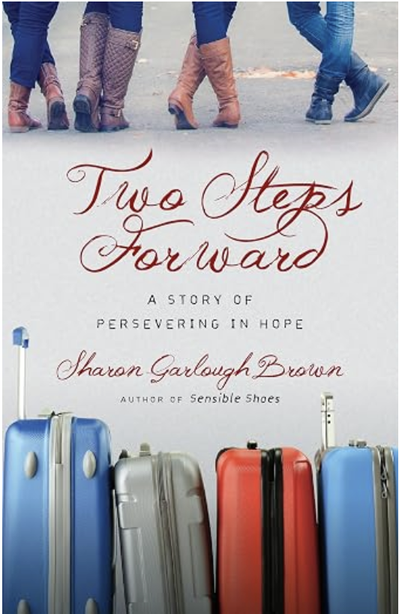

Please contact Sheila Barker at sjbarker0379@gmail.com
if you would like an invitation to the Zoom meetings
at 5.00 pm on Wednesdays or a copy of the book.
The book is available on amazon for $31.43 including tax.

- Bible Study is every Saturday morning 0830-0900 on Zoom. All are welcome to preview and discuss the readings for the Sunday service. Please ask Valerie to add your email address to the invitation list.

- Prayer Requests can be given on a piece of paper to either of the Wardens or the Vicar or entered in the Prayer Request Book on the lectern. Alternatively, you can contact Anthea Lewis at antheamlewis@shaw.ca for Pray First Prayer Circle, which is a confidential online prayer circle.

- Music Requests may be given to the Wardens or the Vicar.

- AA meets in the hall every Tuesday and Friday at noon.

- Every Thursday in the hall 1100-1200 we have a social time with coffee, games if you like or just talk.

- At 1000-1100 on Thursdays there is an Interactive Bible Study on the day’s Lectionary readings. All are welcome – discover the treasures in this amazing book!

- 5th Sunday of each month will be a potluck lunch after the service

- Sunday August 16th – Baptism of Liane Loeppky.

Ministerial Meandering
Bullying

“Get on your knees and choke yourself, scumbag!” So enters Gunnery Sergeant Hartman into the life of the ill-fated Leonard Lawrence, who he promptly re-names ‘Private Pyle’. The film is ‘Full Metal Jacket’, and around half of its length is made up of the systematic, relentless, and brutal bullying of the ‘fat boy’ - Private Pyle - in his group of US Marine recruits.
One of the interesting developments within this part of the movie is the changing reaction of Leonard’s peer group, as they initially despise him, then try to help him, as his failures result in punishment for the whole squad, so it is to their advantage to help him succeed.

What is also of interest to those of us who have been subjected to military discipline, is that the person who was cast to play Gunnery Sergeant Hartman had been, in real life, a Marine Corps Drill Instructor, and so was able to draw on his own experience to put realism into the role.

You might ask why is there a need to be so downright savage to new recruits who are attempting to join military units, and to a certain extent it should be obvious. Obedience in following orders without question makes for effective combat units. And - I would add - following them immediately. If you delay when someone yells, “Take cover!” while you finish sending off your letter to your girlfriend, tying your bootlace, or clearing your mess tin of the last few beans, you may not be around to perform any such actions ever again. It used to infuriate me when our grandsons would dilly-dally around when asked to do something - it infuriated their mother too! - because one day it would really matter, and they wouldn’t have learned how to react appropriately. “Get off the road!” should not elicit the response, “Why?” - but an instant move to obey the command. So that covers one reason why bullying for obedience is important.

But bullying can be subtle and insidious; people talk about you behind your back because someone has spread a malicious rumour; bits of property go missing just when you need them; you walk into a room and everyone else stops talking and moves away. There are many ways to make people feel very uncomfortable; it is not always physical brutality.

Let us not forget the spoken word here. Insults, and especially lies, told to you and about you are vile - and it is no good trying to tell yourself that they only hurt the one who says them, because that’s not true. Words can hurt - badly; and unlike bruises which can heal, words cannot be unsaid.

Bullies frequently use their position (of authority) or greater physical dominance to intimidate or threaten others. This is the origin of escalation in war-fighting. If your school bully has been shooting you with a pea-shooter that stings, you might buy one to retaliate. So he buys something bigger and more damaging - and the school-boy harassment becomes a competition to find ever-bigger and more powerful ways of retaliating, until we reach ‘mutually assured destruction’.

However intimidating the bully is, he or she is always gambling that the ‘worm doesn’t turn’. There reaches a point where even the most craven of cowards may realize that they have nothing to lose by fighting back, even if it does result in their being beaten again. Sometimes, such a manoeuvre is so surprising to the bully that the battle goes the other way.
On a global scale, it is important that we see when political bullying is occurring and when we need to step up and stand for what is right - even if it costs us in ways we cannot anticipate. Standing up to the global bully when a weaker country cannot is what makes for dependable allies - and good friends you can trust further down the scale. That is what loving your neighbour is all about.

Philip+

A Little Chuckle



Birthdays in the August 

Pam Evans – 8 Leroy Burden – 14
Virginia Jennings – 14 Monica Gibson-Pigsley – 28

Diocesan Cycle of Prayer: We Pray for the Clergy and Congregation:

Care+Share Outreach Program (Parish of St Barnabas); St. Mary the Virgin, South Hill - The Revd Expedito Farinas

Anglican Church of Canada Cycle of Prayer – We Pray for:

The Rt. Rev. Naboth Manzongo Bishop, and the clergy and people of the Diocese of Rupert’s Land.

Collect

Almighty God, you have broken the tyranny of sin and sent into our hearts the Spirit of your Son. Give us grace to dedicate our freedom to your service, that all people may know the glorious liberty of the children of God; through Jesus Christ our Lord, who lives and reigns with you and the Holy Spirit, one God, now and for ever.

Genesis 45:1-15 Fran Froehlich

¹Then Joseph could no longer control himself before all his attendants, and he cried out, “Have everyone leave my presence!” So there was no one with Joseph when he made himself known to his brothers. ²And he wept so loudly that the Egyptians heard him, and Pharaoh’s household heard about it.

³ Joseph said to his brothers, “I am Joseph! Is my father still living?” But his brothers were not able to answer him, because they were terrified at his presence.

⁴ Then Joseph said to his brothers, “Come close to me.” When they had done so, he said, “I am your brother Joseph, the one you sold into Egypt! ⁵ And now, do not be distressed and do not be angry with yourselves for selling me here, because it was to save lives that God sent me ahead of you. ⁶ For two years now there has been famine in the land, and for the next five years there will be no plowing and reaping. ⁷ But God sent me ahead of you to preserve for you a remnant on earth and to save your lives by a great deliverance.

⁸ “So then, it was not you who sent me here, but God. He made me father to Pharaoh, lord of his entire household and ruler of all Egypt. ⁹ Now hurry back to my father and say to him, ‘This is what your son Joseph says: God has made me lord of all Egypt. Come down to me; don’t delay. ¹⁰ You shall live in the region of Goshen and be near me—you, your children and grandchildren, your flocks and herds, and all you have. ¹¹ I will provide for you there, because five years of famine are still to come. Otherwise you and your household and all who belong to you will become destitute.’

¹² “You can see for yourselves, and so can my brother Benjamin, that it is really I who am speaking to you. ¹³ Tell my father about all the honor accorded me in Egypt and about everything you have seen. And bring my father down here quickly.”

¹⁴ Then he threw his arms around his brother Benjamin and wept, and Benjamin embraced him, weeping. ¹⁵ And he kissed all his brothers and wept over them. Afterward his brothers talked with him.

Psalm 133

¹ How good and pleasant it is
when God’s people live together in unity!

² It is like precious oil poured on the head,
running down on the beard,
running down on Aaron’s beard,
down on the collar of his robe.
³ It is as if the dew of Hermon
were falling on Mount Zion.
For there the Lord bestows his blessing,
even life forevermore.

Romans 11:1-2a, 29-32 Pam Evans

¹ I ask then: Did God reject his people? By no means! I am an Israelite myself, a descendant of Abraham, from the tribe of Benjamin. ² God did not reject his people, whom he foreknew. Don’t you know what Scripture says in the passage about Elijah—how he appealed to God against Israel:

²⁹ for God’s gifts and his call are irrevocable. ³⁰ Just as you who were at one time disobedient to God have now received mercy as a result of their disobedience, ³¹ so they too have now become disobedient in order that they too may now receive mercy as a result of God’s mercy to you. ³² For God has bound everyone over to disobedience so that he may have mercy on them all.

Matthew 15:10-28 Vicar Philip Barker
¹⁰ Jesus called the crowd to him and said, “Listen and understand. ¹¹ What goes into someone’s mouth does not defile them, but what comes out of their mouth, that is what defiles them.”

¹² Then the disciples came to him and asked, “Do you know that the Pharisees were offended when they heard this?”

¹³ He replied, “Every plant that my heavenly Father has not planted will be pulled up by the roots. ¹⁴ Leave them; they are blind guides. If the blind lead the blind, both will fall into a pit.”

¹⁵ Peter said, “Explain the parable to us.”

¹⁶ “Are you still so dull?” Jesus asked them. ¹⁷ “Don’t you see that whatever enters the mouth goes into the stomach and then out of the body? ¹⁸ But the things that come out of a person’s mouth come from the heart, and these defile them. ¹⁹ For out of the heart come evil thoughts—murder, adultery, sexual immorality, theft, false testimony, slander. ²⁰ These are what defile a person; but eating with unwashed hands does not defile them.”

²¹ Leaving that place, Jesus withdrew to the region of Tyre and Sidon. ²² A Canaanite woman from that vicinity came to him, crying out, “Lord, Son of David, have mercy on me! My daughter is demon-possessed and suffering terribly.”

²³ Jesus did not answer a word. So his disciples came to him and urged him, “Send her away, for she keeps crying out after us.”

²⁴ He answered, “I was sent only to the lost sheep of Israel.”

²⁵ The woman came and knelt before him. “Lord, help me!” she said.

²⁶ He replied, “It is not right to take the children’s bread and toss it to the dogs.”

²⁷ “Yes it is, Lord,” she said. “Even the dogs eat the crumbs that fall from their master’s table.”

²⁸ Then Jesus said to her, “Woman, you have great faith! Your request is granted.” And her daughter was healed at that moment.

Odds and Ends

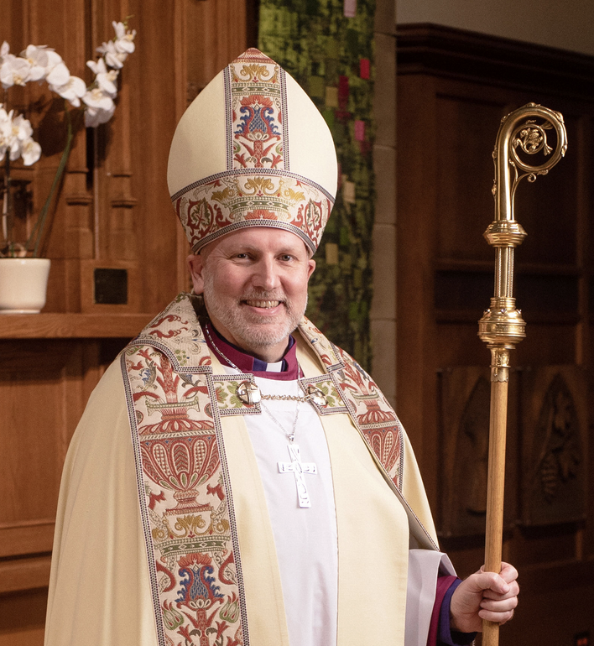

Archbishop John Stephens Visit
Sunday August 23rd, 2026


~Save the Date~

Saturday October 3rd

All Saints Anglican Church
Garage Sale



