
Colington United Methodist Church
August 16, 2026
Twelfth Sunday after Pentecost

welcome and announcements
centering
prelude and lighting of altar candles
All Things Bright and Beautiful Hayes
call to worship
Psalm 133 ǀ UMH 850
opening prayer
God of all glory, you brought the universe into existence, and raised up witnesses to your greatness and love. We praise and adore you. Grant that by the inspiration of your Holy Spirit we may worship and serve
you, and praise your holy name; through Christ our Lord. Amen.
†opening hymn
Thy Word Is a Lamp ǀ UMH 601
the prayers of the people
the first lesson
Genesis 45:1-15
the second lesson
Isaiah 56:1, 6-8
special music
Mountain Over the Hilltop ǀ Becky and Temple
the epistle
Romans 11:29-32
the gospel
Matthew 15:21-28
sermon
“The View from the Far Side” ǀ Rev. Jack Colenda
†affirmation of praise
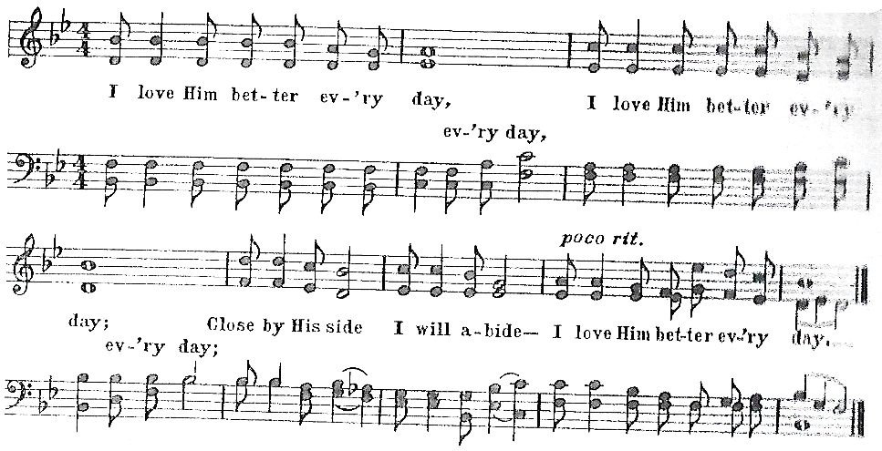
I Love Him Better Every Day

prayer of confession ǀ UMH 893
call to communion
We come, not because we are strong, but because we are weak.
We come, not because of any goodness of our own, but because we need mercy and help.
We come, because we love the Lord a little and would like to love him more.
We come, because he loves us and gave himself for us.
the great thanksgiving
response
Give Thanks ǀ UMH inside cover
giving the bread and cup
†closing hymn
God of the Sparrow God of the Whale ǀ UMH 122
_____________________________________________________________

this week at colington
These opportunities to serve as the Body of Christ are available.
Tuesday – 9 am – Prayer Group
6:15pm – Beach fellowship
Wednesday – 10am - Admin. Council meets.
4:00-6:00pm – Farewell reception for Evelyn Ireland at Run Hill Apts. Community Center.
Saturday – 10am -2pm – Dare County Special Olympics picnic at North Beach Rec. Center. Sign-up sheet in fellowship room.

coming up
Next Sunday – 8:30am – choir practice
9:30 am – Worship, in-person and Facebook Live
Wed., Aug. 26 – 10am – Knitters and crocheters.
1:45 – Volunteers to beach food pantry.
Sun., Aug. 30 – Manna meal following worship. Sign up sheet for sides in fellowship room.

Thanks to today’s volunteers!
Ushers – Steve Knowles/ Ozzie Gray
Scripture Reader – Merinda DeHart
Communion Assistant – Temple Heggie

The flowers on the altar are given by Sue Leggio in memory of Albert Nelson.

Last week’s attendance – 69.

If you would like to make an electronic donation, you may do so using the QR code below



