Holy Trinity Evangelical Lutheran Church

12th Sunday After Pentecost

August 16, 2026, at 10:30 am

Pastor Tina Crog

Order of Worship
*Prelude

* Welcome and Announcements Worship Assistant

* Opening Hymn "Oh, for a Thousand Tongues to Sing" ELW 886
Public Domain VS 1-4
1.Oh, for a thousand tongues to sing my great Redeemer’s praise, the glories of my God and king, the triumphs of his grace!

2.My gracious Master and my God, assist me to proclaim, to spread through all the earth abroad the honors of your name.

3.The name of Jesus charms our fears and bids our sorrows cease, sings music in the sinner’s ears, brings life and health and peace.

4.He speaks, and list’ning to his voice, new life the dead receive;
the mournful, broken hearts rejoice, the humble poor believe.

* Confession and Forgiveness Pastor Tina
Blessed be the holy Trinity, ☩ one God, who calls us by name, claims us as family, and keeps covenant with us through every generation. Amen.

Trusting in God’s mercy, let us confess our sin. Silence is kept for reflection.

God of Jacob, Judah and Benjamin, you have called us into your family by grace, not by earning. Yet we forget who we belong to. We trust our own striving more than your promise. We cling to favoritism, resentment, fear, and scarcity. We wound one another in word and deed. We doubt your provision, resist your calling, and turn away from our neighbors. Forgive us. Remind us whose we are. Teach us to live as people shaped by your covenant of mercy; through Jesus Christ, our Lord. Amen.

Hear the good news: God’s promise does not depend on human perfection. The covenant is gift, not reward. Your past does not define you; God’s mercy does. In the name of Jesus Christ, your sins are forgiven. Amen.

* Kyrie “Have Mercy on Us Lord” ELW pg 203

1.Have mercy on us, Lord, and hear our solemn prayer.
We come to hear your living word; it saves us from despair.

2.Have mercy on us, Christ, and wash away our sin.
Pour out your grace and make us whole that new life may begin.

3.Have mercy on us, Lord; make sin and shame depart.
Renew us with your saving pow’r, create in us new hearts!

* Canticle of Praise “Glory Be To God In Heaven” ELW pg 204

1.Glory be to God in heaven; peace, goodwill to all the earth.
Mighty God of all creation, Father of surpassing worth:
we exalt you, we adore you, we lift high our thanks and praise.
Saints and angels bow before you; here on earth our songs we raise.

2.Glory be to Christ forever, Lamb of God and Lord of love.
Son of God and gracious Savior, you have come from heav’n above; on the cross you died to save us; now you reign at God’s right hand. Hear our prayer; restore, forgive us; in your promise firm we stand.

3.Holy One we now acclaim you; Lord alone, to you we call;
Holy One in faith we name you, God most high, yet near to all:
Jesus Christ, with God the Spirit, in the Father’s splendor bright.
For the peace that we inherit, glory b e to God on high!

*Greeting Pastor Tina

*Prayer of the Day Worship Assistant
God of all peoples, your arms reach out to embrace all those who call upon you. Teach us as disciples of your Son to love the world with compassion and constancy, that your name may be known throughout the earth, through Jesus Christ, our Savior and Lord. Amen.

* Passing of the Peace Worship Assistant
may the peace of christ be with always. and also with you.

Share the peace of Christ with one another with a wave.

*Children’s Moment Pastor Tina

*First Lesson: Genesis 45:1-15 Reader
[After Judah offered himself in place of his brother Benjamin,] ¹ Joseph could no longer control himself before all those who stood by him, and he cried out, “Send everyone away from me.” So no one stayed with him when Joseph made himself known to his brothers. ² And he wept so loudly that the Egyptians heard it, and the household of Pharaoh heard it. ³ Joseph said to his brothers, “I am Joseph. Is my father still alive?” But his brothers could not answer him, so dismayed were they at his presence.
⁴ Then Joseph said to his brothers, “Come closer to me.” And they came closer. He said, “I am your brother, Joseph, whom you sold into Egypt. ⁵ And now do not be distressed or angry with yourselves because you sold me here, for God sent me before you to preserve life. ⁶ For the famine has been in the land these two years, and there are five more years in which there will be neither plowing nor harvest. ⁷ God sent me before you to preserve for you a remnant on earth and to keep alive for you many survivors. ⁸ So it was not you who sent me here but God; he has made me a father to Pharaoh and lord of all his house and ruler over all the land of Egypt. ⁹ Hurry and go up to my father and say to him, ‘Thus says your son Joseph, God has made me lord of all Egypt; come down to me; do not delay. ¹⁰ You shall settle in the land of Goshen, and you shall be near me, you and your children and your children’s children, as well as your flocks, your herds, and all that you have. ¹¹ I will provide for you there, since there are five more years of famine to come, so that you and your household and all that you have will not come to poverty.’ ¹² And now your eyes and the eyes of my brother Benjamin see that it is my own mouth that speaks to you. ¹³ You must tell my father how greatly I am honored in Egypt and all that you have seen. Hurry and bring my father down here.” ¹⁴ Then he fell upon his brother Benjamin’s neck and wept, while Benjamin wept upon his neck. ¹⁵ And he kissed all his brothers and wept upon them, and after that his brothers talked with him.
The Word of the Lord. Thanks be to God.

*Second Lesson: Romans 9:1-2a, 29-32 Reader
[Paul writes:] ¹ I ask, then, has God rejected his people? By no means! I myself am an Israelite, a descendant of Abraham, a member of the tribe of Benjamin. ^{2a} God has not rejected his people whom he foreknew.
²⁹ For the gifts and the calling of God are irrevocable. ³⁰ Just as you were once disobedient to God but have now received mercy because of their disobedience, ³¹ so also they have now been disobedient in order that, by the mercy shown to you, they also may now receive mercy. ³² For God has imprisoned all in disobedience so that he may be merciful to all.
The Word of the Lord. Thanks be to God.

* Gospel Acclamation "Alleluia! Lord and Savior" ELW pg. 205

Al-le-lu-ia! Lord and Savior: open now your saving word.
Let it burn like fire within us; speak until our hearts are stirred.
Al-le-lu-ia! Lord, we sing for the good news that you bring.
* Gospel: Matthew 15:21-28
The Holy Gospel according to Matthew, the 15th chapter. Glory to you, O Lord.
²¹ Jesus left that place and went away to the district of Tyre and Sidon. ²² Just then a Canaanite woman from that region came out and started shouting, “Have mercy on me, Lord, Son of David; my daughter is tormented by a demon.” ²³ But he did not answer her at all. And his disciples came and urged him, saying, “Send her away, for she keeps shouting after us.” ²⁴ He answered, “I was sent only to the lost sheep of the house of Israel.” ²⁵ But she came and knelt before him, saying, “Lord, help me.” ²⁶ He answered, “It is not fair to take the children’s food and throw it to the dogs.” ²⁷ She said, “Yes, Lord, yet even the dogs eat the crumbs that fall from their masters’ table.” ²⁸ Then Jesus answered her, “Woman, great is your faith! Let it be done for you as you wish.” And her daughter was healed from that moment.

The Gospel of the Lord. Praise to you, O Christ.

*Sermon Pastor Tina

* Hymn of the Day "Build a Longer Table" ACS 1062
One License A-700000
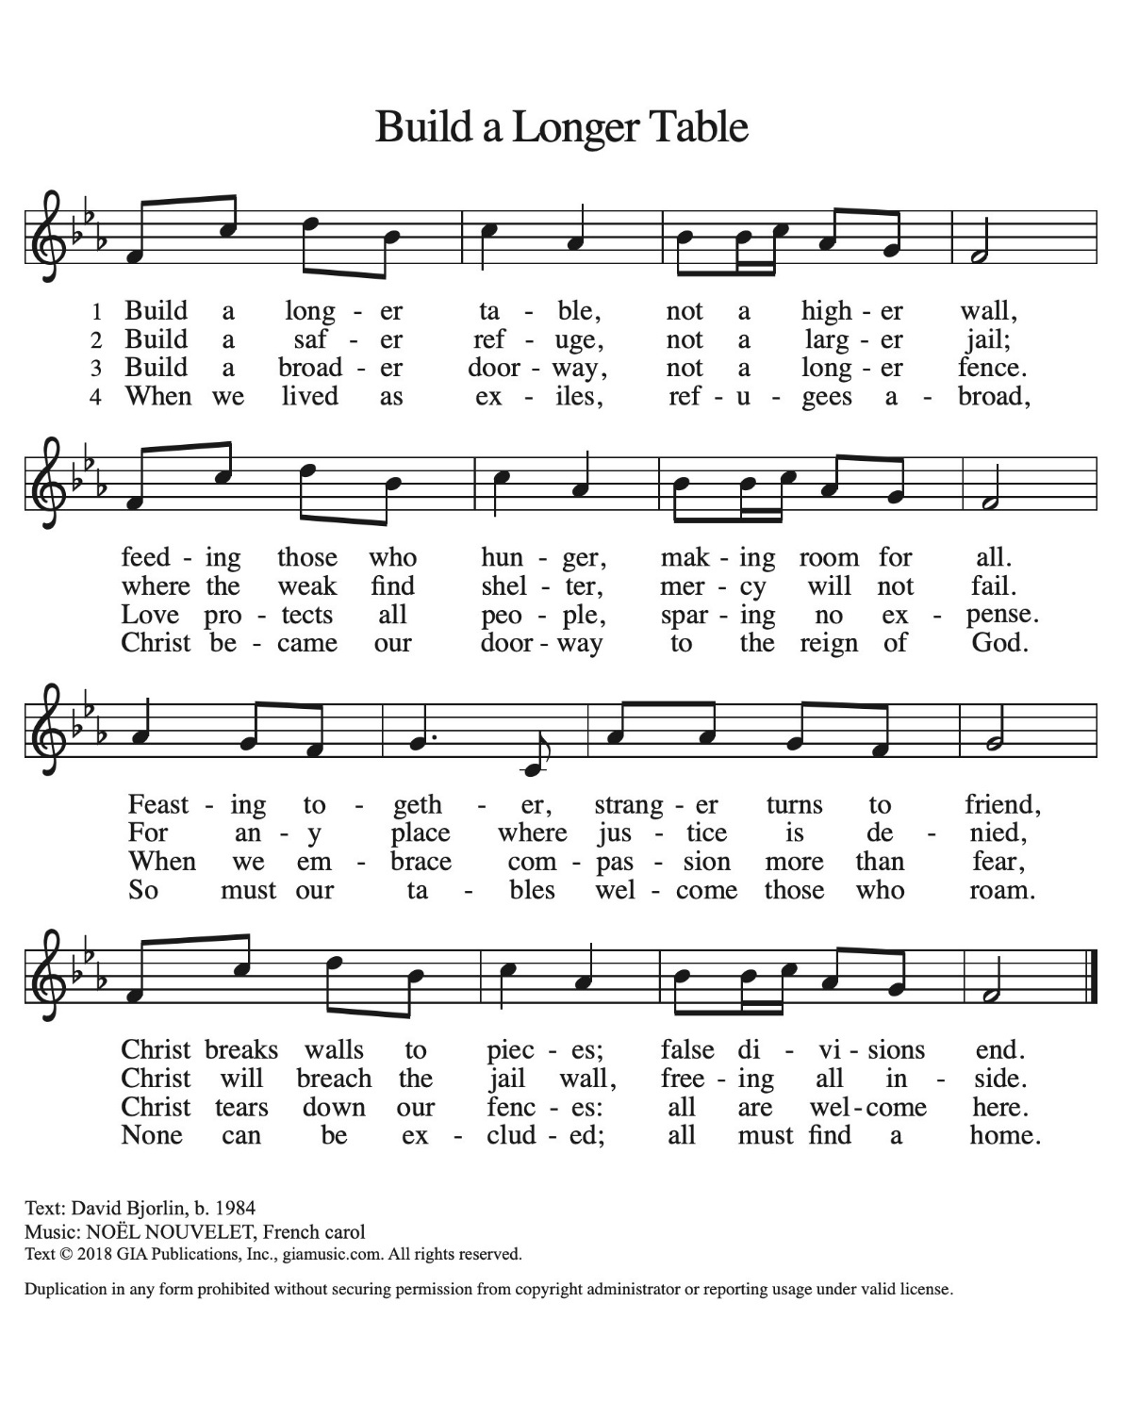
* Apostle’s Creed Worship Assistant
Let us proclaim our faith in the words of the apostle’s creed.
I believe in God, the Father almighty,
creator of heaven and earth.
I believe in Jesus Christ, God's only Son, our Lord,
who was conceived by the power of the Holy Spirit,
born of the Virgin Mary,
suffered under Pontius Pilate,
was crucified, died, and was buried;
he descended to the dead.
On the third day he rose again;
he ascended into heaven,
he is seated at the right hand of the Father,
and he will come to judge the living and the dead.
I believe in the Holy Spirit,
the holy catholic Church,
the communion of saints,
the forgiveness of sins,
the resurrection of the body,
and the life everlasting. Amen.

* Prayers of Intercession Pastor Tina
Be Seated
Prayer requests and Shares of Joy
With bold trust in God’s unfailing provision, we pray for the church, those in need, and all of God’s creation.

A brief silence.

For believers around the world who stream to your holy mountain, that all be united in faith and harmony in the body of Christ. Let your church on earth be a witness to the beloved community of your heavenly kingdom. Merciful God, receive our prayer.

For your wondrous creation, that it thrives and flourishes as you intend. Raise up wise stewards to defend the natural world against carelessness and destruction. Safeguard endangered species and their habitats (especially). Merciful God, receive our prayer.

For the nations of the world and all in authority, that they heed the cry of the outcast and ensure care for the most vulnerable. Give wisdom to leaders of countries, congregations, and communities, that they lead and serve justly. Merciful God, receive our prayer.

For all who are lonely, grieving, or struggling with chronic pain, that they find comfort, community, and hope. Send relief to all who struggle with illness of any kind (especially). Merciful God, receive our prayer.

For this congregation, for visitors and those new to this faith community, that all may recognize the presence of Christ in each new face. Draw this community together in love and strengthen it in unwavering faith. Merciful God, receive our prayer.

For the saints before us whose work is done, that their faithful example continues to direct your church. May their witness remind us that your gifts and calling are irrevocable, whether in life or death. Merciful God, receive our prayer.

Receive our prayers and answer, O God, as you have promised. All this we ask in the name of your Son, Jesus Christ our Lord. Amen.

* Offering Worship Assistant
The monthly mission for August is for “The Collaboration and Shared Missions.” let us give to god what he has first given us.

*Offering Music by Jared

* Offering Hymn “We Are an Offering” ELW #692
CCLI-11222261

We lift our voices, we lift our hands, we lift our lives up to you:
We are an offering. Lord, use our voices, Lord, use our hands,
Lord, use our lives, they are yours: we are an offering.
All that we have, all that we are, all that we hope to be, we give to you; we give to you. We lift our voices, we lift our hands, we lift
our lives up to you: we are an offering, we are an offering.

* Offering Prayer Worship Assistant and Congregation
Loving God, we offer at your table the gifts of our hearts. Help us take heart in you and share freely of your love, so that all creation can taste your abundance. We ask this in the name of Jesus, through the Spirit abiding with us now and forever. Amen.

*The Great Thanksgiving (spoken) Pastor Tina
The Lord be with you.
And also with you.
Lift up your hearts,
We lift them to the Lord.
Let us give thanks to the Lord, our God.
It is right to give God our thanks and praise.

* Preface

*Holy, Holy, Holy ELW pg. 207

Holy, holy, holy Lord, God of power and might,
heav’n and earth are full of your glory. Hosanna in the highest.
Blessed is he who comes in the name of the Lord. Hosanna in the highest, hosanna in the highest.

* Eucharistic Prayer and Words of Institution

* Lord’s Prayer ELW pg 208

Our Father, who art in heaven, hallowed be thy name, thy kingdom come, thy will be done, on earth as it is in heaven.
give us this day our daily bread; and forgive us our trespasses, as we forgive those who trespass against us; and lead us not into temptation, but deliver us from evil. For thine is the kingdom, and the power, and the glory, forever and ever. amen.

*Lamb of God ELW pg. 208

1. O Lamb of God, you bear the sin of all the world away;
you suffered death our lives to save: have mercy now, we pray.

2.O Lamb of God, you bear the sin of all the world away;
you set us free from guilt and grave; have mercy now, we pray.

3.O Lamb of God, you bear the sin of all the world away;
eternal peace with God you made: give us your peace, we pray.

*Special Music during Holy Communion by jared

*Post Communion Blessing Pastor Tina

* Post Communion Hymn “As the Grains of Wheat” ELW 465 vs. 2
One License A-700000
As the grains of wheat once scattered on the hill were gathered into one to become our bread; so may all your people from all the ends of earth be gathered into one in you.
2.Let this be a foretaste of all that is to come when all creation shares this feast with you.

* Prayer After Communion Pastor Tina and Congregation
Compassionate God, through the gifts of bread and wine our hearts are filled with the abundance of your love. Strengthen us that we, through this holy meal, may share your love freely, as you have shared with us. We ask this in the name of Jesus, through the Spirit nourishing us now and forever. Amen.

* Blessing Pastor Tina

* Closing Hymn "My Faith Looks Up to Thee" ELW 759
Public Domain
1.My faith looks up to thee, thou Lamb of Calvary, Savior Divine!
Now hear be while I pray, take all my guilt away, oh, let me from this day be wholly thine!

2.May thy rich grace impart strength to my fainting heart, my zeal
inspire; as thou hast died for me, oh, may my love to thee pure,
warm, and changeless be, a living fire!

3.While life’s dark maze I tread and griefs around me spread, be
thou by guide; bid darkness turn today, wipe sorrow’s tears away, nor let me ever stray from thee aside.

4.When ends life’s transient dream, when death’s cold, sullen stream shall o’er be roll; blest Savior, then, in love fear and distrust remove; oh, bear me safe above, a ransomed soul!

* Dismissal
Go in peace, sharing the gifts of Christ! Thanks be to God!

*Postlude

