City Road United Methodist Church
A Lighthouse Congregation

Rev. Tim Nicholson, Pastor
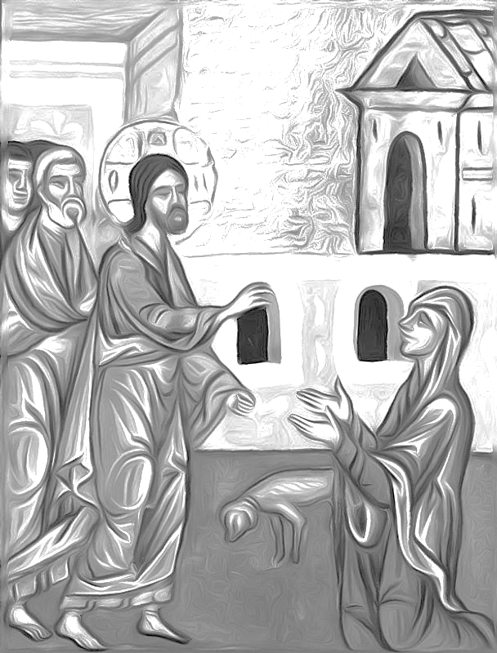

Office: (252) 335-2658
cityroadec.net crumcec@gmail.com

Facebook: https://www.facebook.com/CityRoadUMC

Sunday School: 10:00 a.m.
Sanctuary Worship: 11:00 a.m.

Tommy Venters- Organist/Choir Director
Dawn Baker- Secretary/Technology Specialist
Jo Ann Herring- We Care
Service of Word
12th Sunday After Pentecost
August 16th, 2026 11:00 am
Gathering
Prelude
Words of Welcome
*Call to Worship
We will all join in this prayer together:
Almighty and everlasting God,
in whom we live and move and have our being,
you created us for yourself,
so that our hearts are restless until they find rest in you.
Grant to us such piety of heart and strength of purpose
that no selfish passion may hinder us from knowing your will,
and no weakness from doing it.
In your light may we see life clearly
and in your service find perfect freedom;
through Jesus Christ our Lord. Amen.
(The Book of Worship 1965)

*Opening Hymn “Leaning on the Everlasting Arm” UMH 133

Prayers of the People
Silent Prayer
Pastoral Prayer
The Lord’s Prayer
Our Father who art in heaven, hallowed be thy name. Thy kingdom come; thy will be done on earth as it is in heaven. Give us this day our daily bread, and forgive us our trespasses, as we forgive those who trespass against us; and lead us not into temptation but deliver us from evil. For thine is the kingdom, and power, and glory forever. Amen

Proclamation & Response
Psalter Reading Psalm 133
Children’s Time
Call to the Offering
Offertory
*Doxology UMH 95
*Prayer of Dedication

*Hymn of Preparation “Freely, Freely” UMH 389

Anthem Chancel Choir

Scripture Matthew 15: 10-28
Message Pastor Tim Nicholson

Apostle’s Creed UMH 881

Sending Fourth
*Sending Hymn “Blest Be the Tie That Binds” UMH 557
*Benediction “Pass It On” UMH 572
*Postlude

Bulletin image attribution: Bazzi Rahib, The Canaanite Woman Asks for Healing for Her Daughter.http://diglib.library.vanderbilt.edu/act-imagelink.pl?RC=57555
CCLI License # 11639232

